**Microservices Webinar – Outer Architecture**

“Deep-dive into Microservice Outer Architecture” WSO2

February 3, 2016

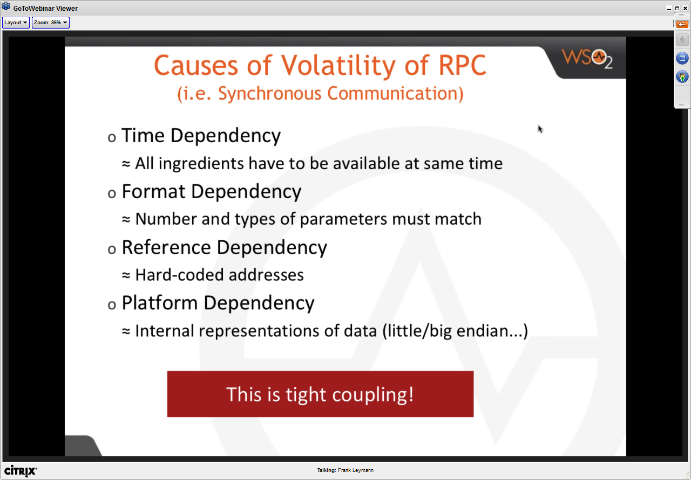

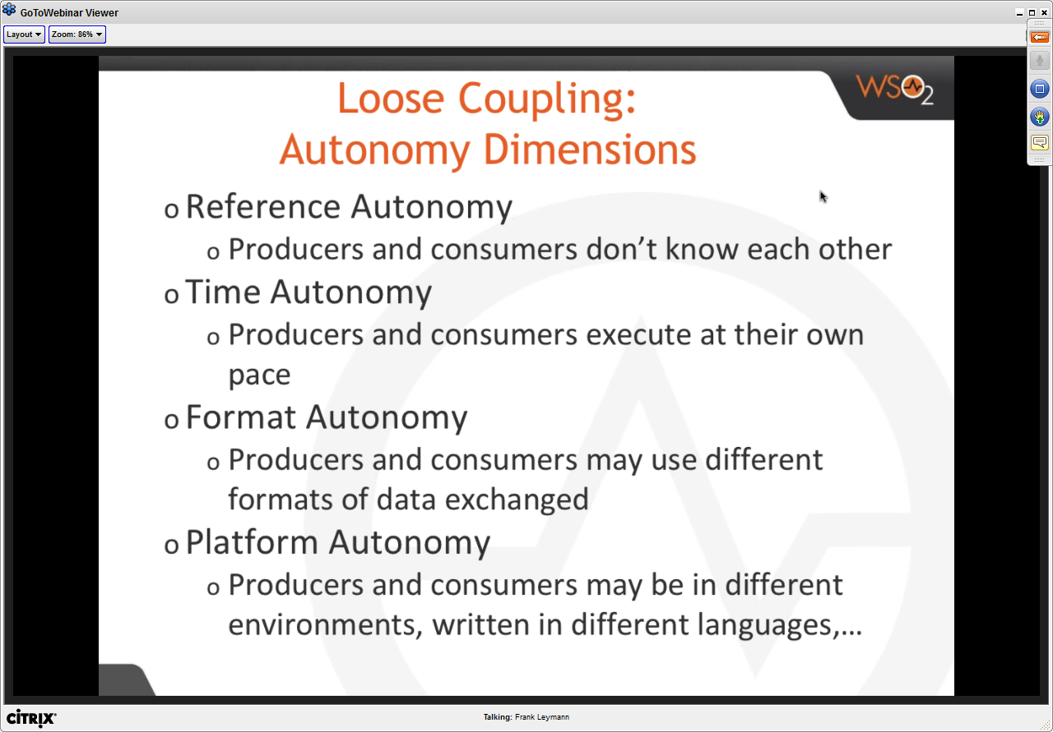

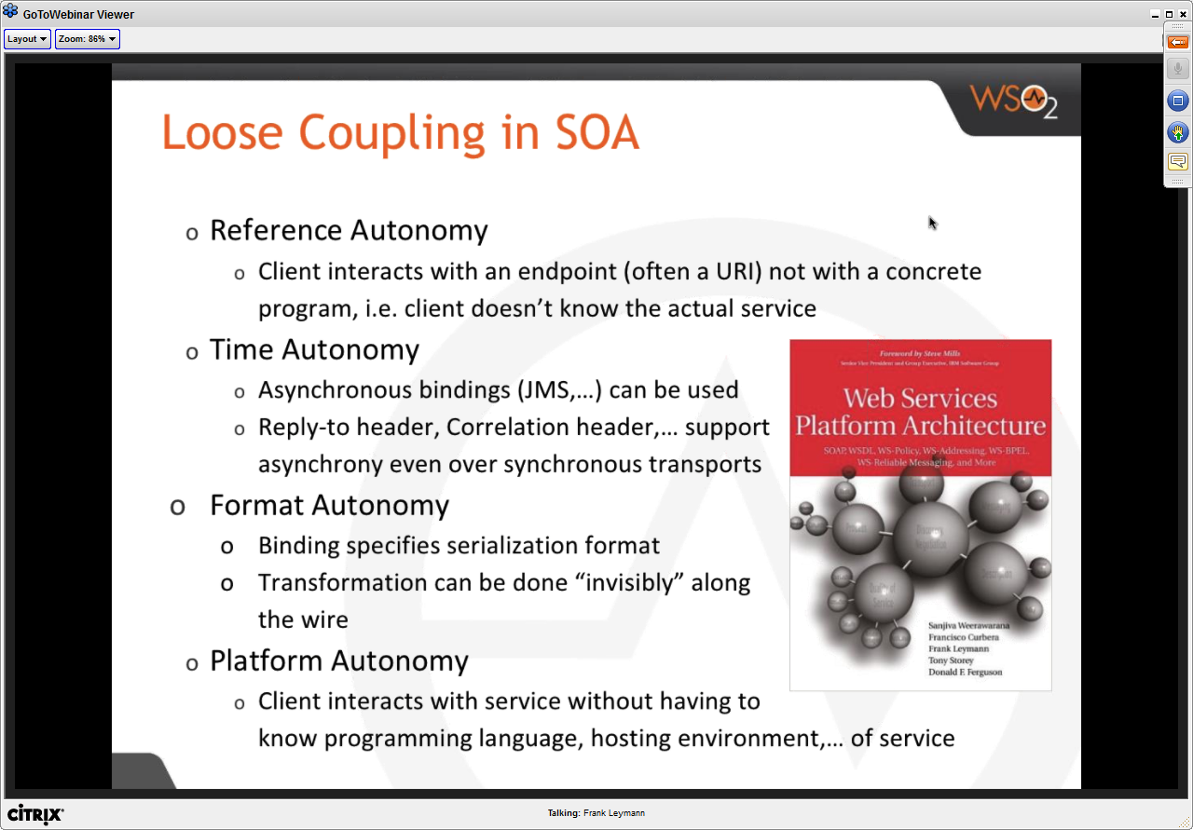

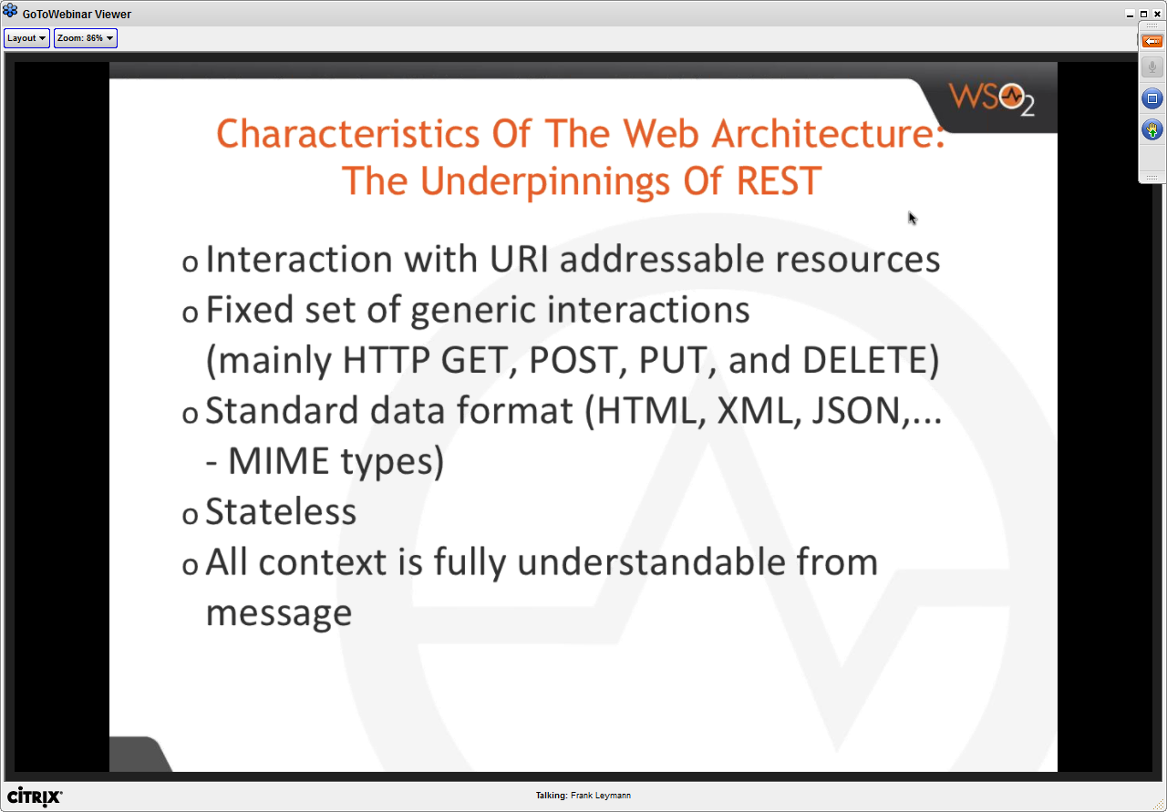

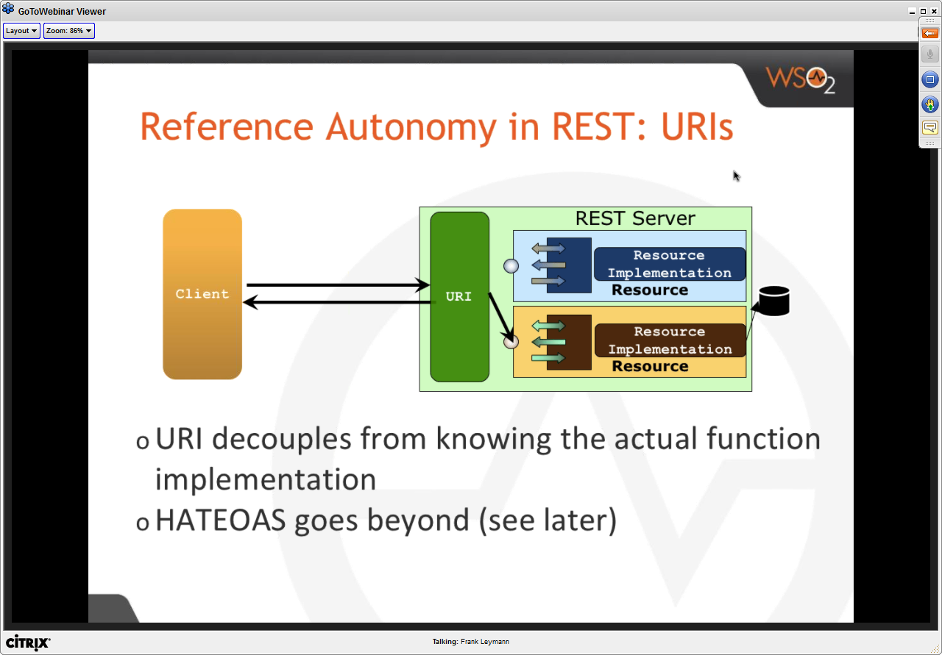

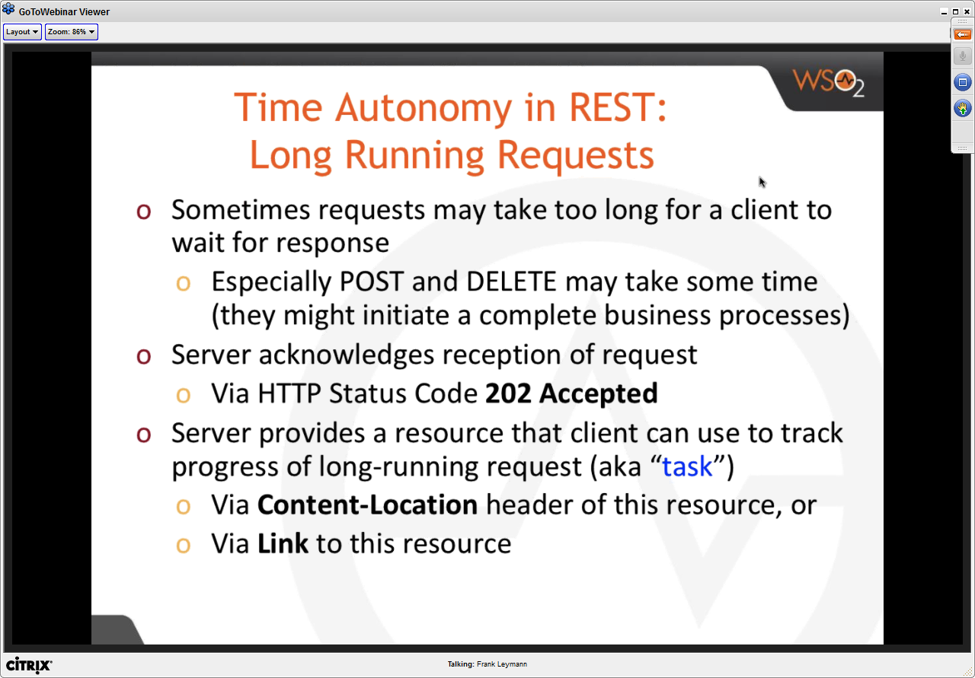

* Situation in case of a long running transaction
  + Server acknowledges with HTTP 202 and Content location – also known as a task resource
  + Client can reach out to content-location URI with gET later to get the end result from the long running transaction

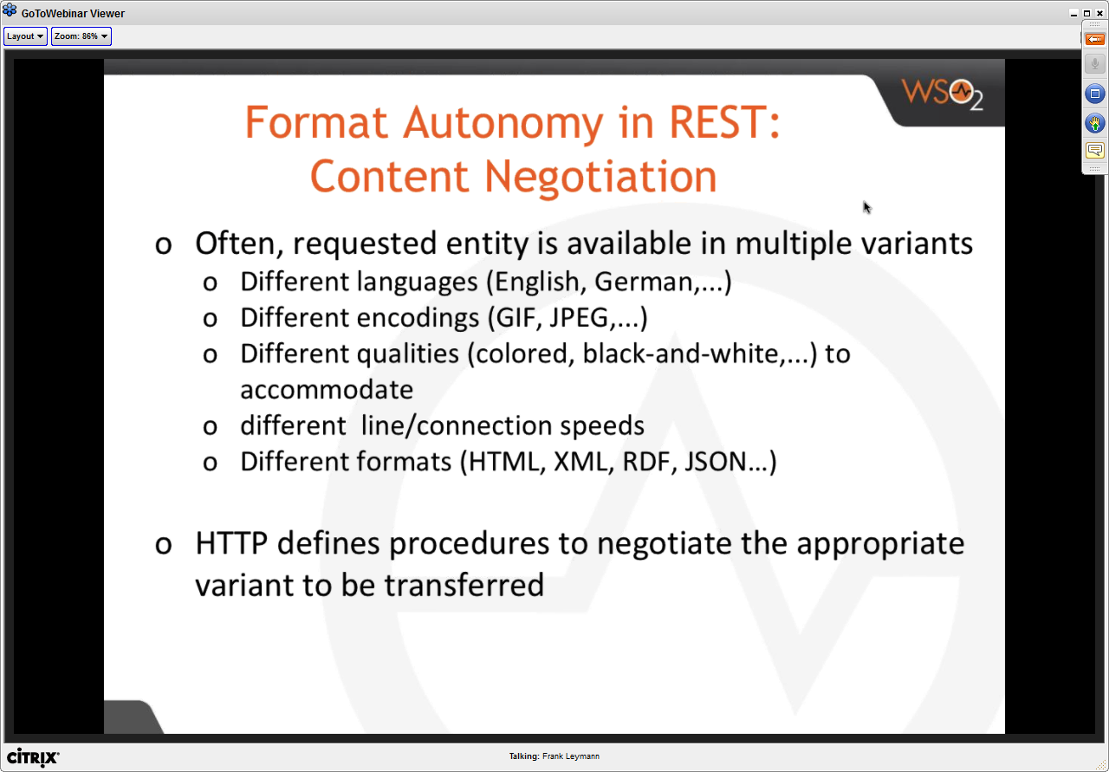

* HTTP has the ability to negotiate between server and client as to what version/variant the resource will be in

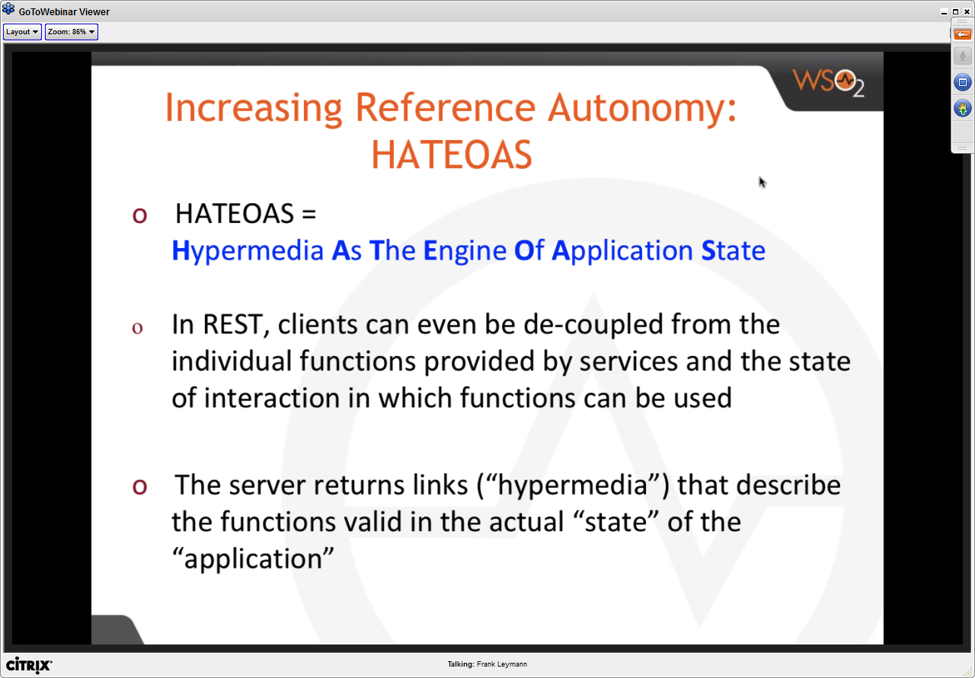

* Client is further decoupled from the individual functions of the server – you as a client need not know things in advance.

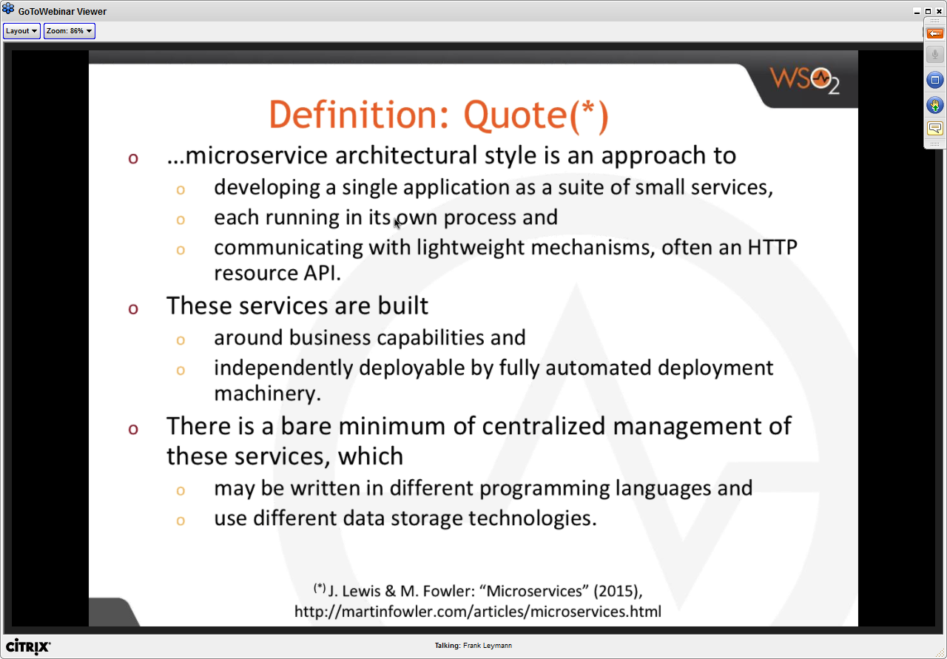

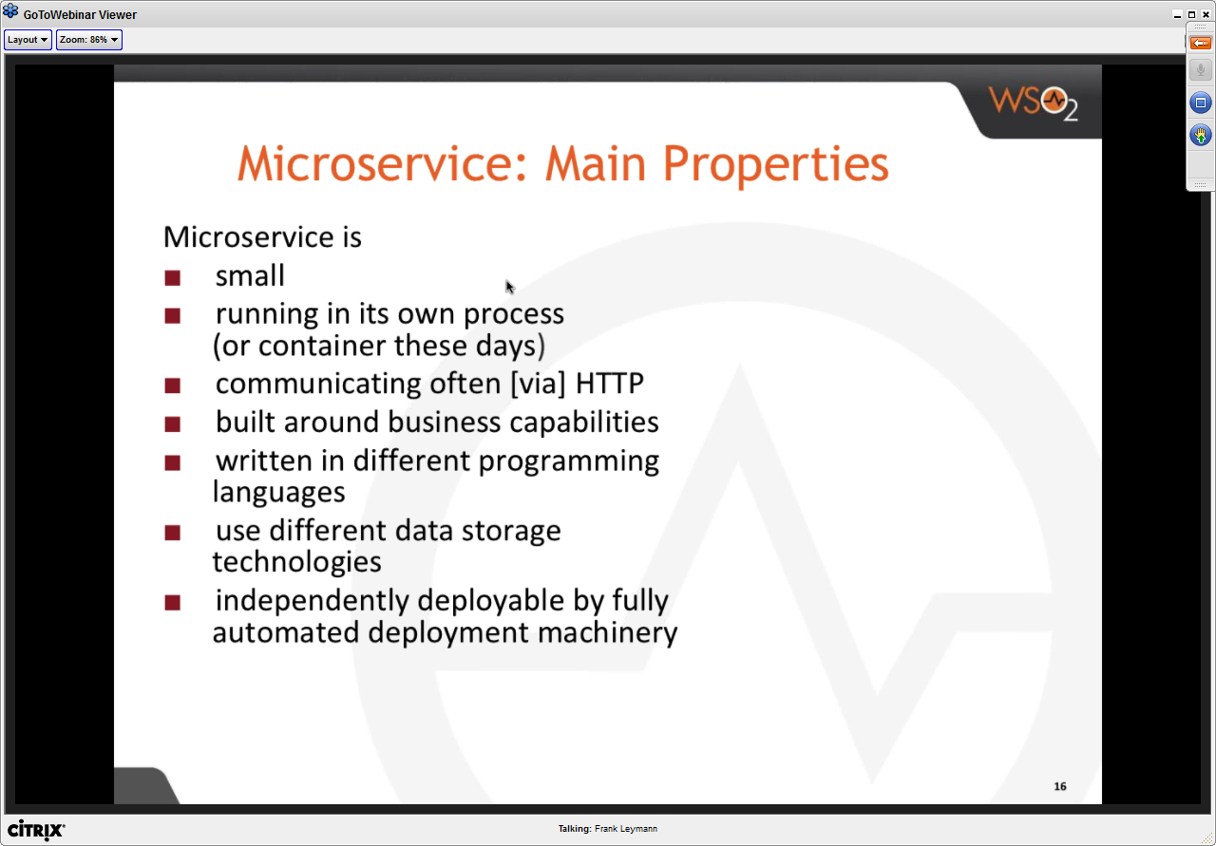

* Microservice is a service that is independently deployable by fully automated deployment capability

Solution to HA and Scalability for large monolithic application is to split it into microservices and scale individual components

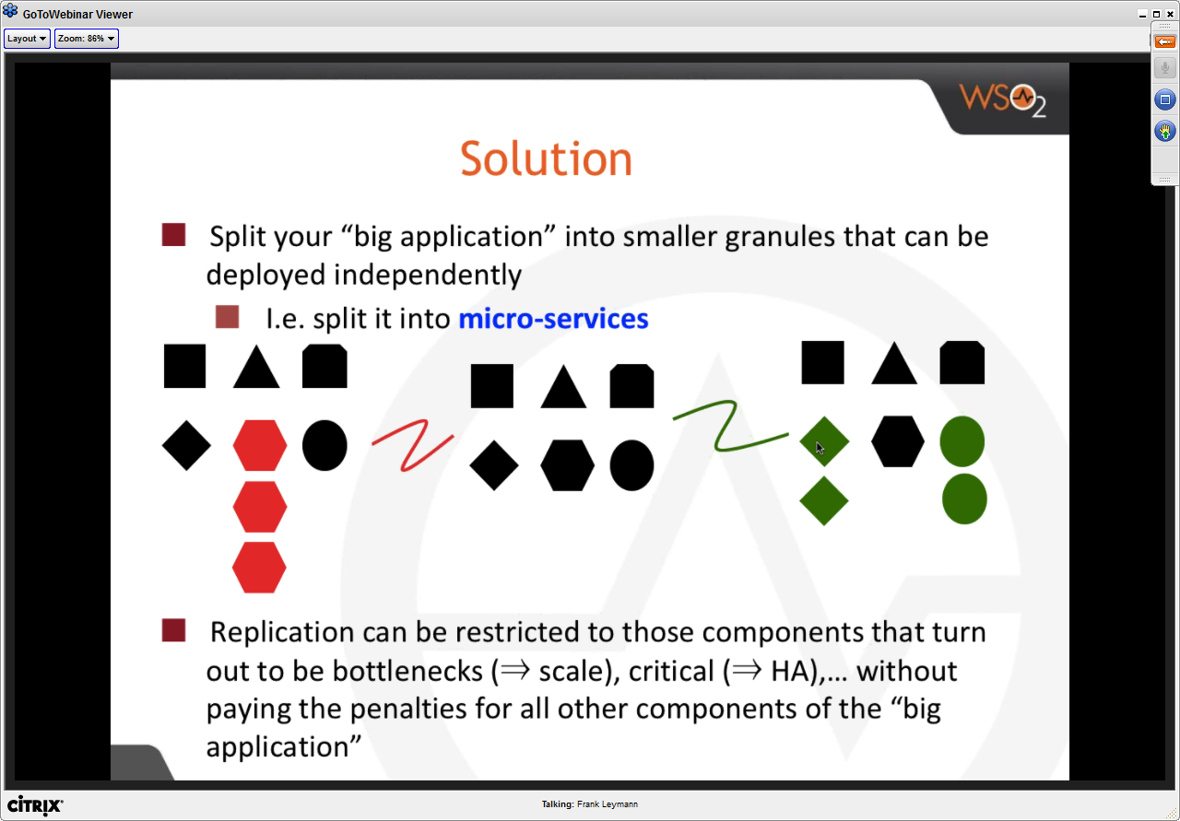

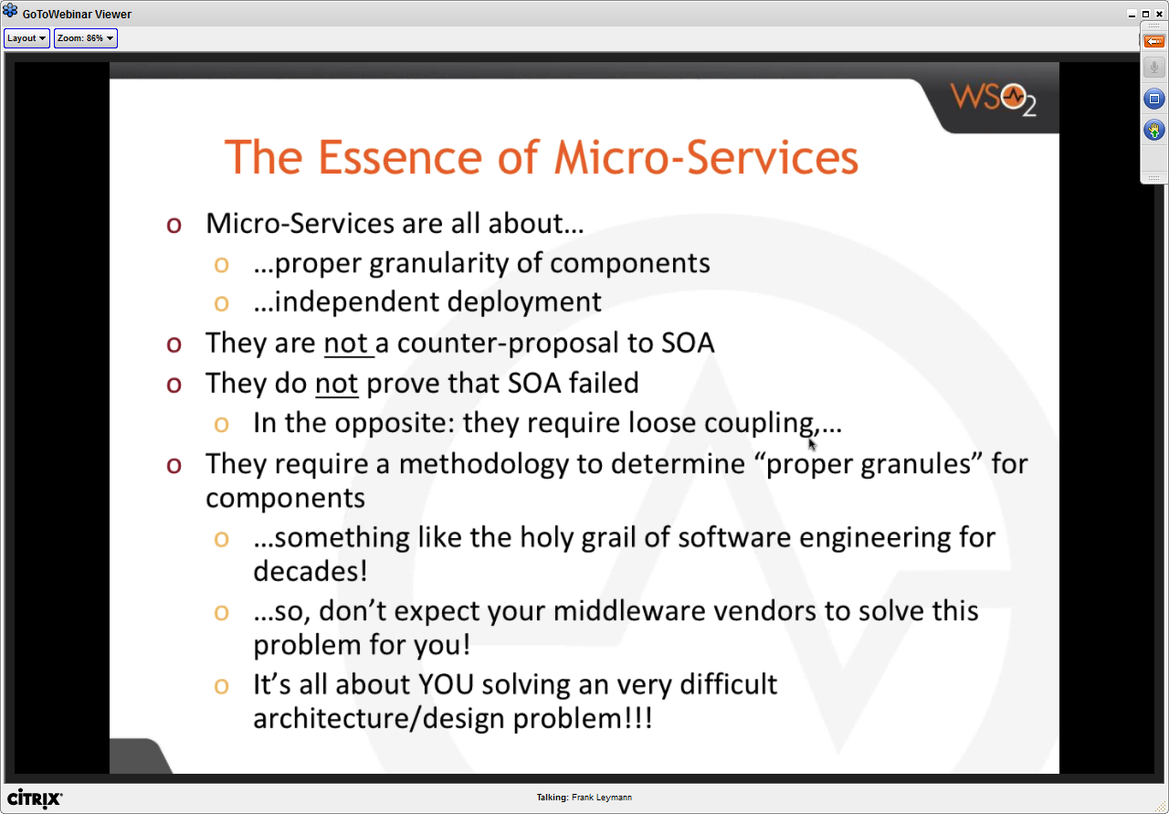

Microservices Design

* No Shared DBs
  + This is difficult for

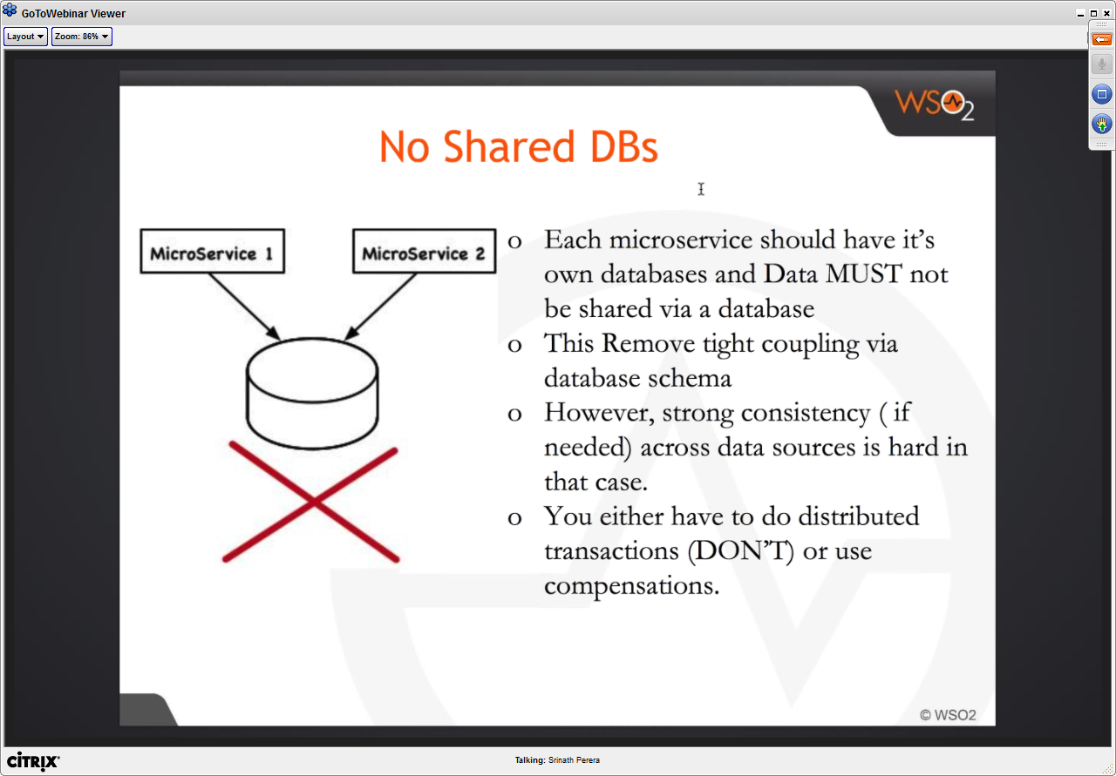

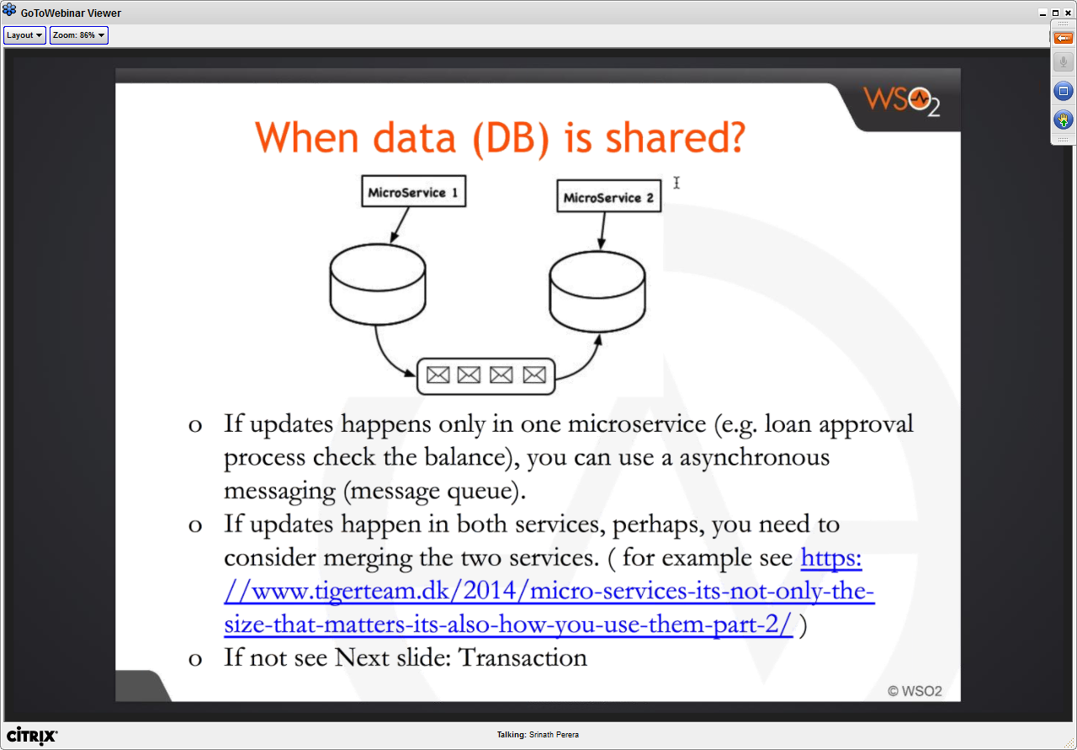

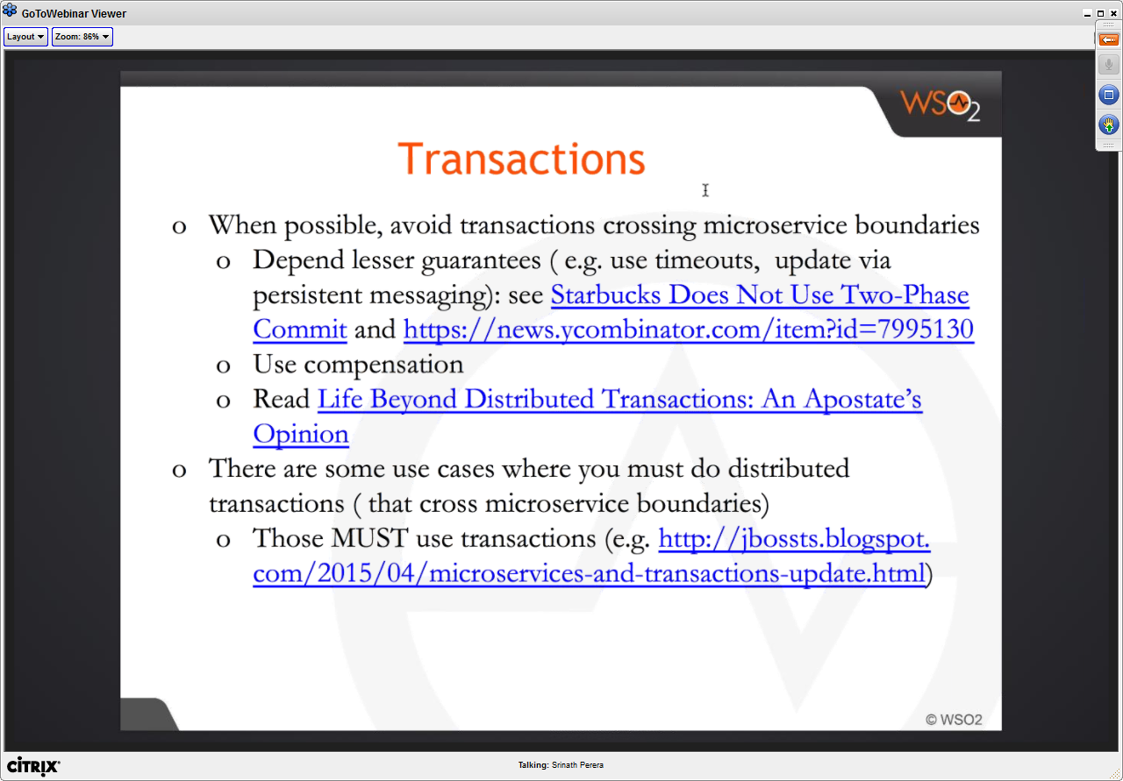

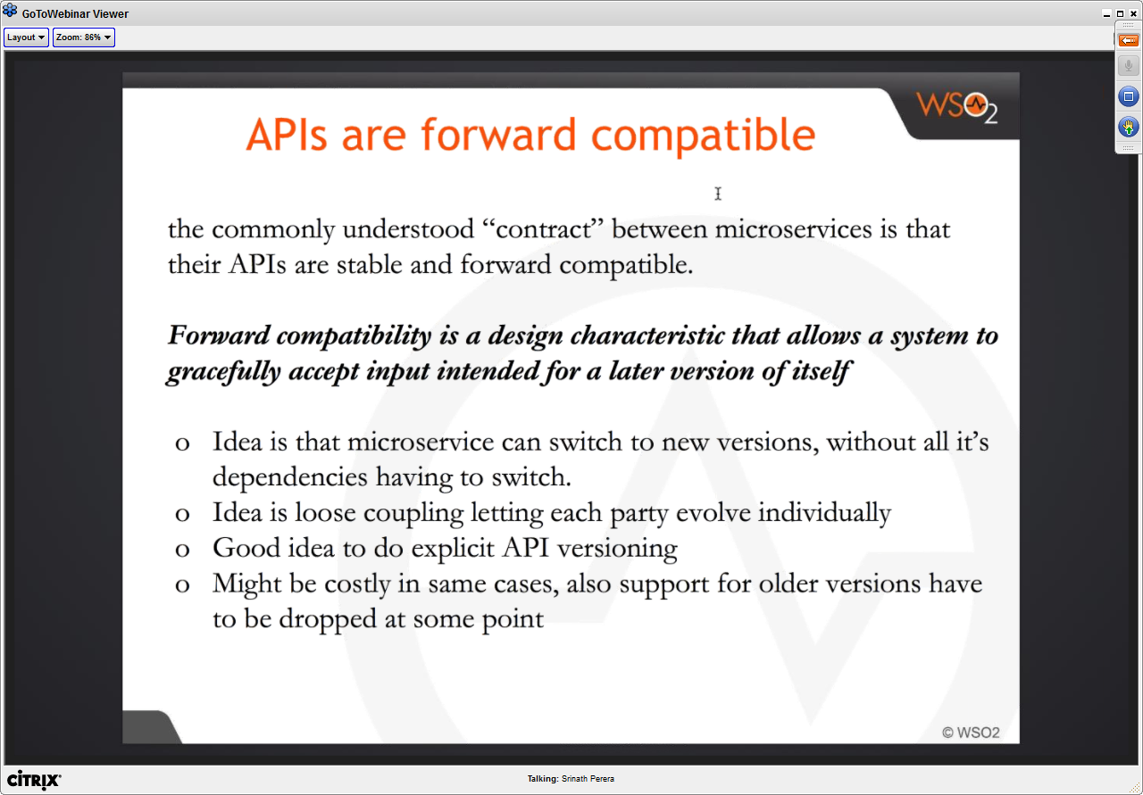

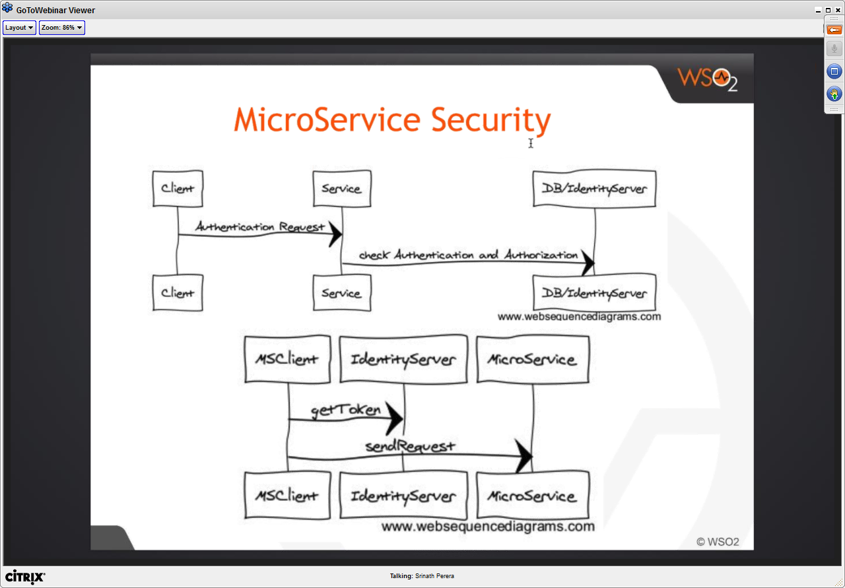

* Traditional security models are not good for Microservices as service cross-communications are discouraged in microservices
  + One proposed approach using tokens
    - He is saying SAML token would not require microservice to check back token validity with identity service

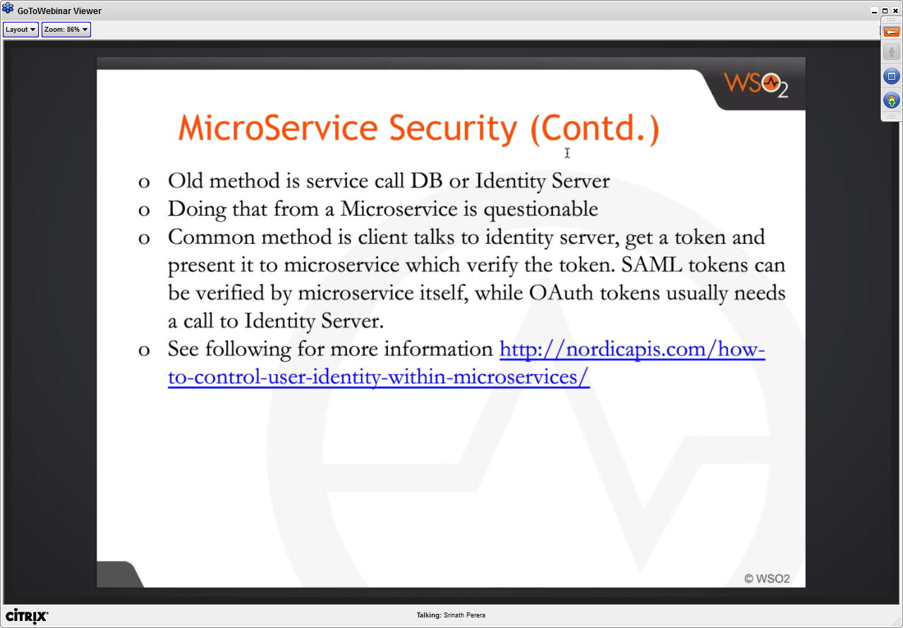

Composition with Microservices

* Composition with SOA

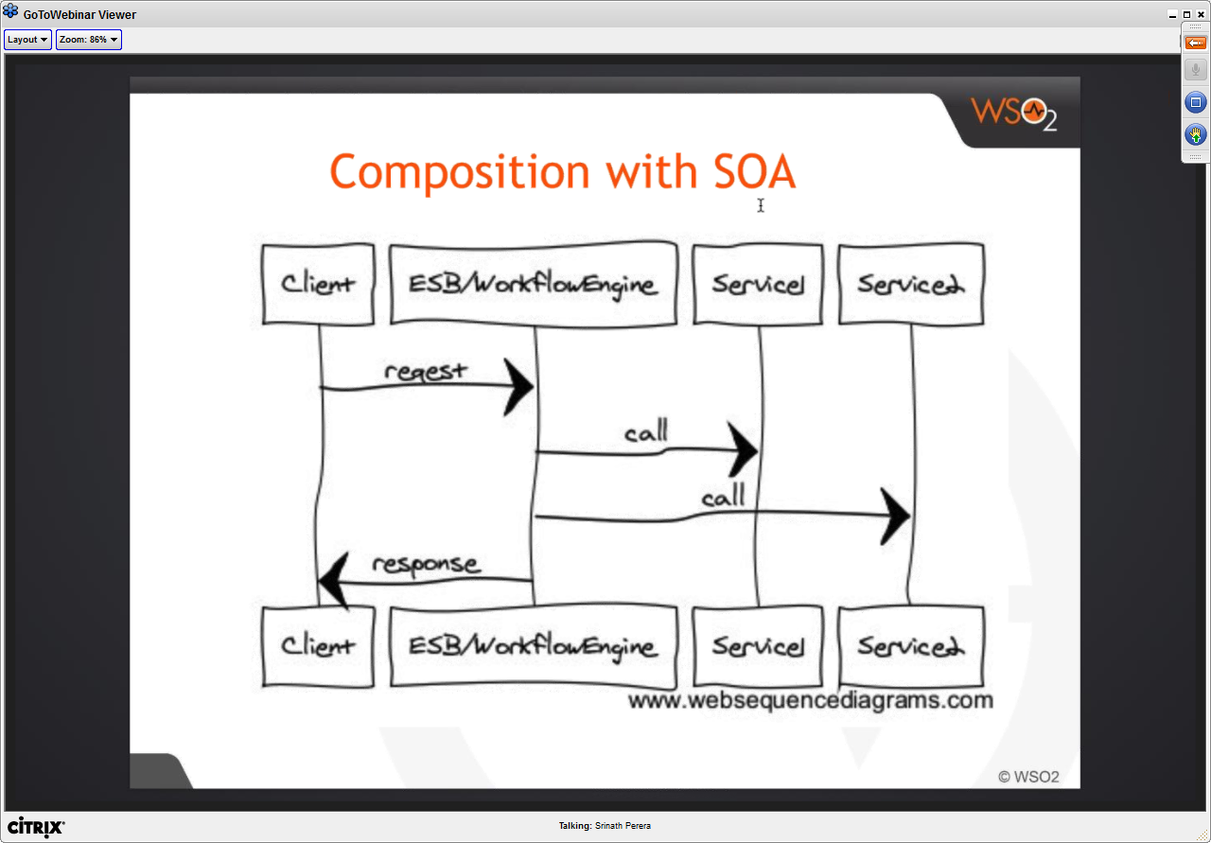

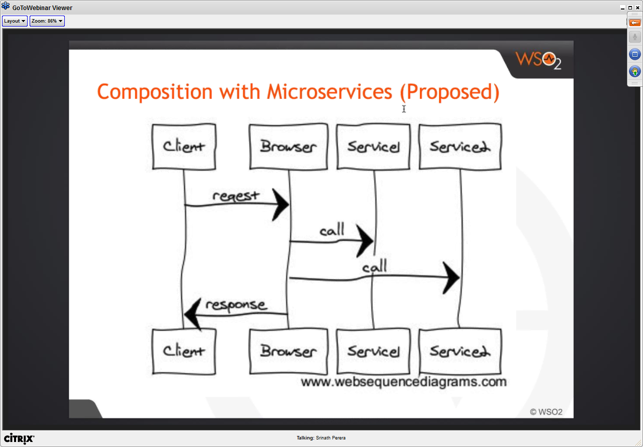

* Above situation is where browser is making different individual service calls

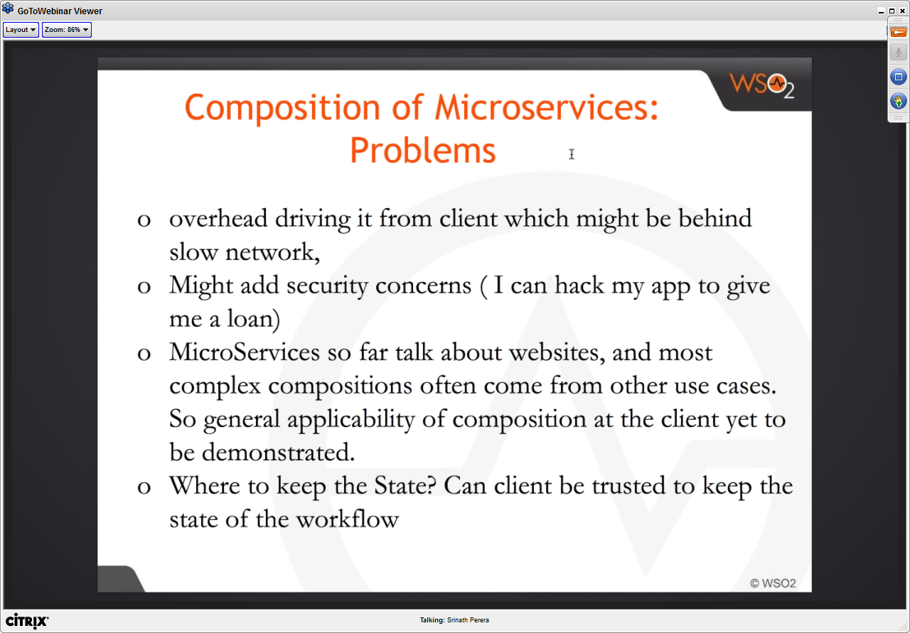

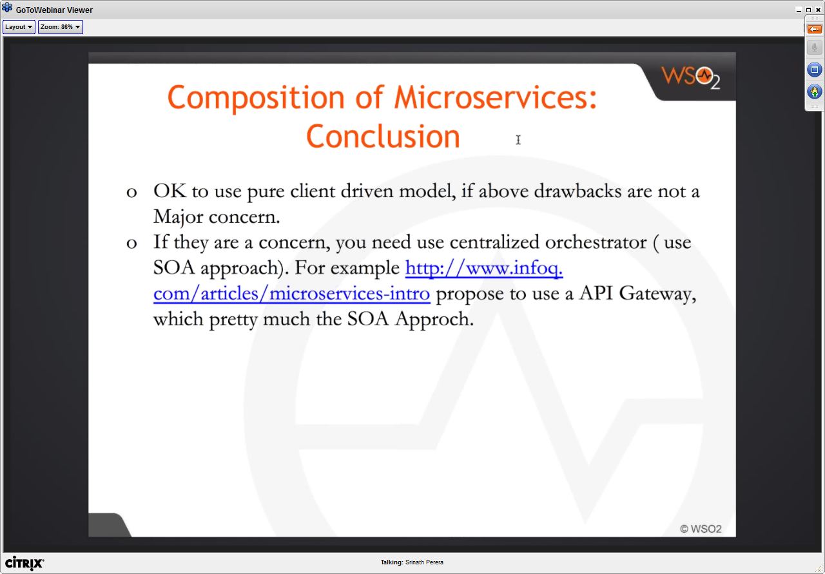

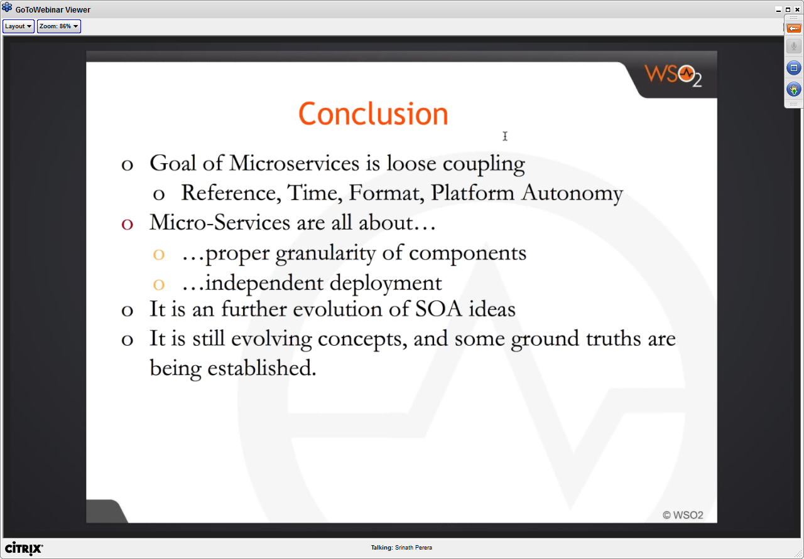

**Deep-dive into Microservices Inner Architecture (WSO2)**

February 10, 2016

Afkham Azeez, director, Architecture, WSO2

Microservices Architecture - definitions

A method of developing software applications as a suite of *independently deployable, small, modular* services in which each service runs a *unique process* and *communicates through a well-defined, lightweight mechanism* to serve a business goal

A SOA composed of loosely coupled elements that have bounded contexts

*Loosely coupled elements:* Each service can be updated independently, no coupling at the DB level

*Bounded context:* Microservices code can be updated without understanding the peers

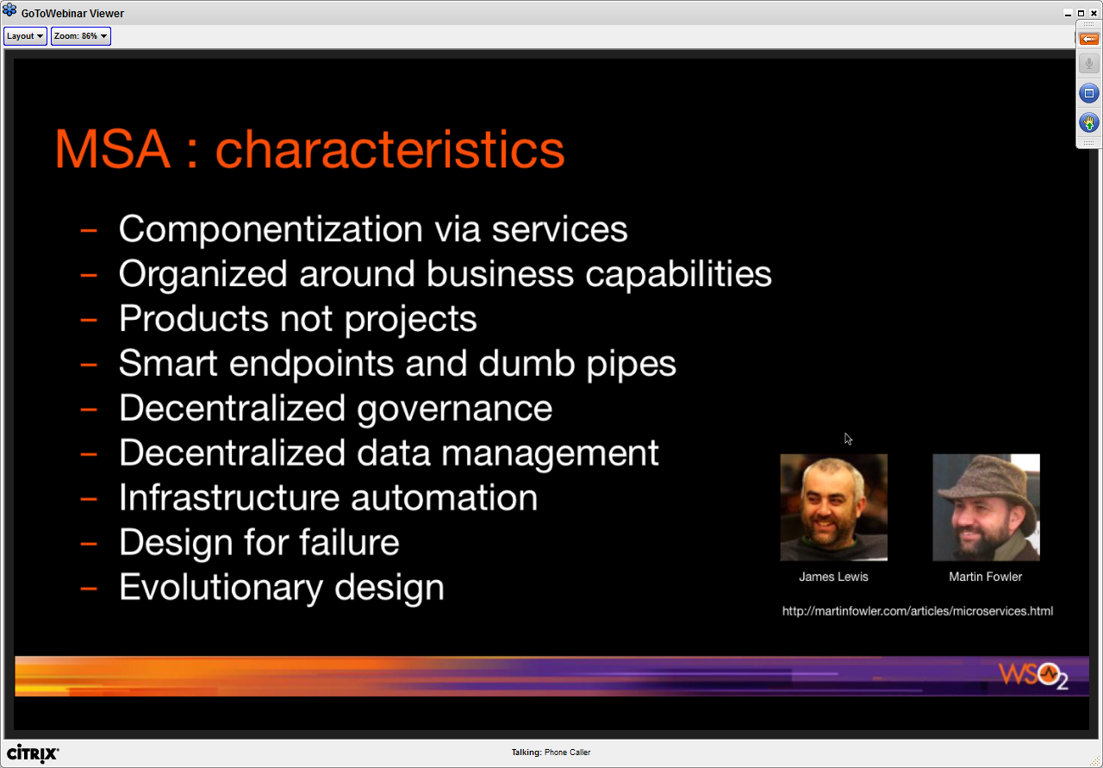

From a Gartner Research Paper – Microservices Inner and Outer Architecture

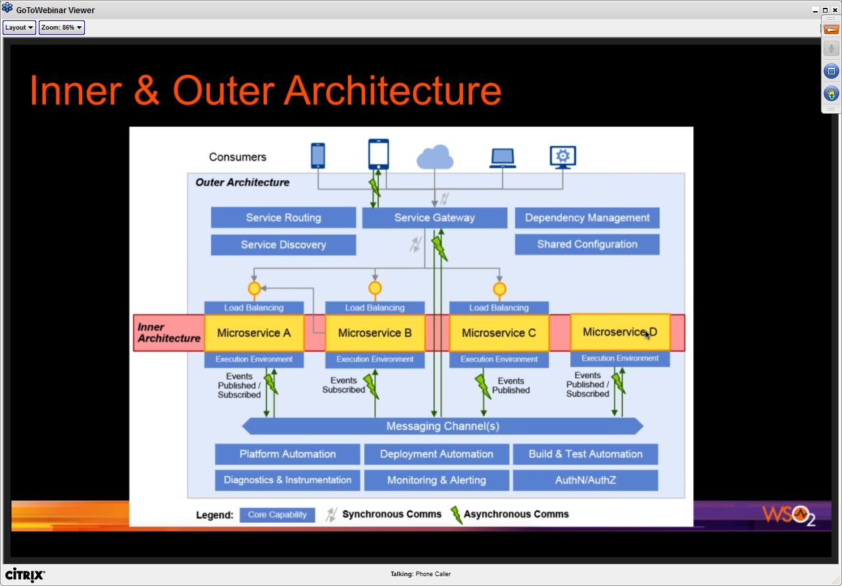

* MSA
  + Increases the complexity of the overall system
  + Inner architecture becomes simpler
  + but the complexity moves to ‘outer’ architecture. You now need
    - Service gateway, service routing, service discovery, dependency management, configuration management, messaging channels and other management mechanisms (which can no longer be dependent on native solutions)

Inner Architecture

* Implementation structure of each microservice
* Single responsibility principle
* Delivery of the service as a self-contained unit of deployment
* Each microservice can adopt an architecture best suited for the capabilities it delivers
  + Each team can use the optimal technology stack

Units of Deployment

* Some options
  + Self-contained jar files – includes all dependencies
  + OS images – MS is packages within a OS image (like light-weight CoreOS)
  + OS container images – More popular, e.g. docker
* Be consistent about the unit of deployment in your MSA solution

Units of Deployment

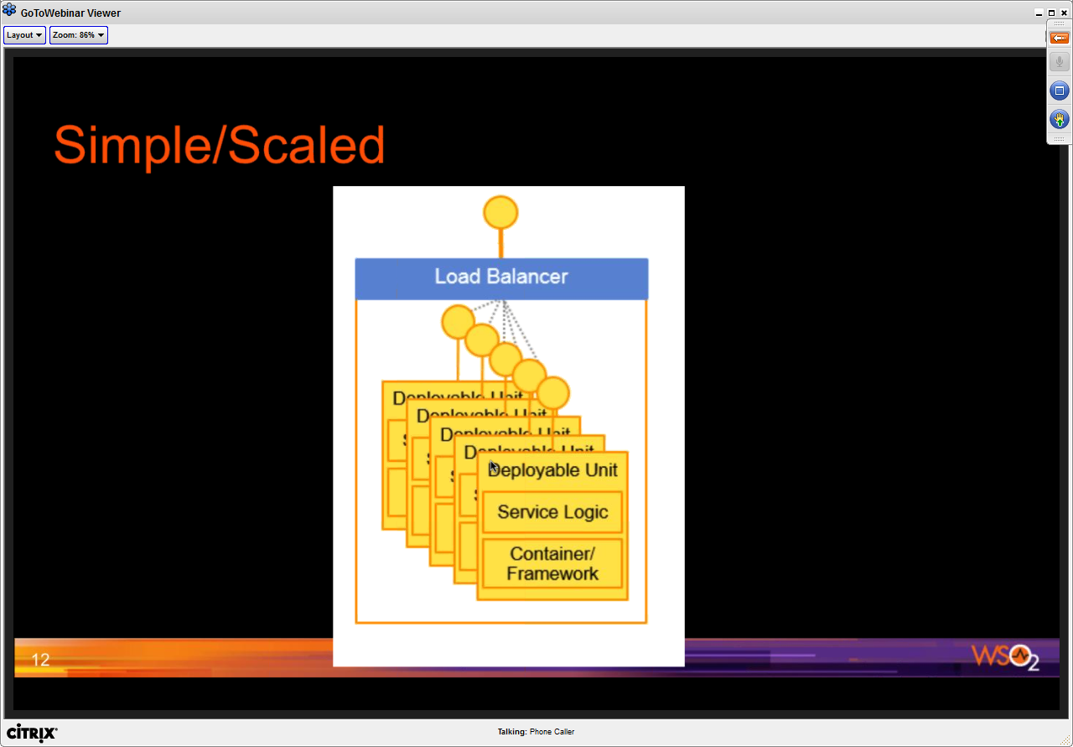

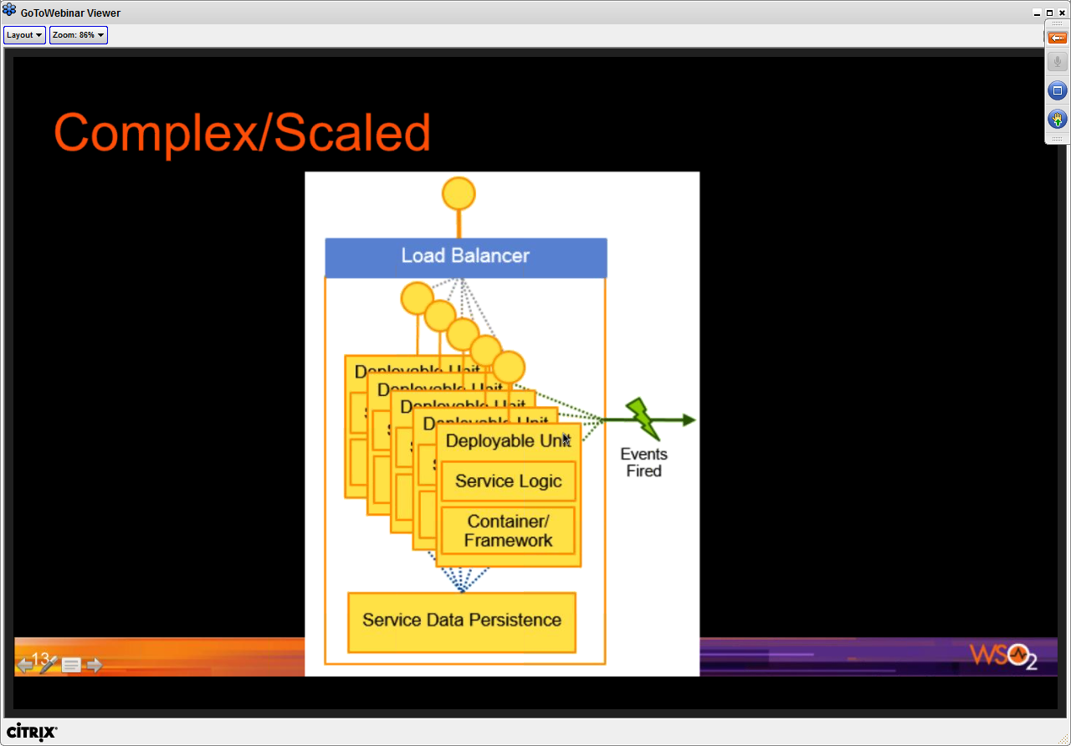

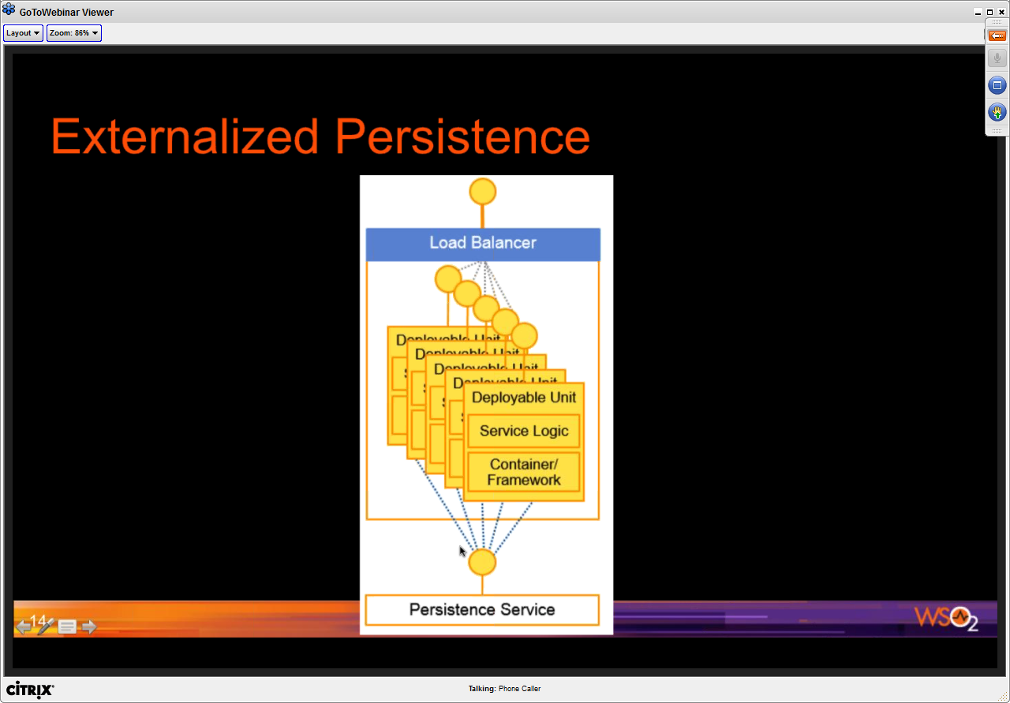

* Difference is that the Persistence service is an external service
  + Data is stored separately by an externalized service

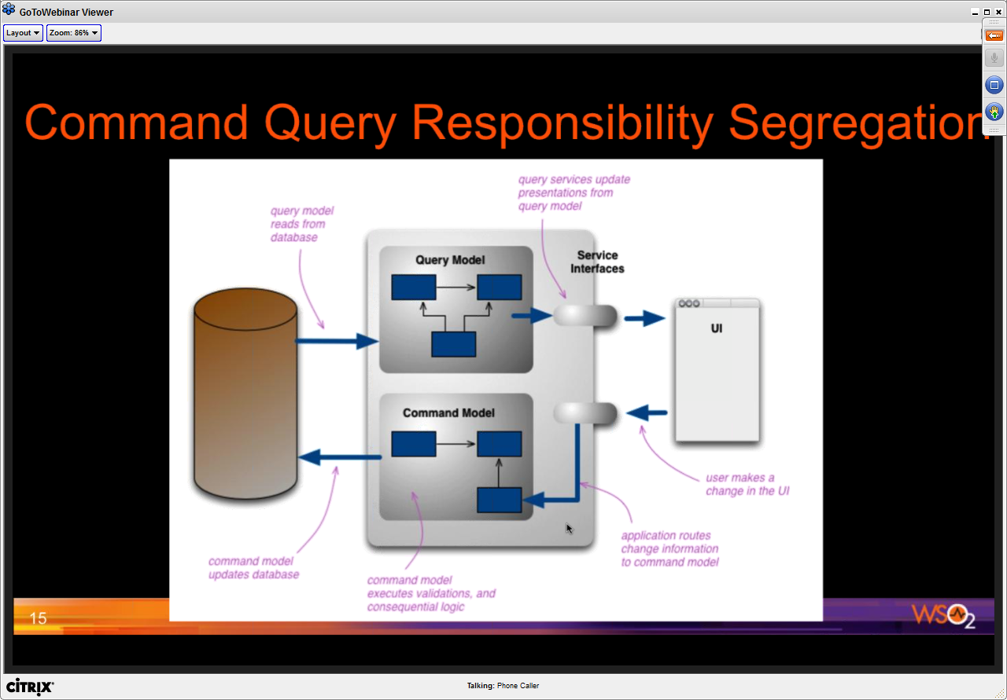

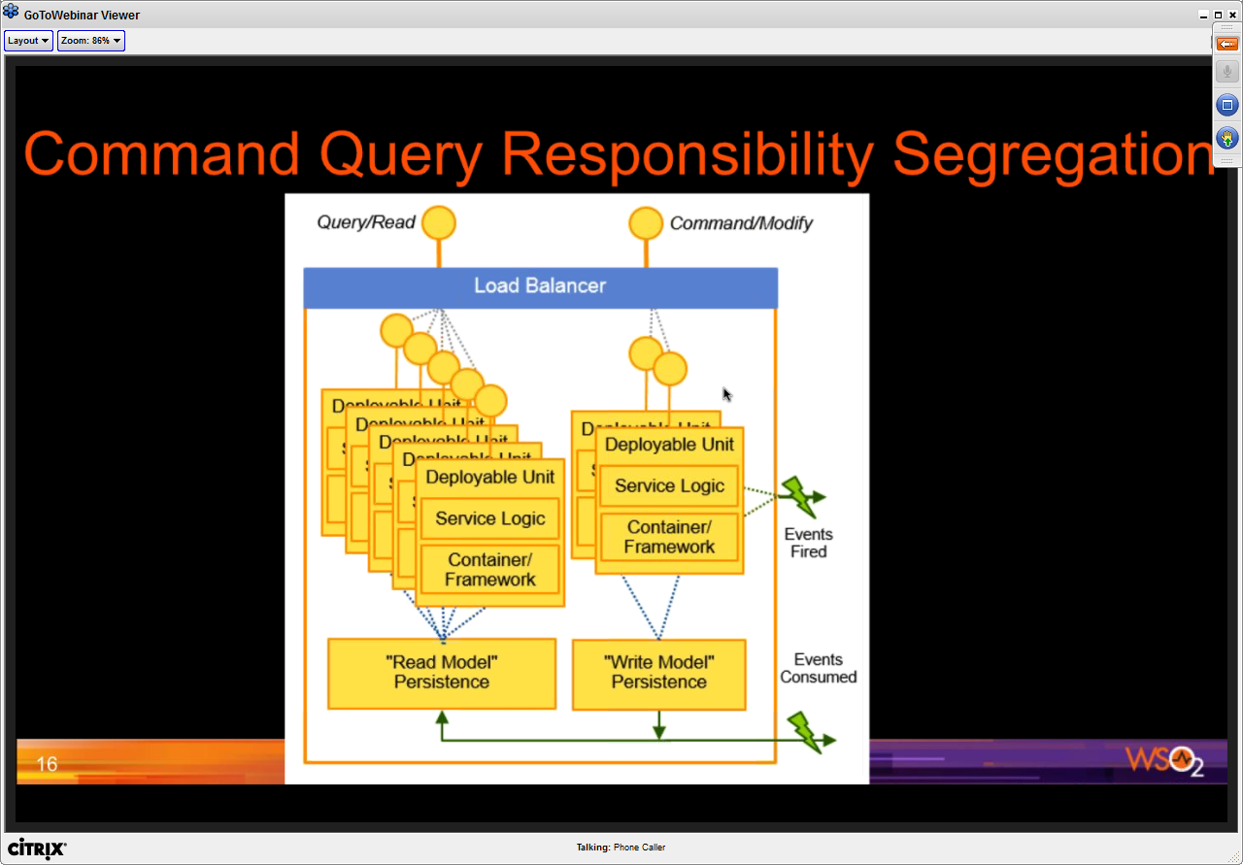

Other aspects:

* API definition using specifications like Swagger
* Metrics gathering & monitoring of your microservices is important

Recommendations

* Keep the inner architecture simple and consistent
* Use polyglot cautiously
  + Standards, consistency, patterns, best practices
  + Treat polyglot opportunities as exception cases

WSO2 Microservices Framwork for Java (MSF4J)

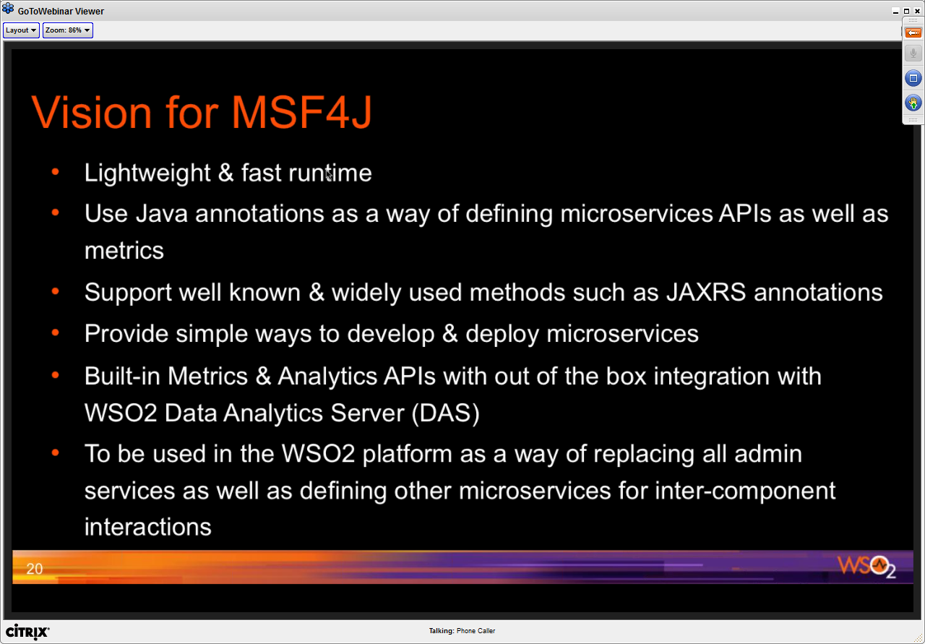

MSF4J Implementation

* Based on the new Carbon 5.0 kernel
* Transport is based on Netty 4.0
* Supports streaming
* High performance
* 5 MB pack size
* Starts within 300 ms
* ~25MB memory

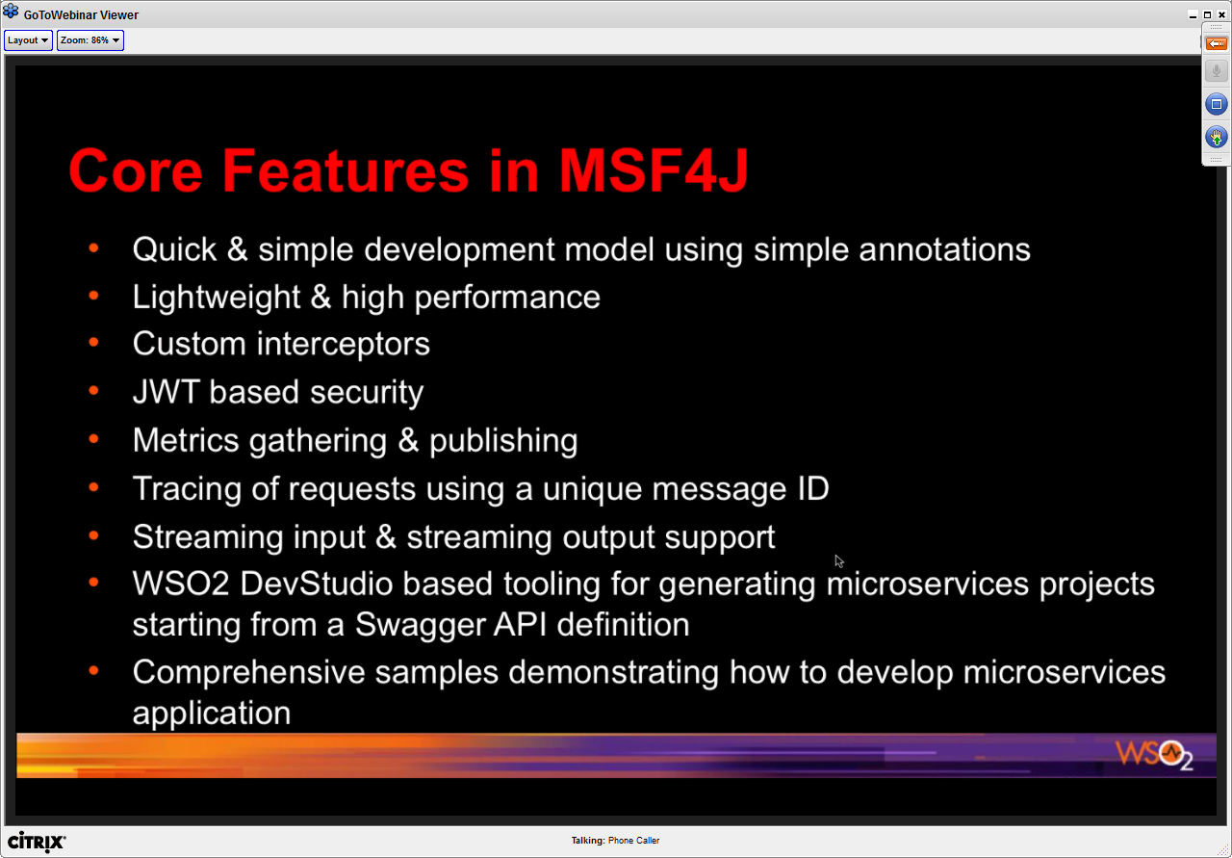

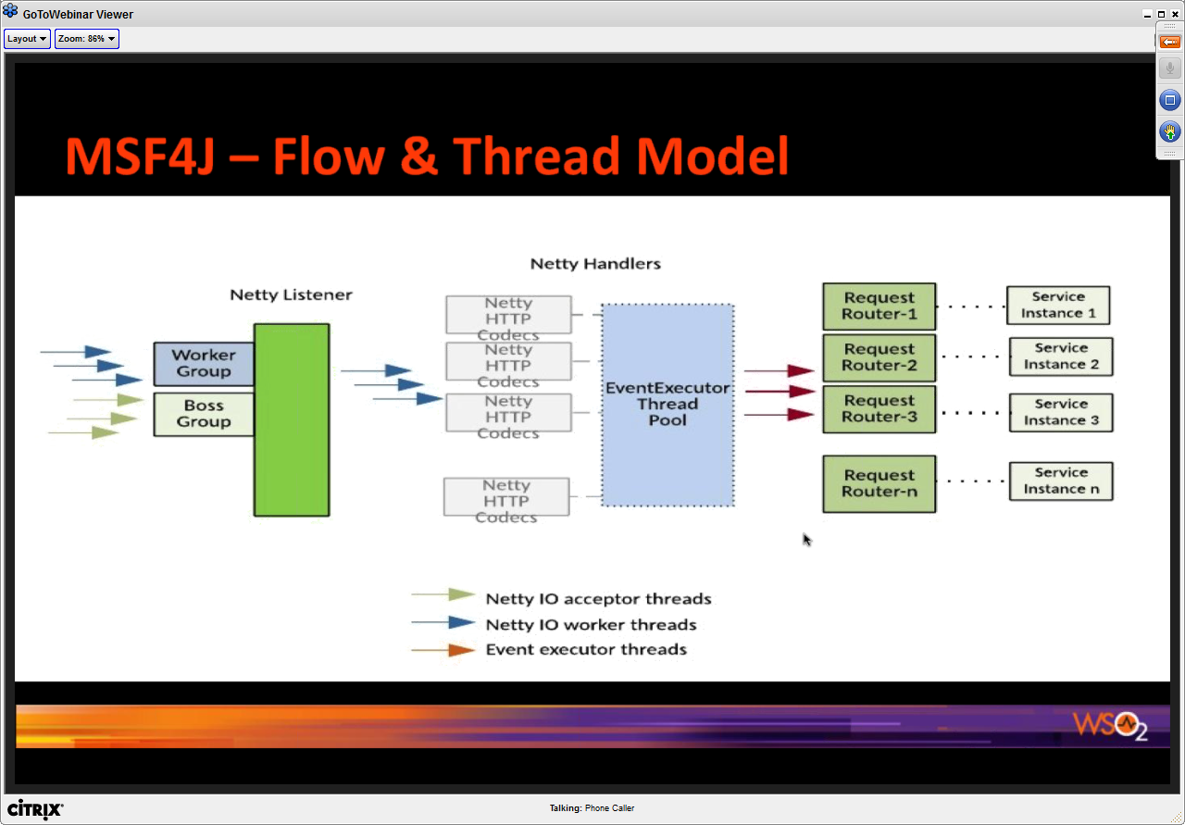

Threading model is important aspect:

* Inbound transport based on Netty
* REqeusts passed through a number of HTTP codecs and then handed over to Executor Thread pool
* The request router is responsible for handling off the request to your service
* There is a mechanism to add interceptors, examples might be OAuth interceptor

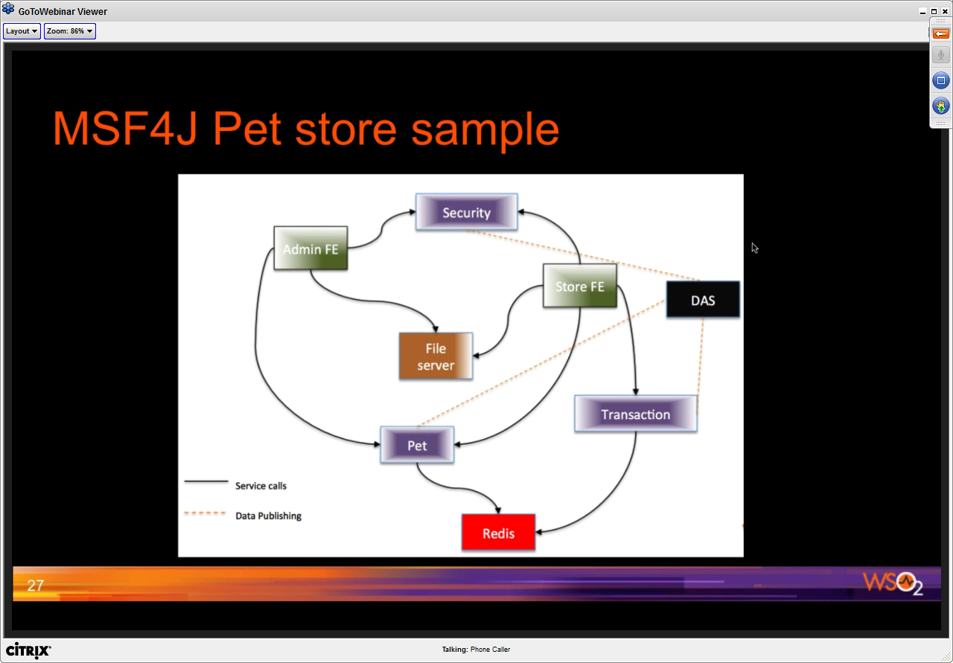

Inspired by the JavaEE Petstore sample

* DAS – WSO2 Data Analytics Server
* Persistence on Redis

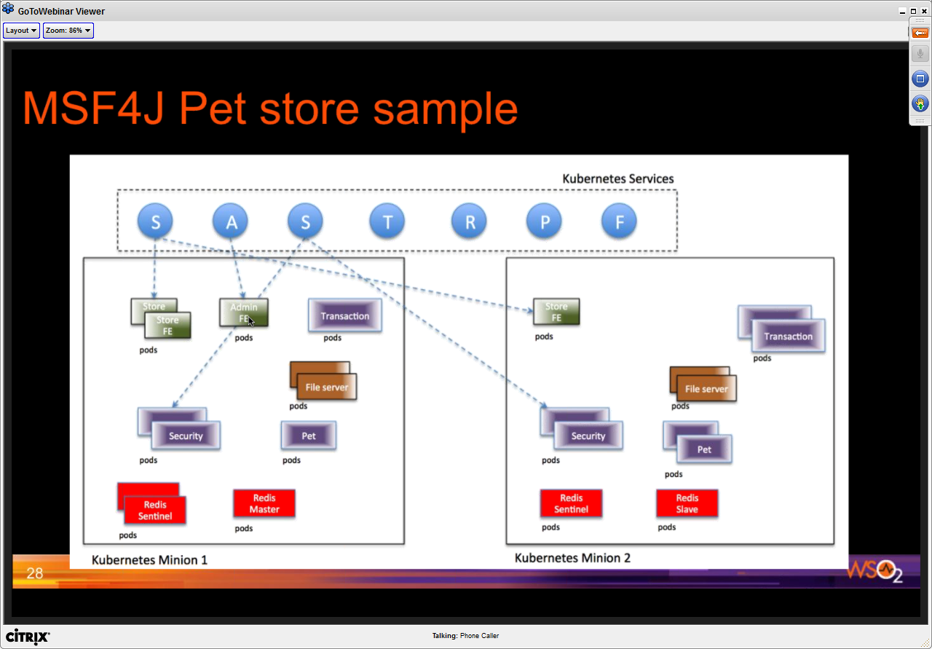

* Kubernetes used to manage Docker services
* Kubernetes has its own DNS services

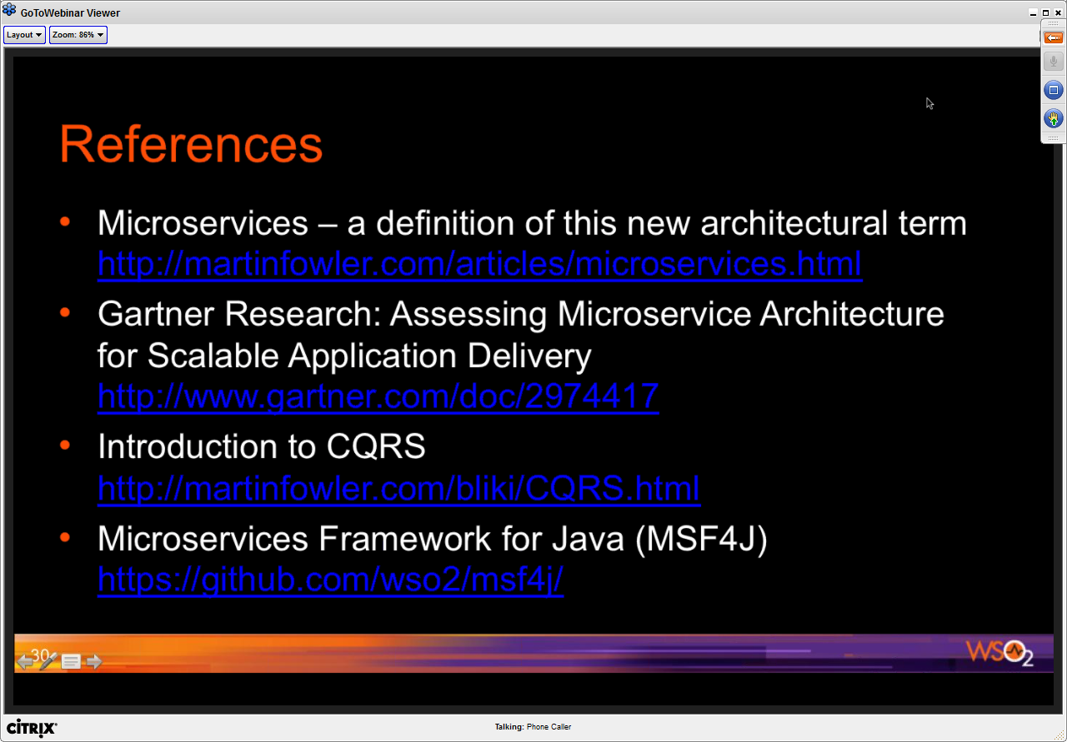

**Developing & Managing Java-based Microservices with Kubernetes**

May 3, 2016

Virtual Java User Group @VirtualJug #VirtualJUG

ZeroTurnAround (JRebel: Reload code changes instantly), RebelLabs (XRebel: )

vJUG24 will be launching tomorrow – 24 hour virtual conference – 24 sessions.

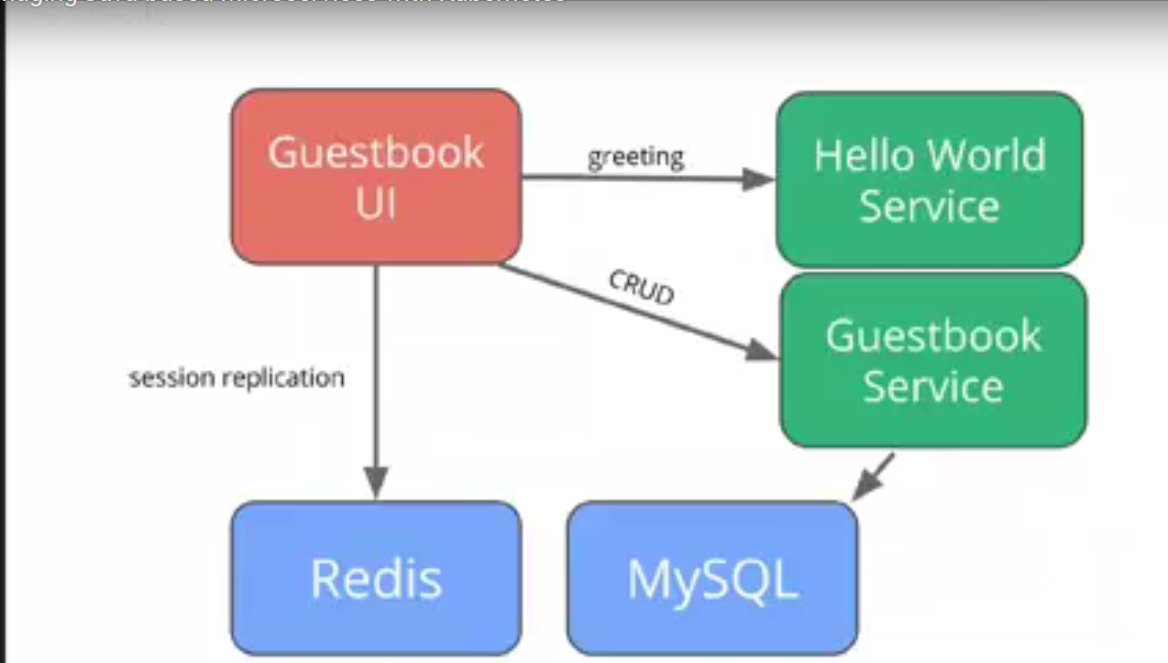

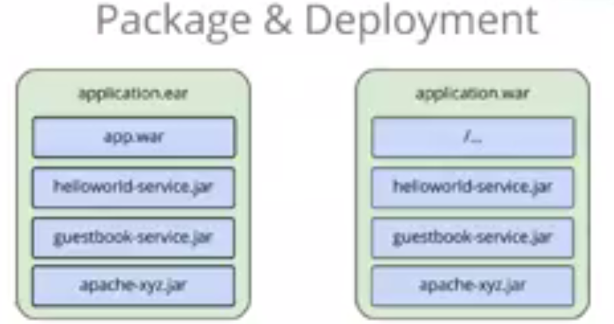

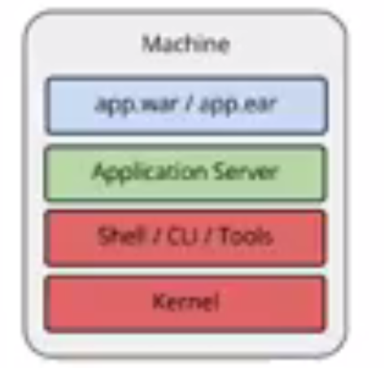

* Challenges
  + Long time to provision servers
  + Error prone
  + Difficult to replicate across to multiple servers – need to go through the same steps

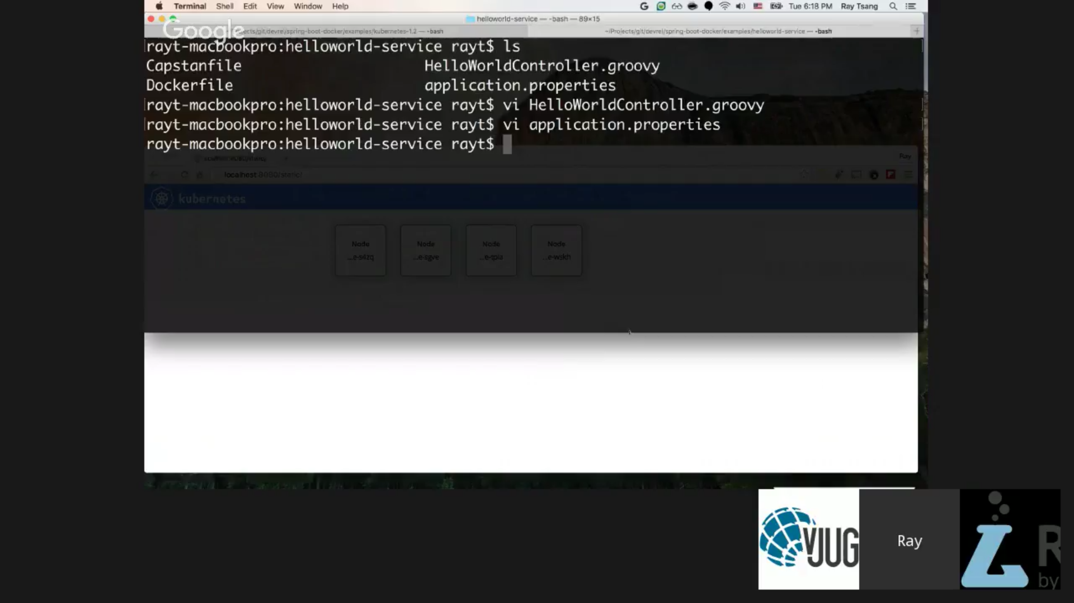

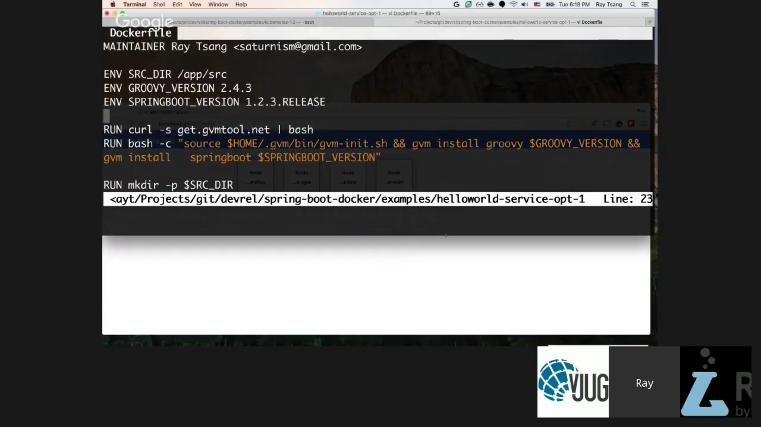

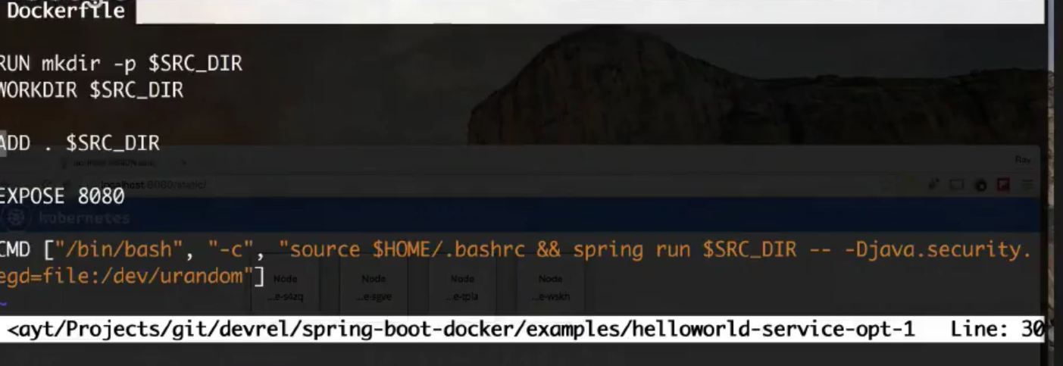

* Using Maven image to package

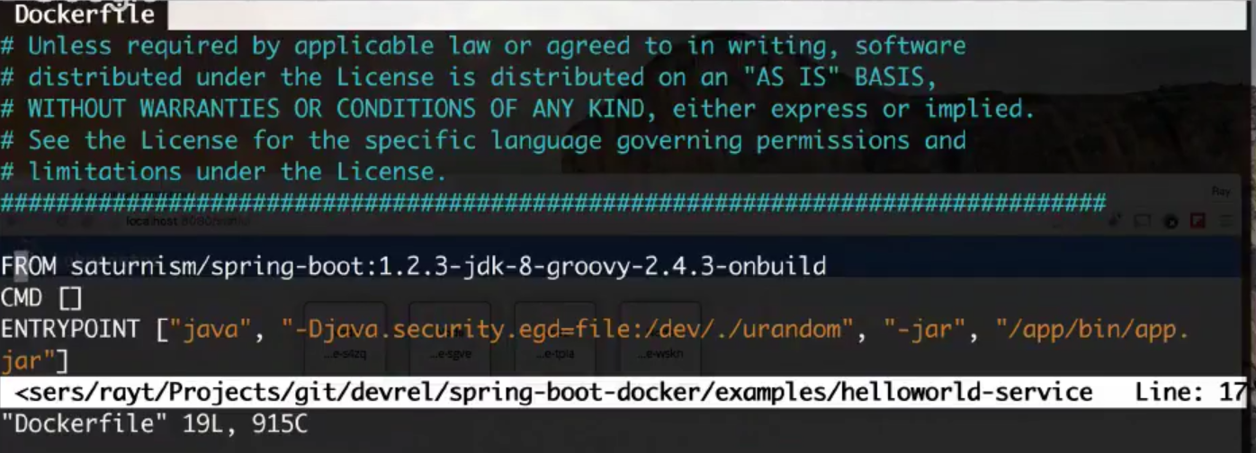

If there are multiple components use Docker Compose.

Kubernetes

* Kubernetes is a container orchestration tool.
* It is container agnostic. For e.g. docker, rocket

Google cloud container – Managed kubernetes cluster.

**Mulesoft Webinar (BrightTalk) Best Practices for Microservices**

May 10, 2016

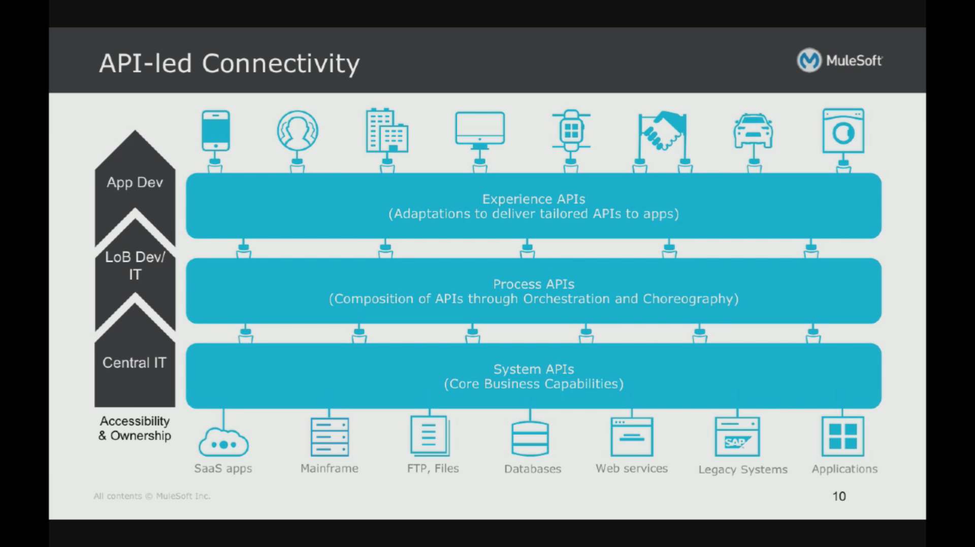

Microservice is have:

* Discrete responsibility
* Small team organization
  + Everything from design
  + API is considered a business product
  + All lc belongs and owned by the team who owns it
* Ease of deployment
  + Continuous delivery

API Types

* System APIs
* Process APIs
* Experience APIs

Design Characteristics for Micro-services

* Business Oriented APIs
* Adaptable (same service can deliver its capabilities through multiple channels)
* Loosely coupled
* Autonomous (The compute resources being used by it)
* Discoverable (clear understanding of business capability and service interface)
* Composable

Business Domain Orientation

* Focus on business domain
* Cross-domain integration through experience APIs
* Avoids the monolith

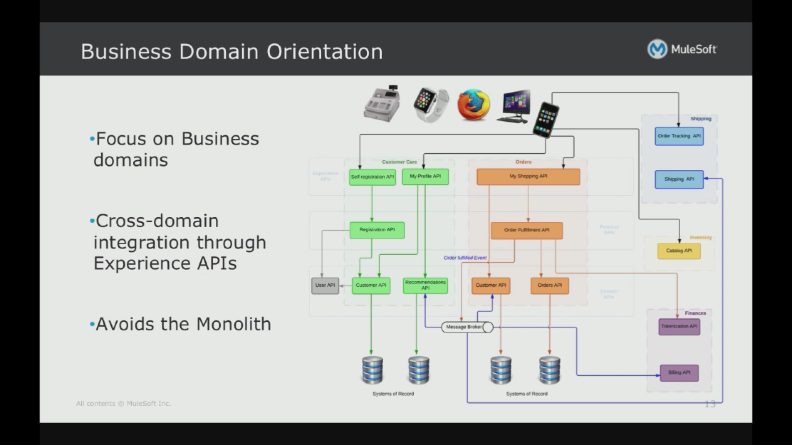

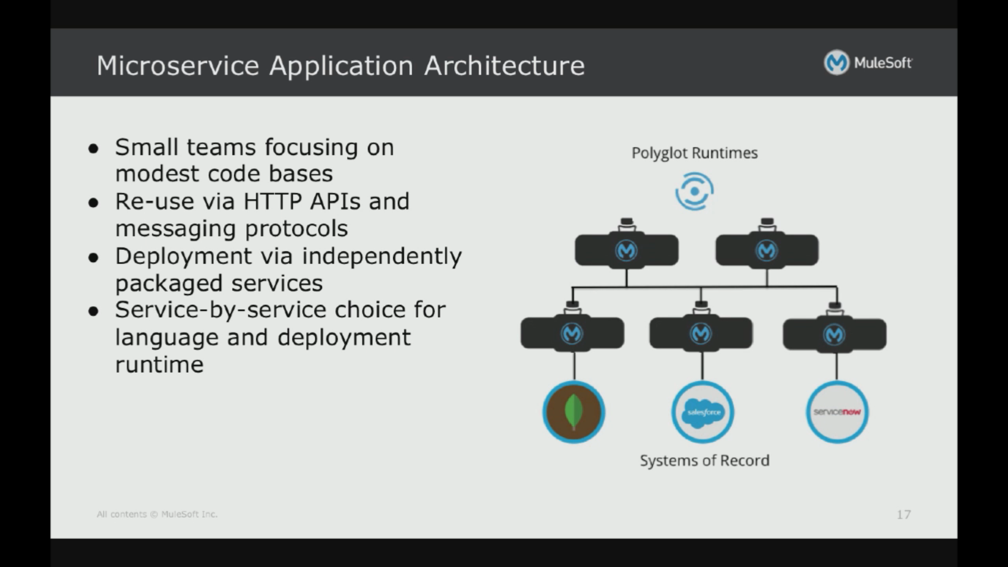

Continuous Delivery

* Design the contract for a microservice
* Develop the microservice implementation
* Test the microservice
* Automate the Release of the microservice

Software development of microservices should be automated to as much as possible

Self-service of Microservice consumption

* Decentralize application development to different LOBs & functional partners
* Managing microservices at scale raises challenges
  + Service discovery & documentation
  + Fault tolerance
  + Quality of service
  + Security

IT has decentralized and democratized application development

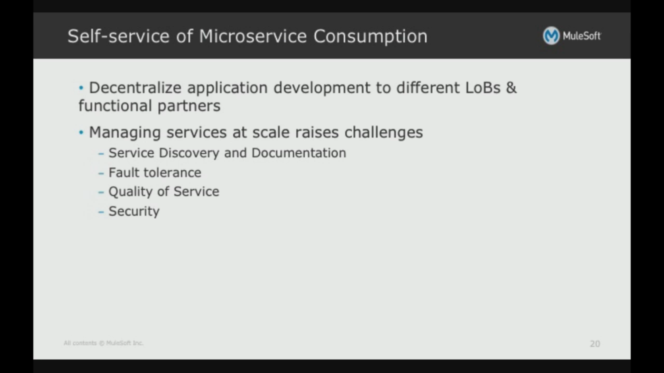

Facilitating Self-service

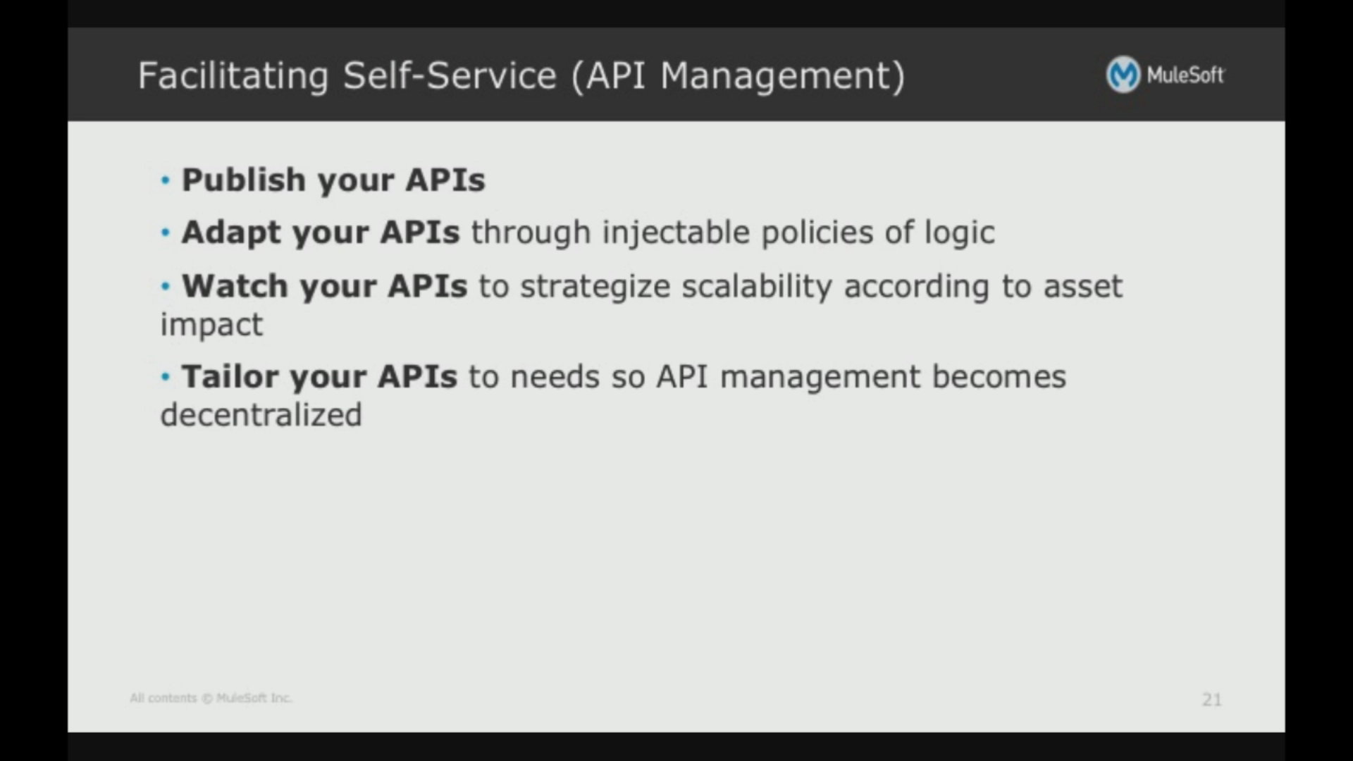

Mulesoft takes a holistic view of development of microservices

* API Notebook allows writing code samples and running it against live API endpoint (intelligent simulation)
* Anypoint Studio has a polyglot support
* Anypoint Exchange – community with reusable artifacts, templates/connectors. Also registry to expose your APIs
* MUnit is a testing framewrk which uses drag-drop for building use-cases. Allows you to mock responses from backend. Supports JUnit

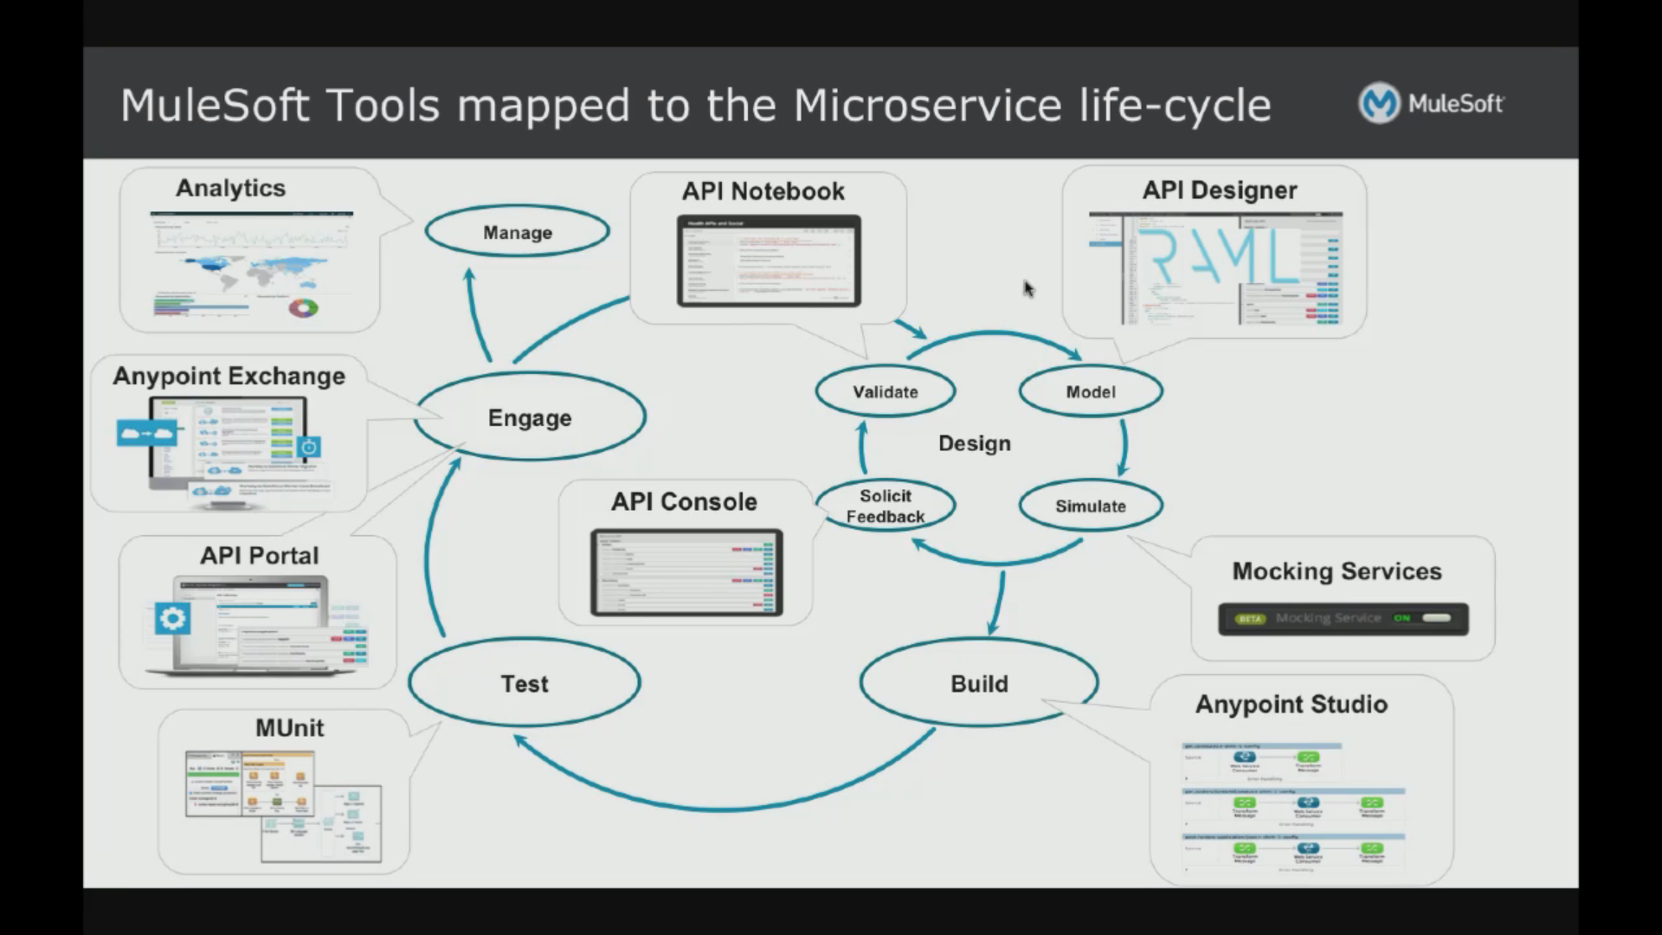

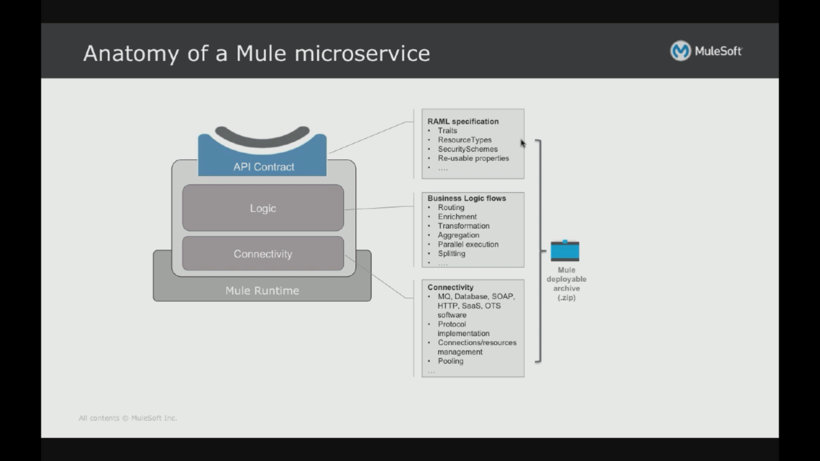

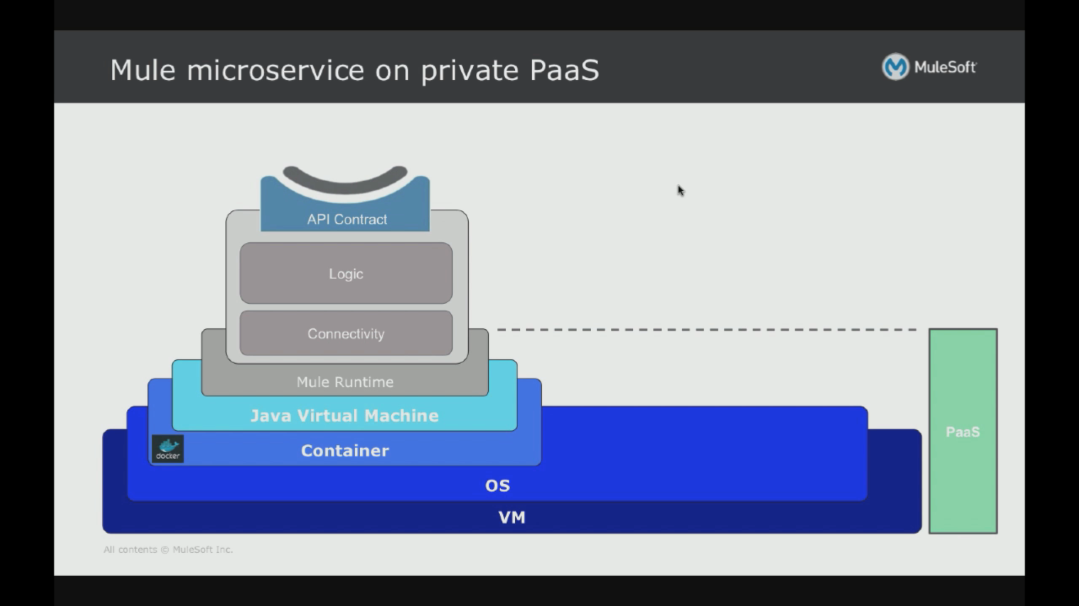

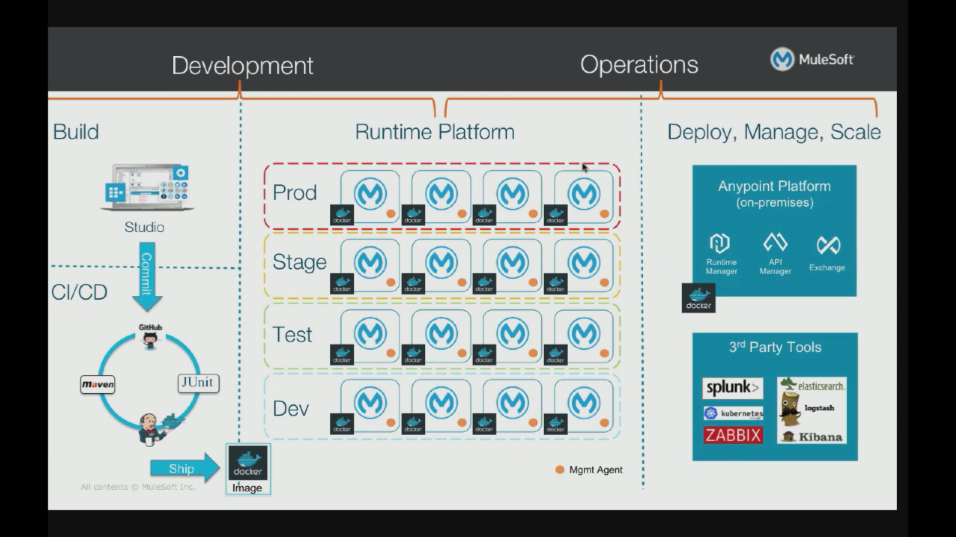

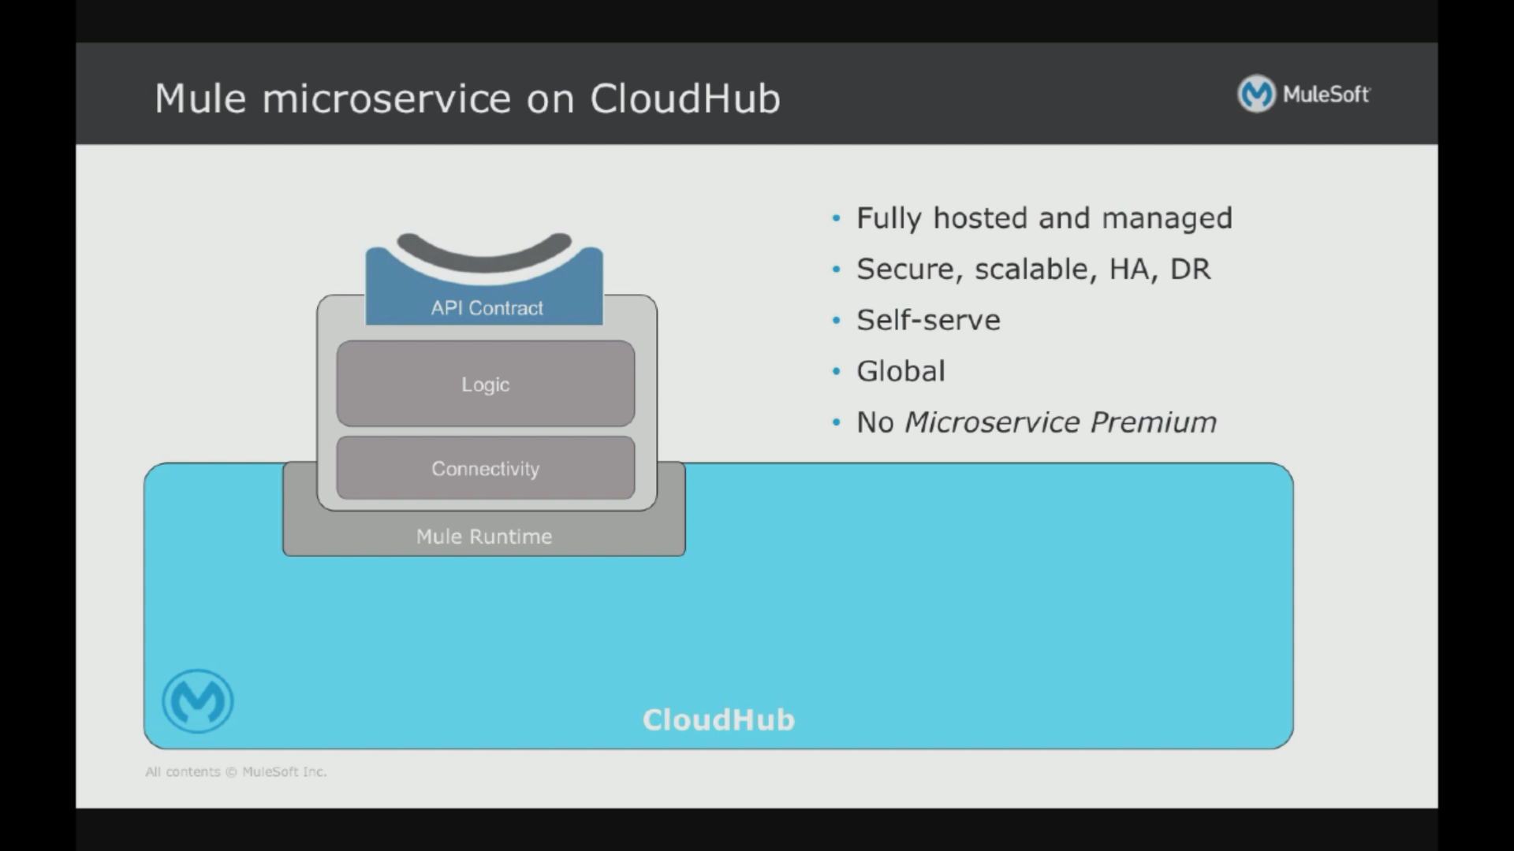

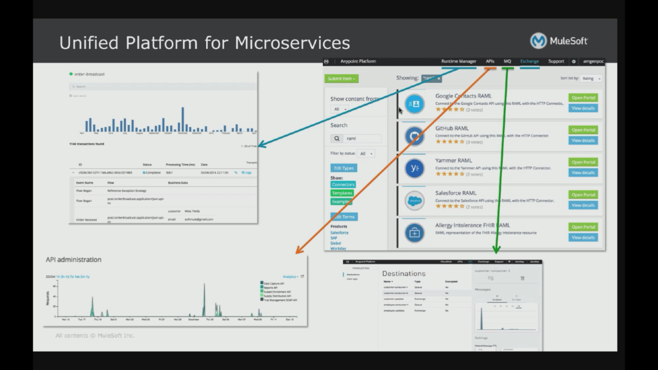

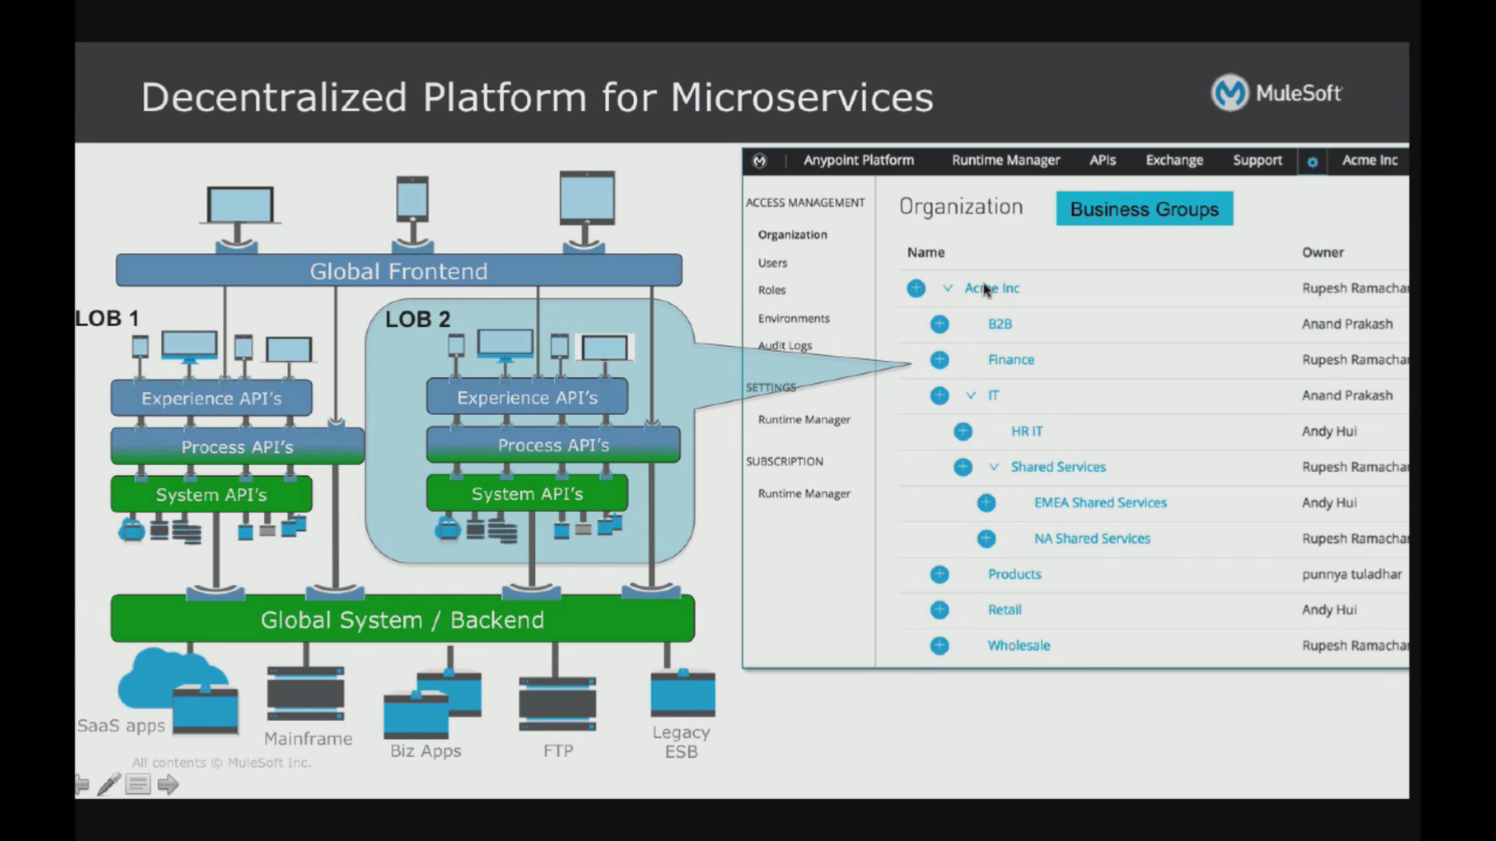

Summarize

* Holistic approach centered around API led connectivity
* Connected through existing systems

Practical tips based on customer experience

* Focusing on each line of business (narrower scope), working in silos
* Lot of customers are looking at containerization
* Keeping teams small is also important

**Microservices by Iron.io**

* **Microservices** represents convergence of modern cloud and modern application development
* **Microservices** means to make things better, not necessarily easier.
* **Common characteristics** of microservices
  + Independent in development & deployment
  + Single responsibility
  + Loosely coupled
  + Stateless
  + Asynchronous
  + Interchangeable - easily replaceable even removable without affecting others

|  |  |
| --- | --- |
| Technology | Business |
| Smaller services centered around specific capabilities | Focused and flexible workgroups |
| Independently developed & deployed functional components | Shorter release cycles |
| Lightweight cloud-native communication and processing | Cost effective scalable systems |
| Multiple language and data sources fit for the service | No vendor or framework lock-in |

**Considerations**

* Building and maintaining highly available distributed systems is complex
* More moving parts means more components to keep track of and configure properly
* Loosely couple services means steps must be taken to keep data consistent
* Distributed asynchronous processes create network latency and more API traffic
* Testing a monitoring individual services is challenging

**Decomposing application into microservices**

* Approach
  + From scratch
  + Refactor
  + New features**
* Identifying candidate components
  + Basic rule: business capability encapsulation
  + However, this is too broad a rule. There are other things to consider
    - Outside of user response loop: Very immediate real-time activities vs asynchronous jobs/processing
    - 3rd party service API calls: great place to start.
    - Long running processes: e.g. encoding of video
    - Transaction processing
    - Scale-out/burst processing
    - Scheduled jobs

**Microservices Communication**

* Queue all things: Provides reliable transport
  + Acknowledge data delivery
  + Retry down endpoints
  + Act as a delivery buffer
  + Keep data ordered properly
* Problem with dumb pipes (as against the dumb-pipes)
  + When end-points are down
  + Overloaded endpoints (lost, duplicated, unordered)

**Microservices Communication**

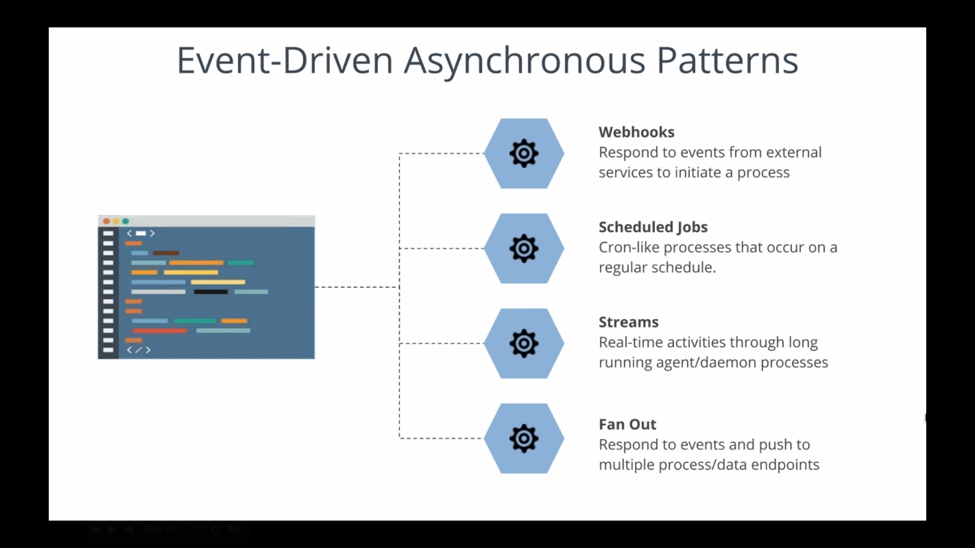

* Webhooks are great ways to respond to events from external services to initiate a process

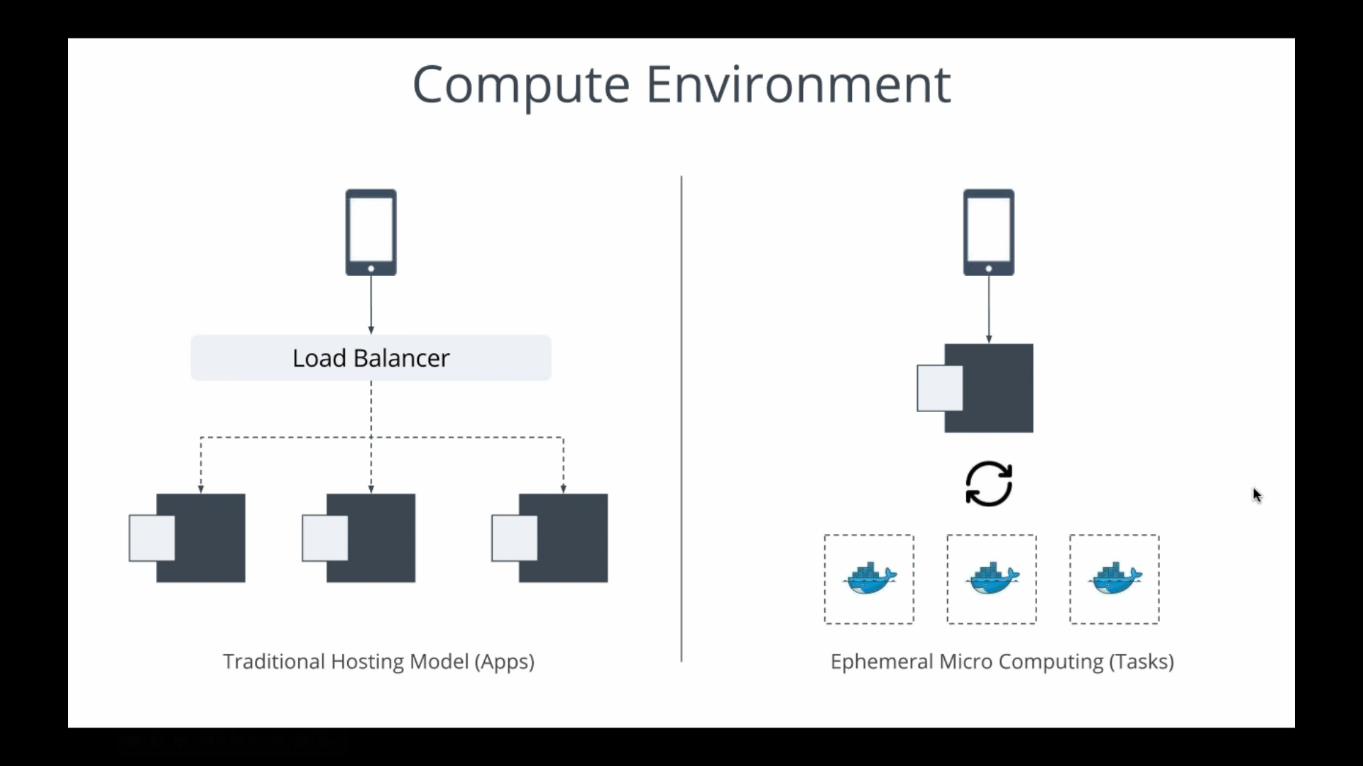

* Microservices
  + Ephermal – means they need not be up and listening to requests, instead they just need to be available on demand for processing a task?? Hence more effective in
  + VMs and servers are orchestrating individual tasks

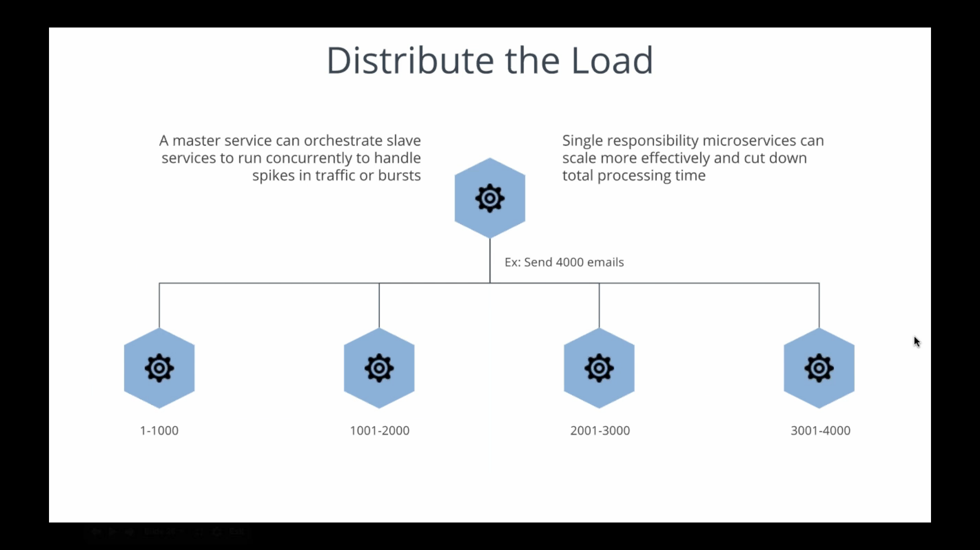

* Managing state:

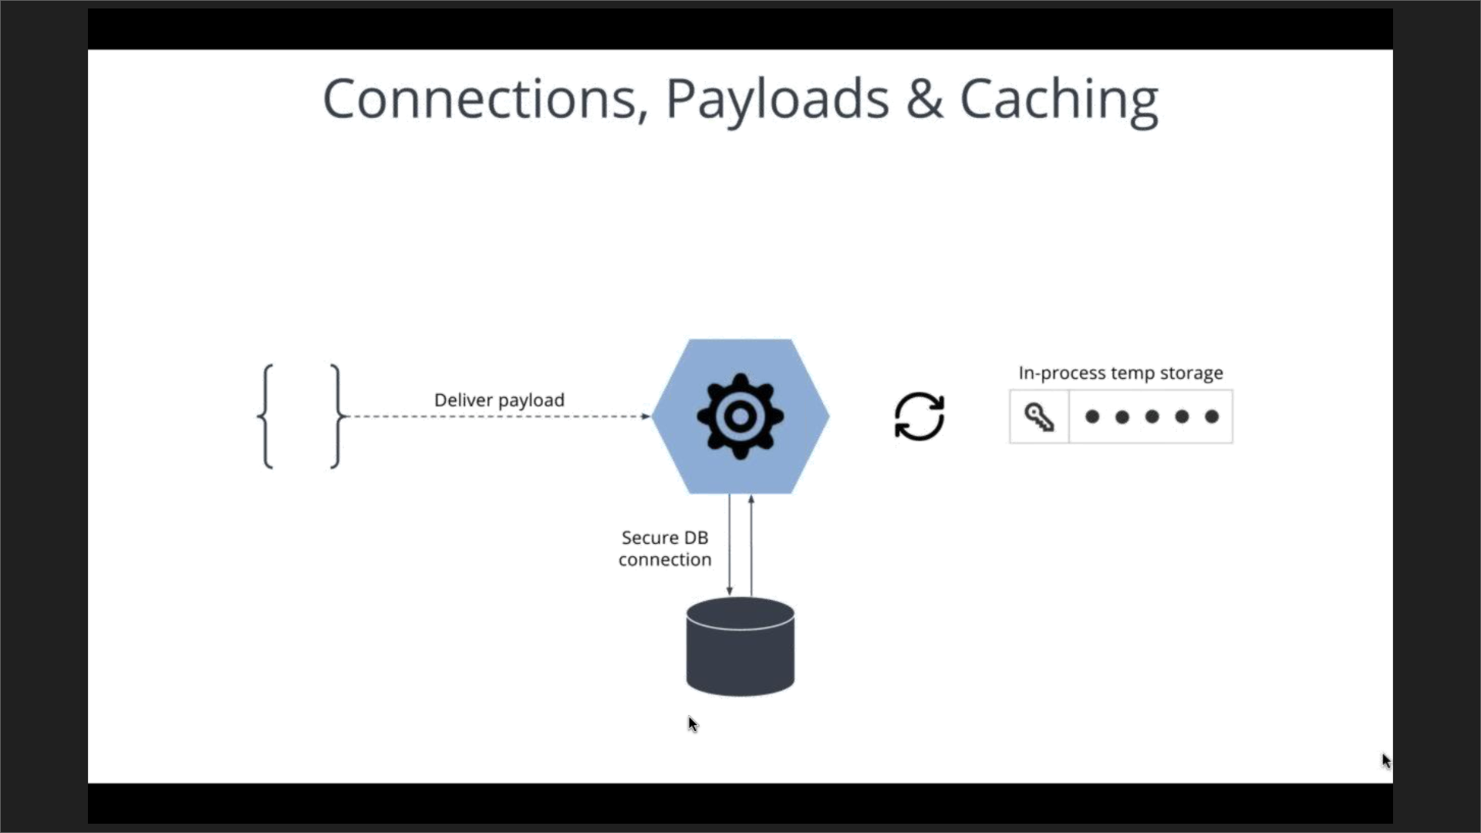

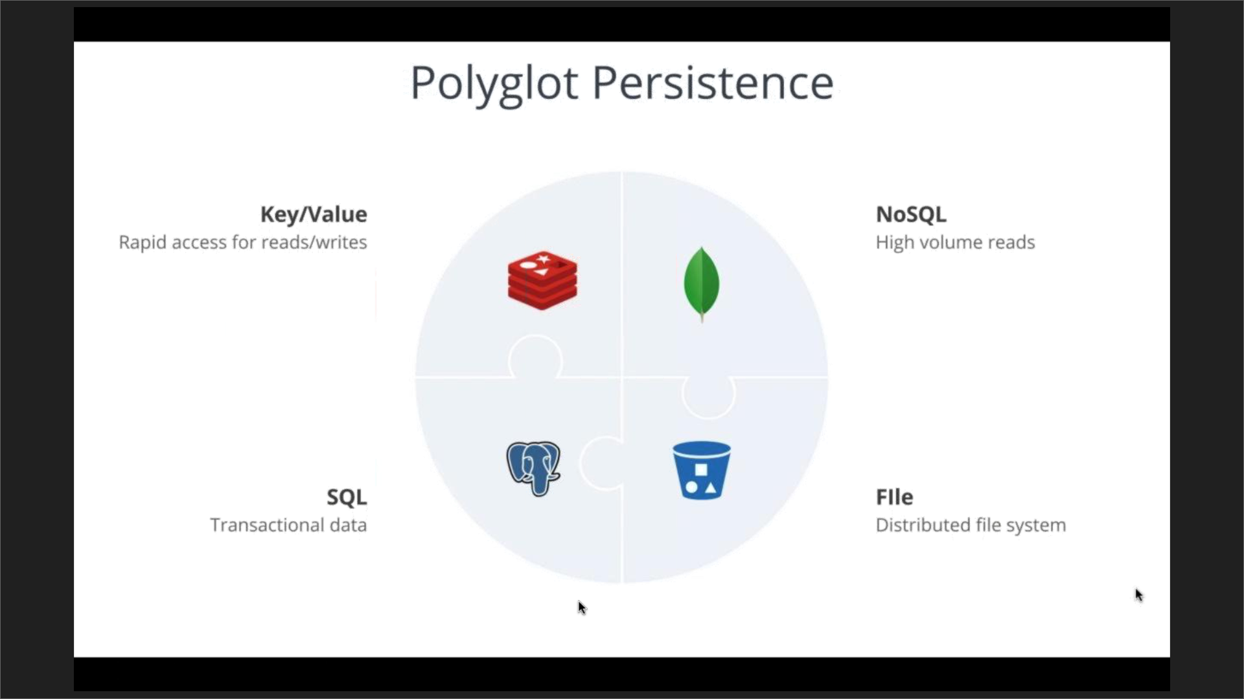

* Polyglot persistent models comes with their
* While preserving stateless
* Presentation Layer

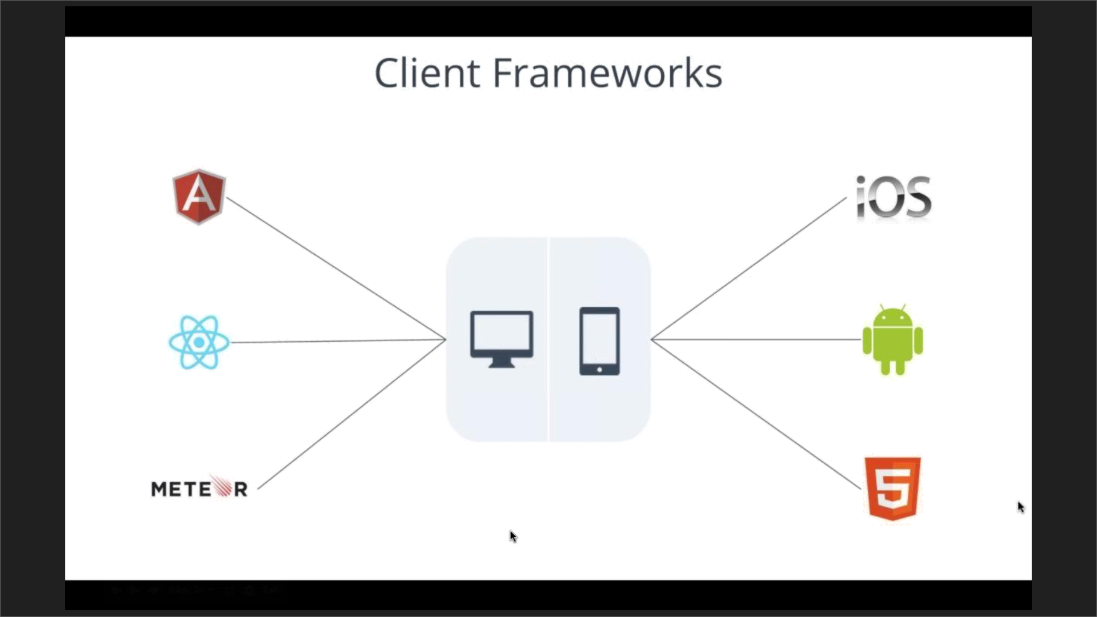

* + Considerations
    - Route via the API gateway not directly from devices
    - Fine-grained auth support may be needed in certain cases
    - Balance inline processing vs out of process
    - Pre-process for faster loading times
    - Out-of-process for greater responses
  + Always remember that your user see your application as ONE unit b
* Operations
  + More about choreography than orchestration – not a single workflow

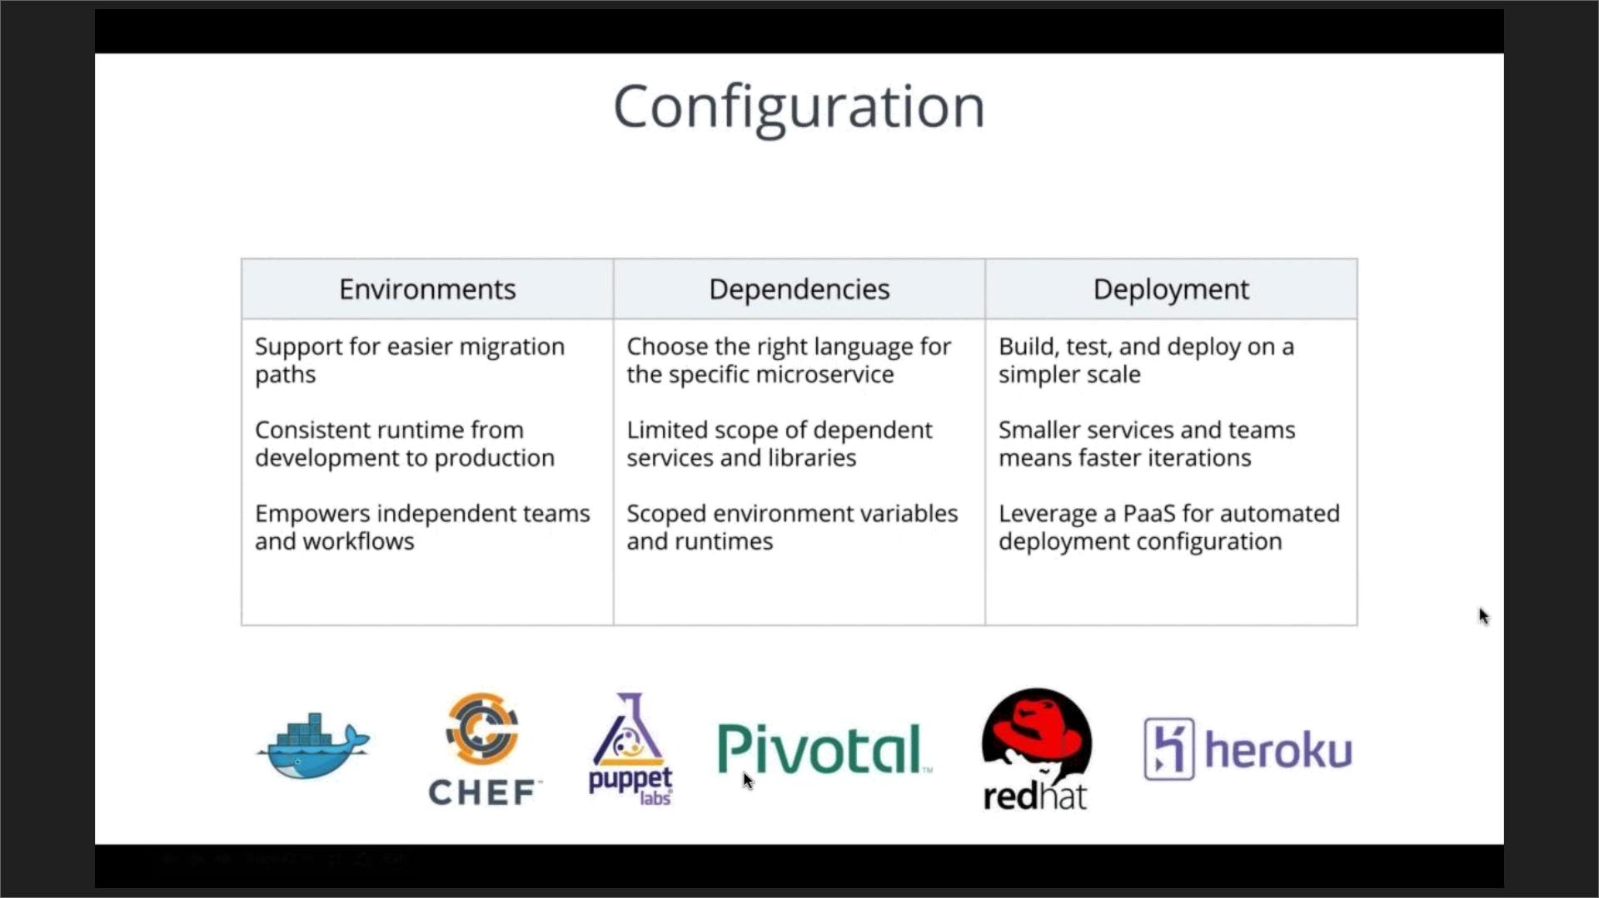

* + Configuration
    - Environments
    - Dependencies
    - Deployment
  + Continuous Delivery
    - Code 🡪 Test 🡪 Deploy
* Monitoring & Analytics
  + Responsibilities
    - Runtime monitoring
    - Performance testing
    - Audit trails
    - Logging
    - Error handling
    - Alerting

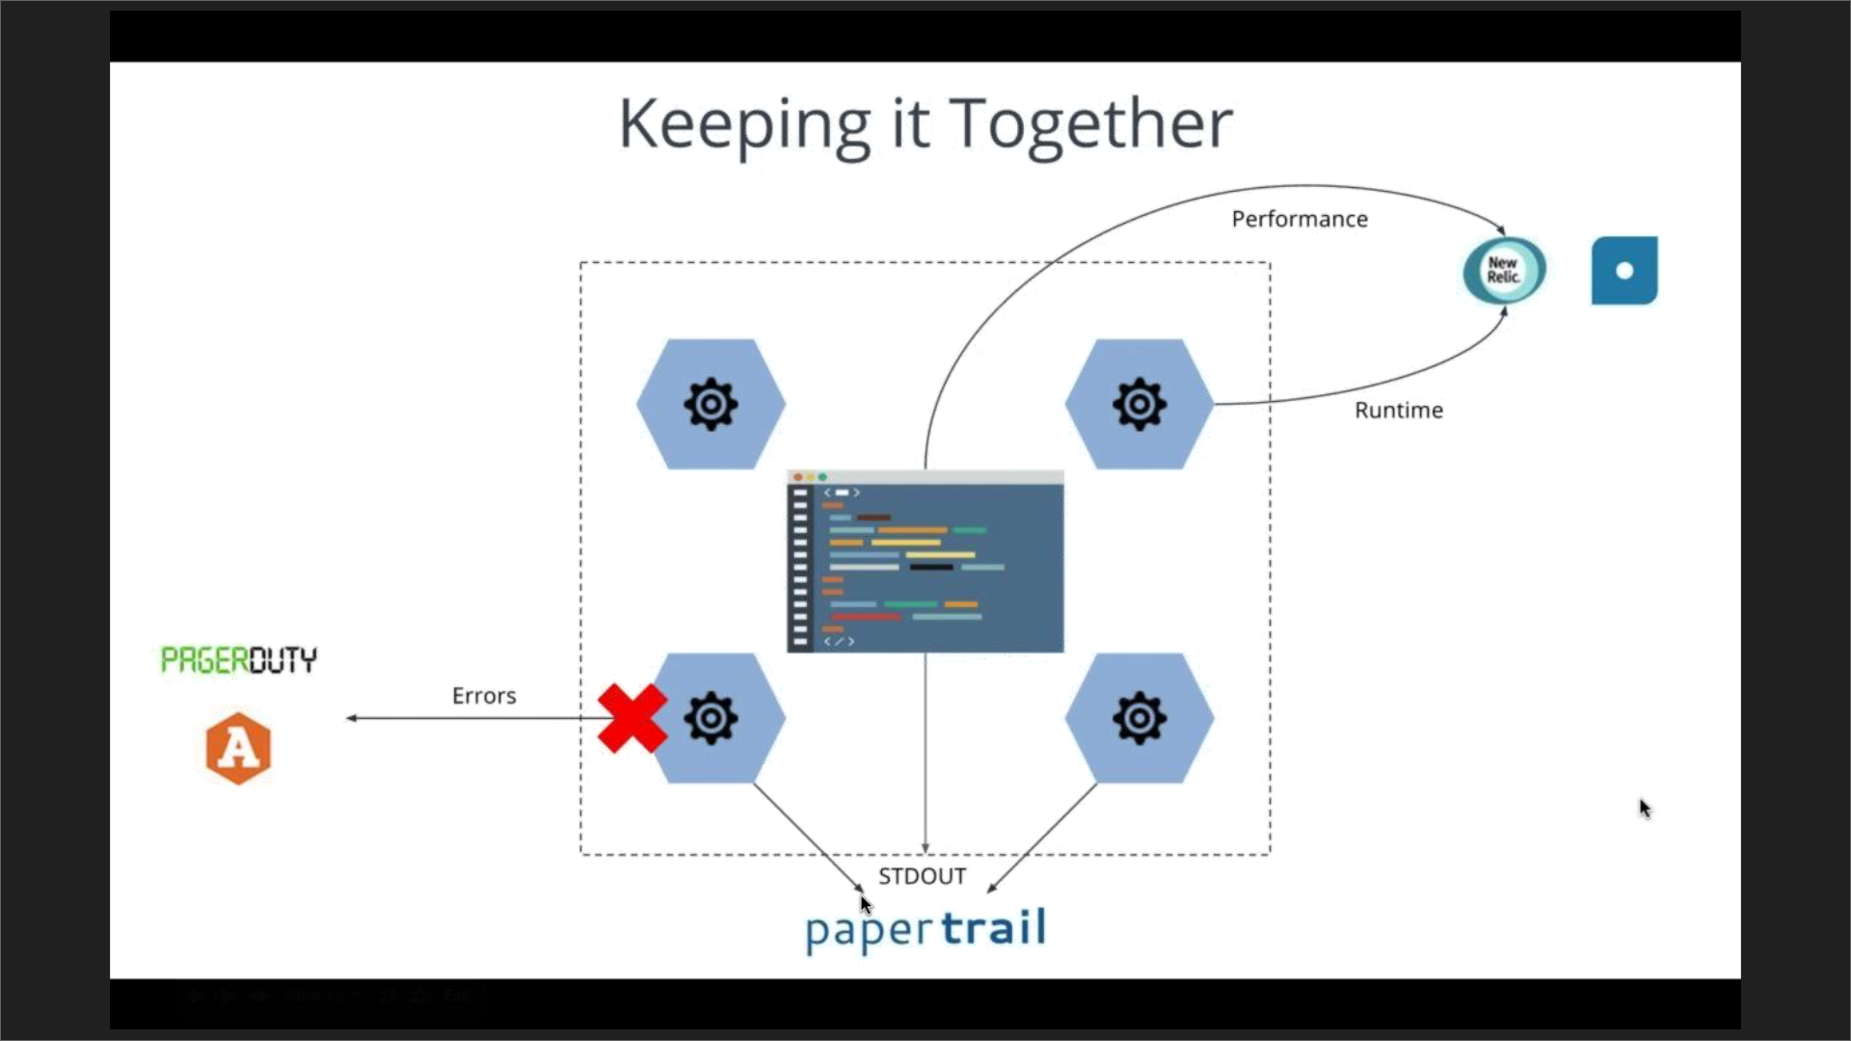

* + All STDOUT to a single location
  + Treat microservices as a portion of the entire application
  + With microservices, monitoring and analytics must be done both at the individual level and as a whole application level

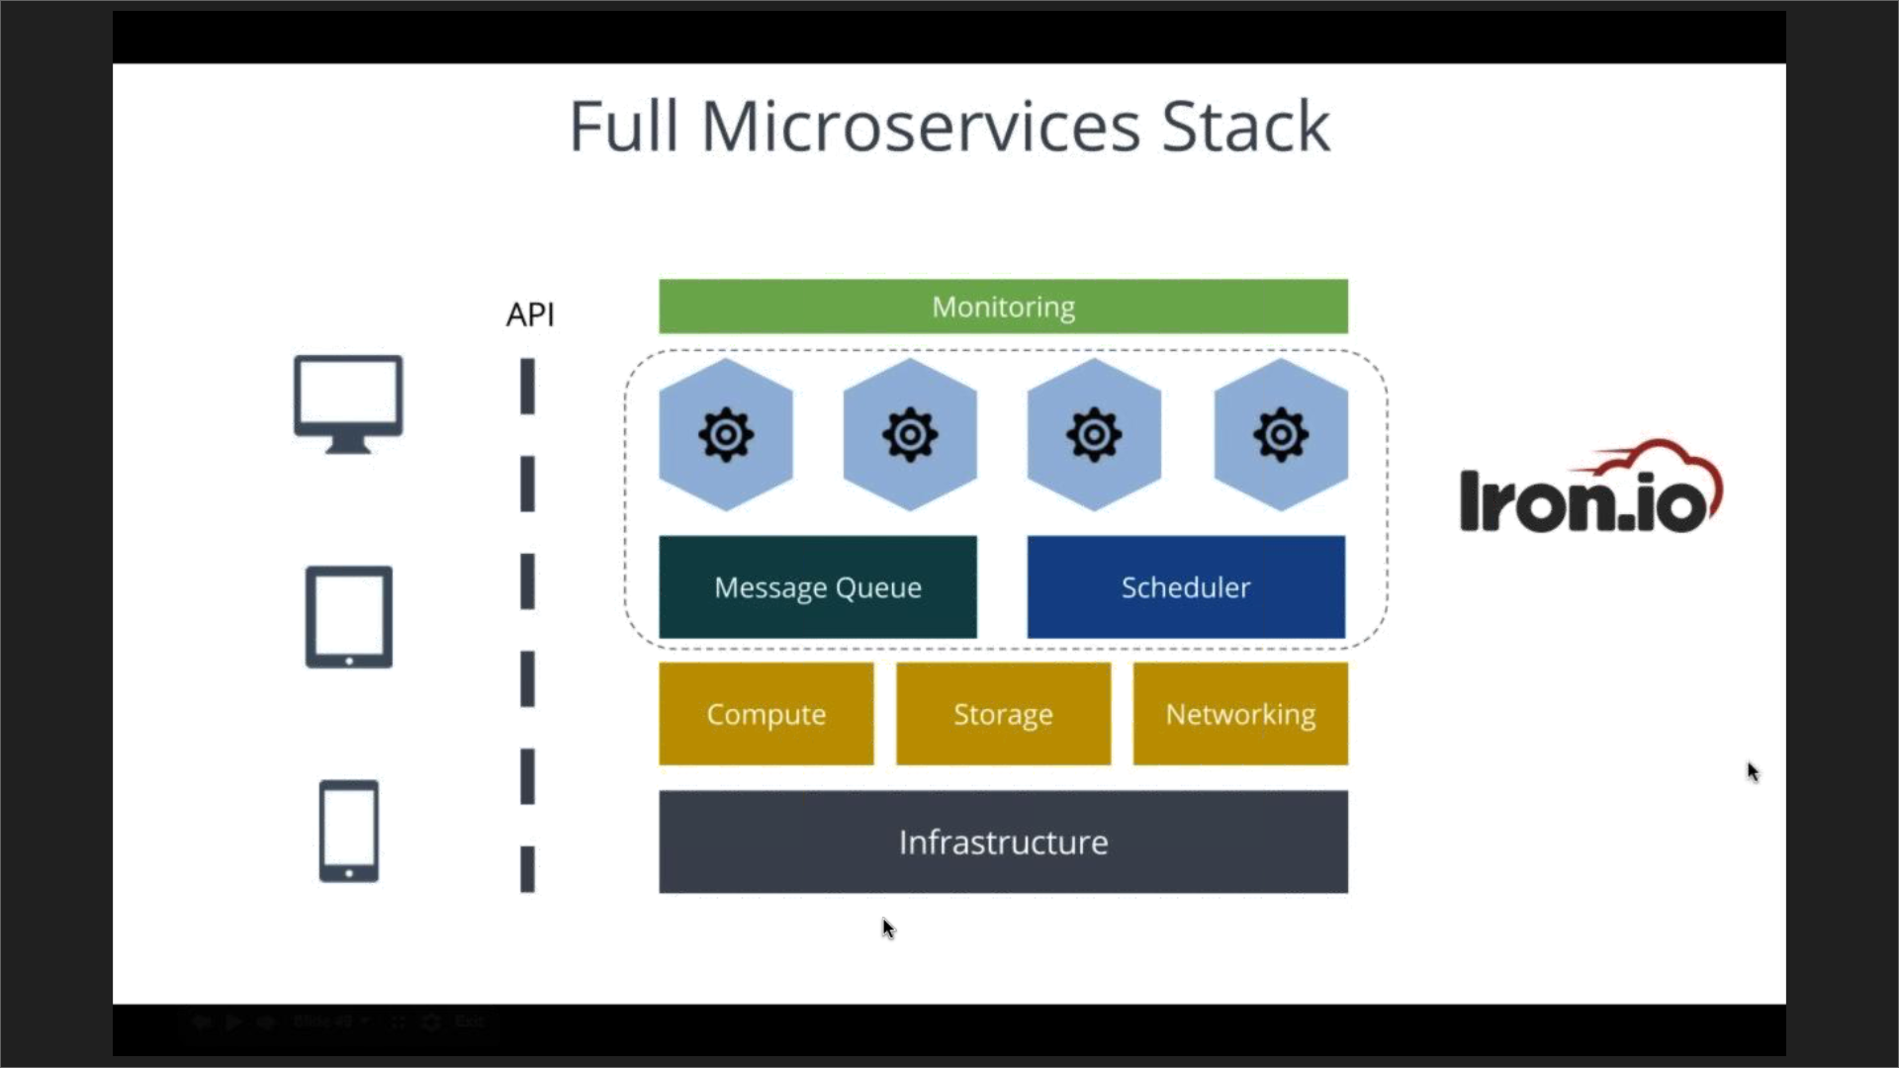

* How Iron.io can help?
  + Pair programming – get a hands-on walkthrough of Iron.io platform
  + Architecture Review – Share some best practices and advise
  + Free trail
* Large ETL jobs – candidates for microservices
  + Typical recommendation to split ETL into E, T & L microservices
* Lambda
  + Limited to 5 mins
  + Code supported for 3 languages
  + Direct competitor to Iron.io
  + Issues with error handling

**Akana Webinar**

Eat microservices One bit at a time (Ian Goldsmith)

June 16, 2016

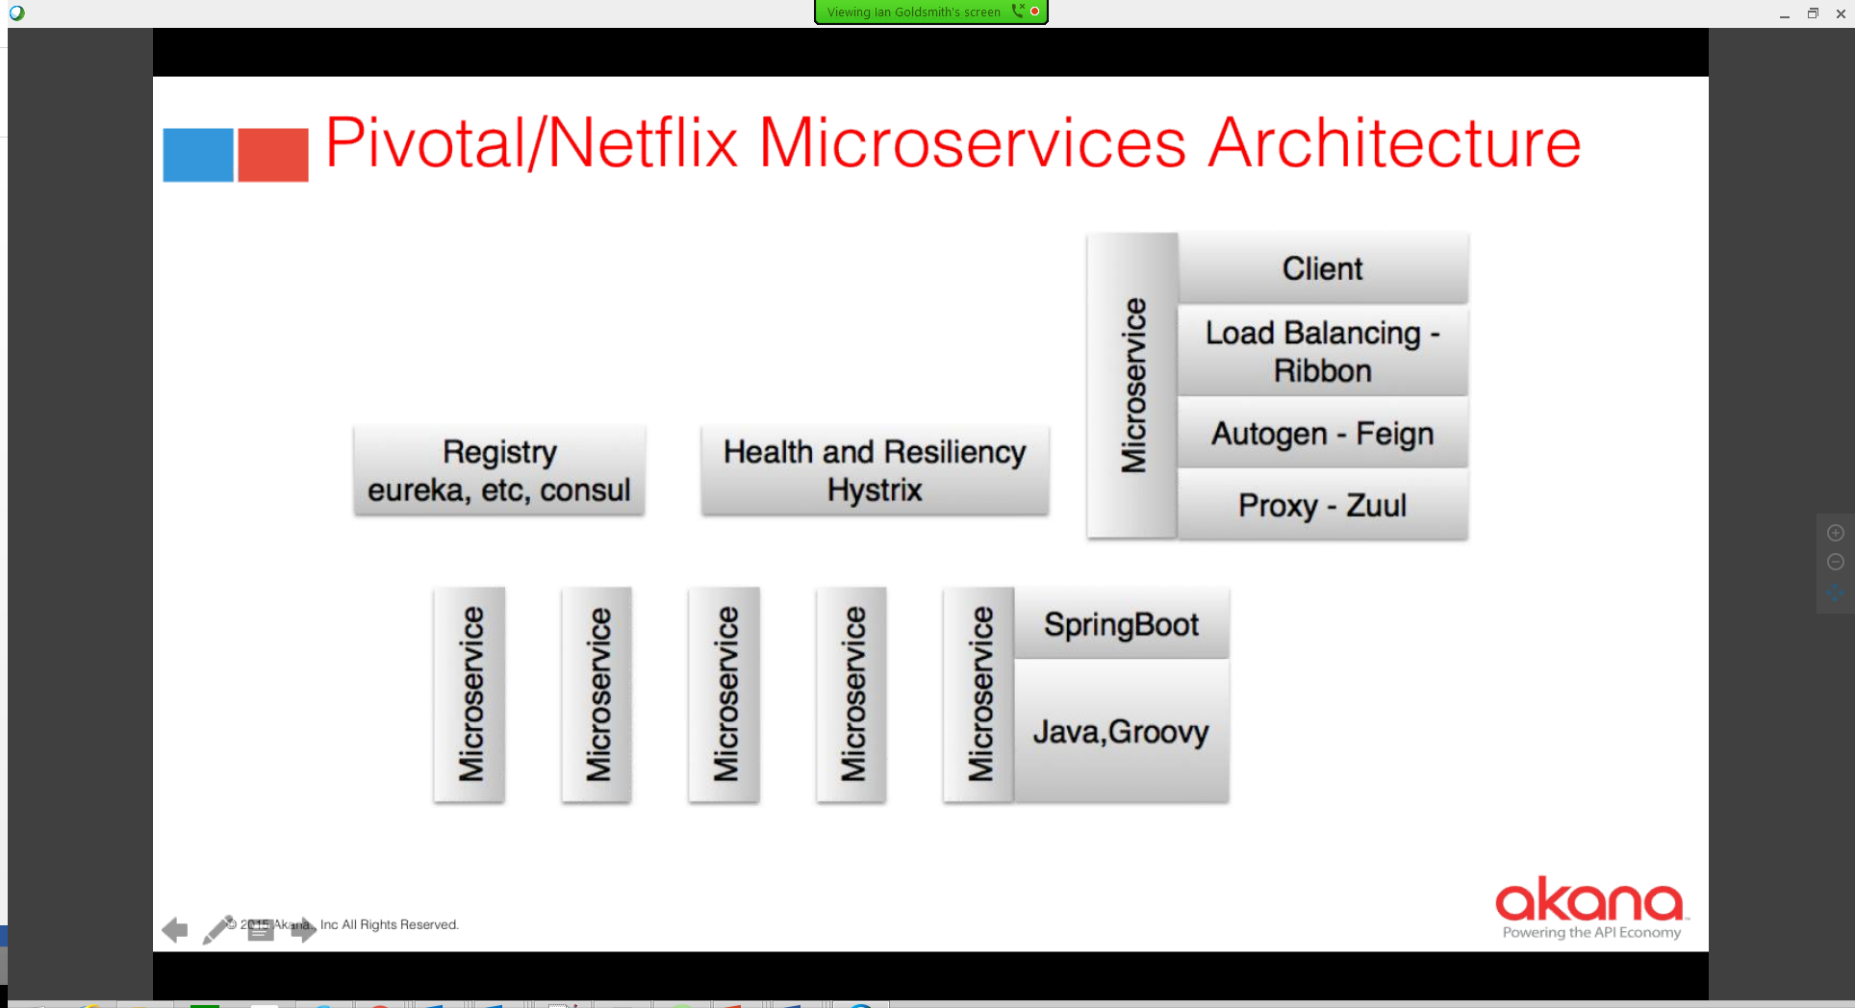

* The technology for microservices is not important, the interface is important – bounded context
* According to Akana – Microservices is SOA + DevOps + Containers
* Microservices are a reaffiremation of SOA principles
  + Dovetail into agile
  + Dovetail in devops
  + Dovetail in domain-driven design/BASE
* Point of deflection with SOA
  + Microservices are anti-ESB (dumb pipes)
  + Core premise of SOA was reusability
  + Microservices think more about from one application – reuse across multiple applications is not the primary concern for microservices – will result in conflict
* DevOps
  + The developer interacts with the infrastructure directly. Increases agility
* Microservices
  + Help you decide what kind of rigor you need for different parts of the application
* Containerization
  + Seeing a lot of rapid adoption now
* Drivers
  + Scalability,
  + Conway’s law,
  + Composition of focused services,
  + Agility of development frameworks
  + Cloud

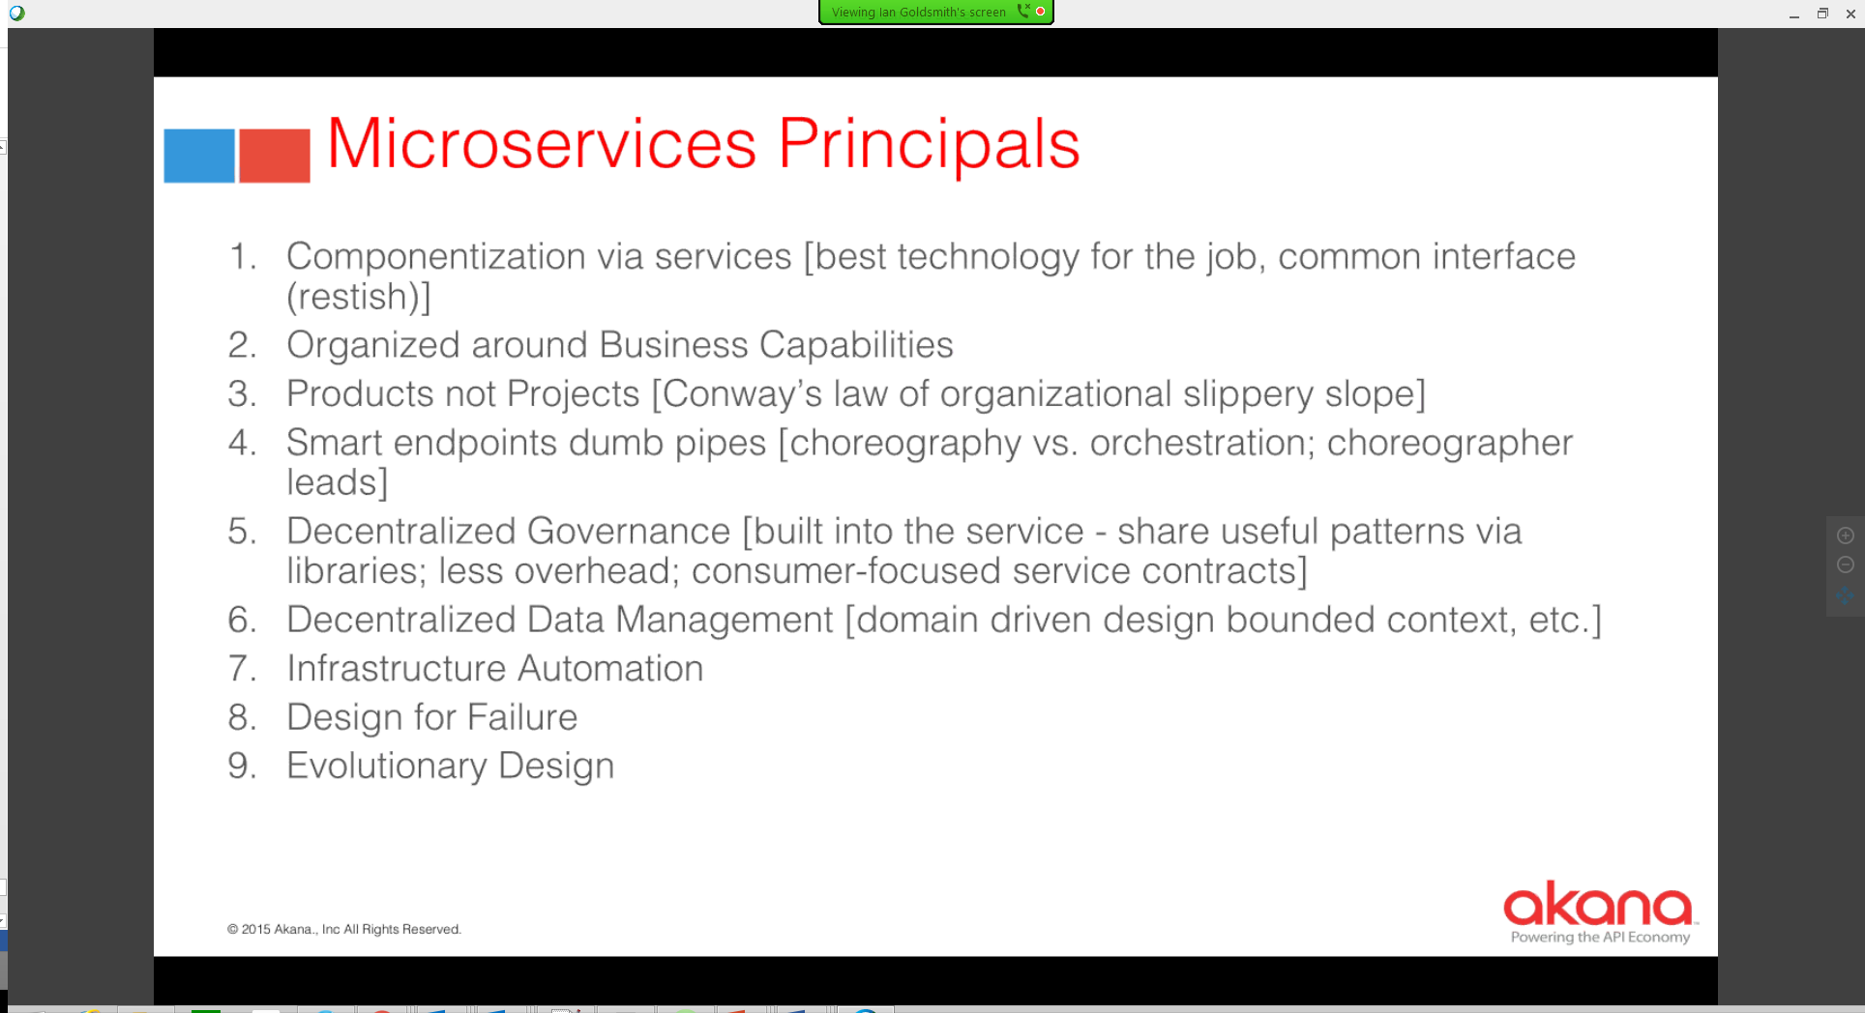

* Decentralized Governance
* Decentralized data management: most difficult – Joins in application layer than data layer

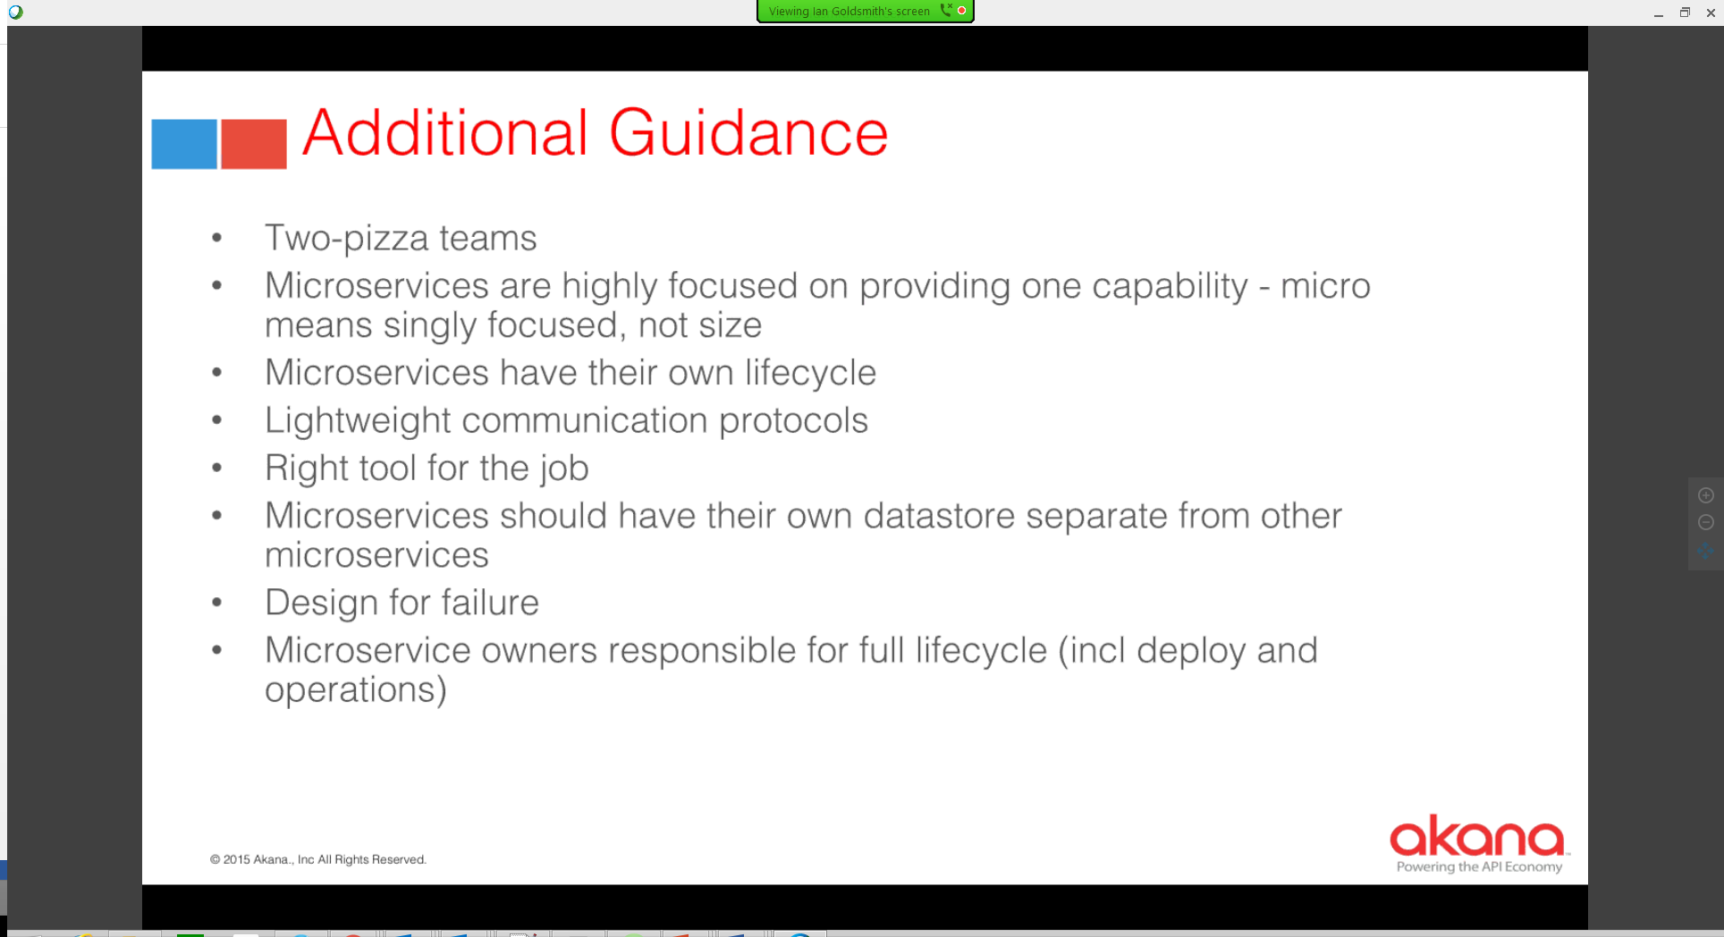

Additional Guidance

* 2 pizza team = small team
* Microservices are

How hard is it to adopt?

* Requires 4 things
  + Maturity of Ops (DevOps, containerization)
  + Willing to re-architect entire app (maybe)
  + Willing to invest in the App – must be strategic
  + App must need Internet scale

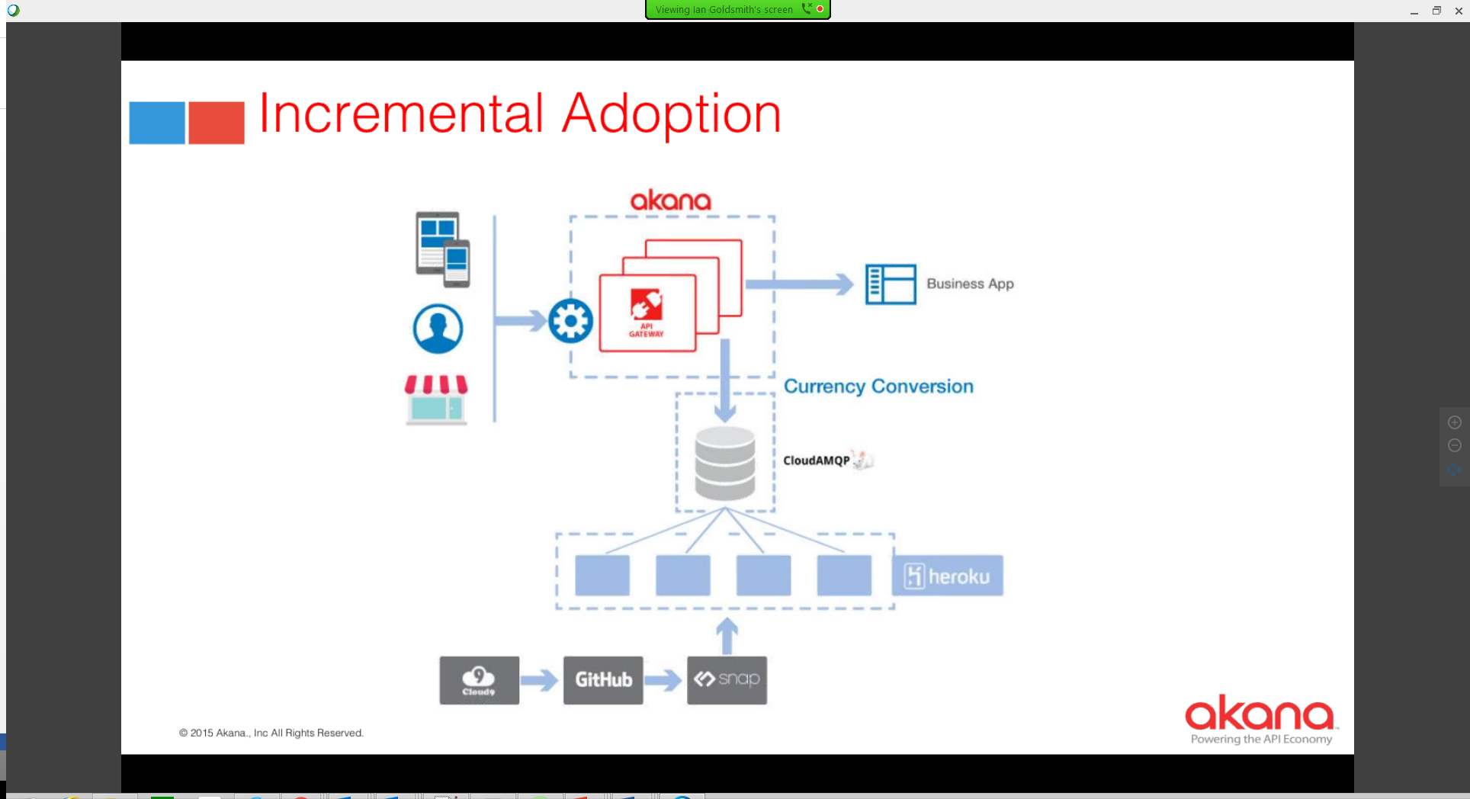



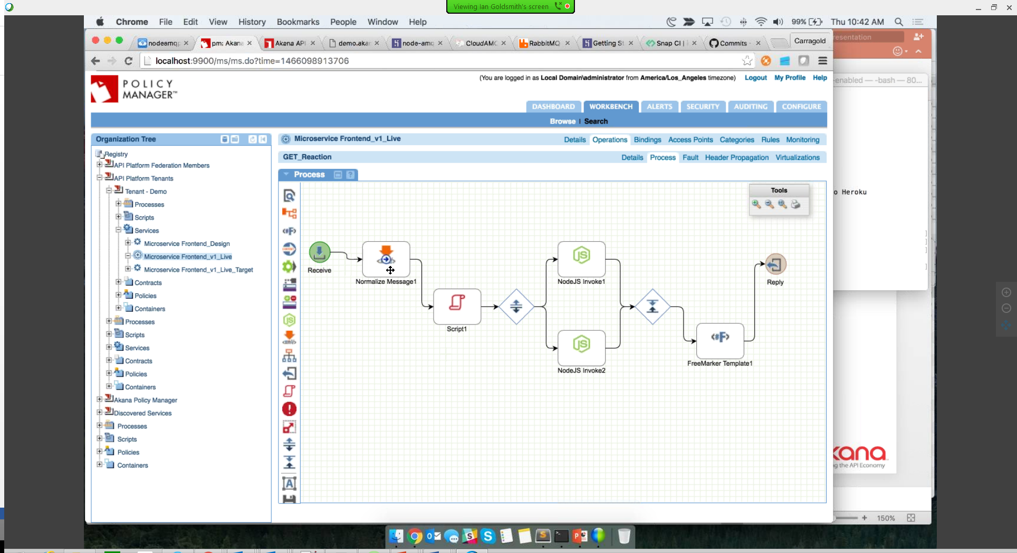

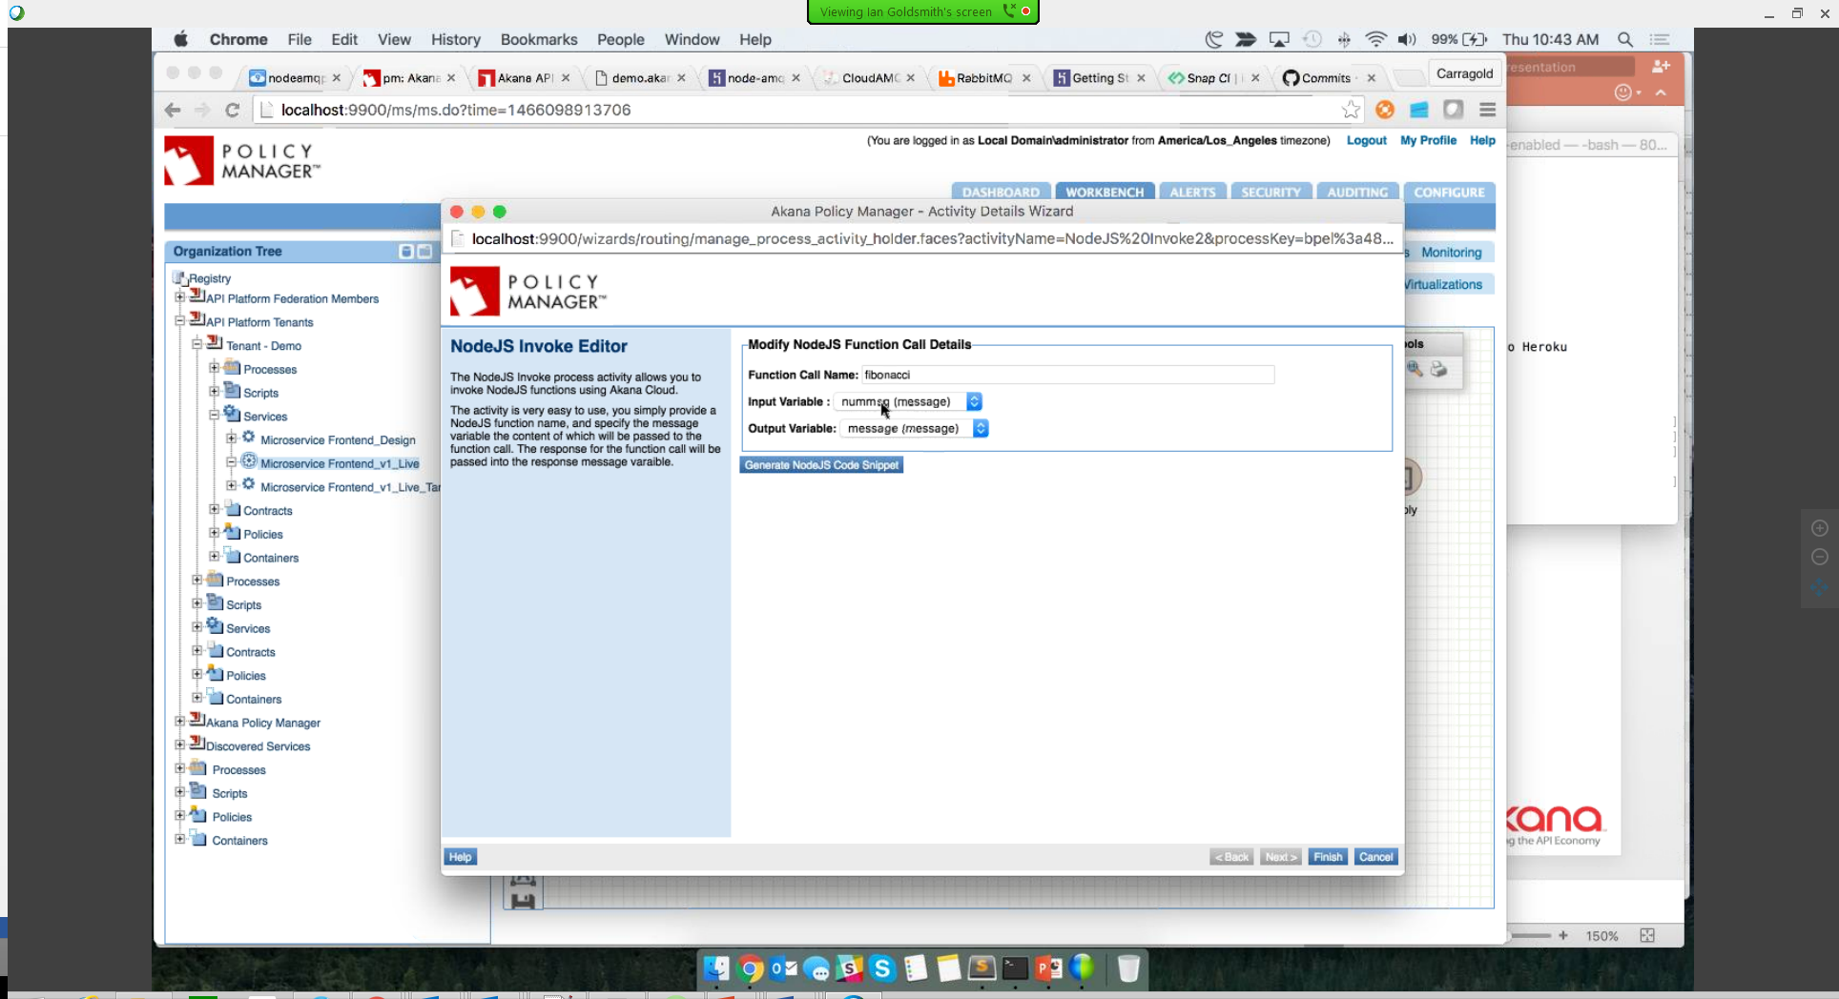

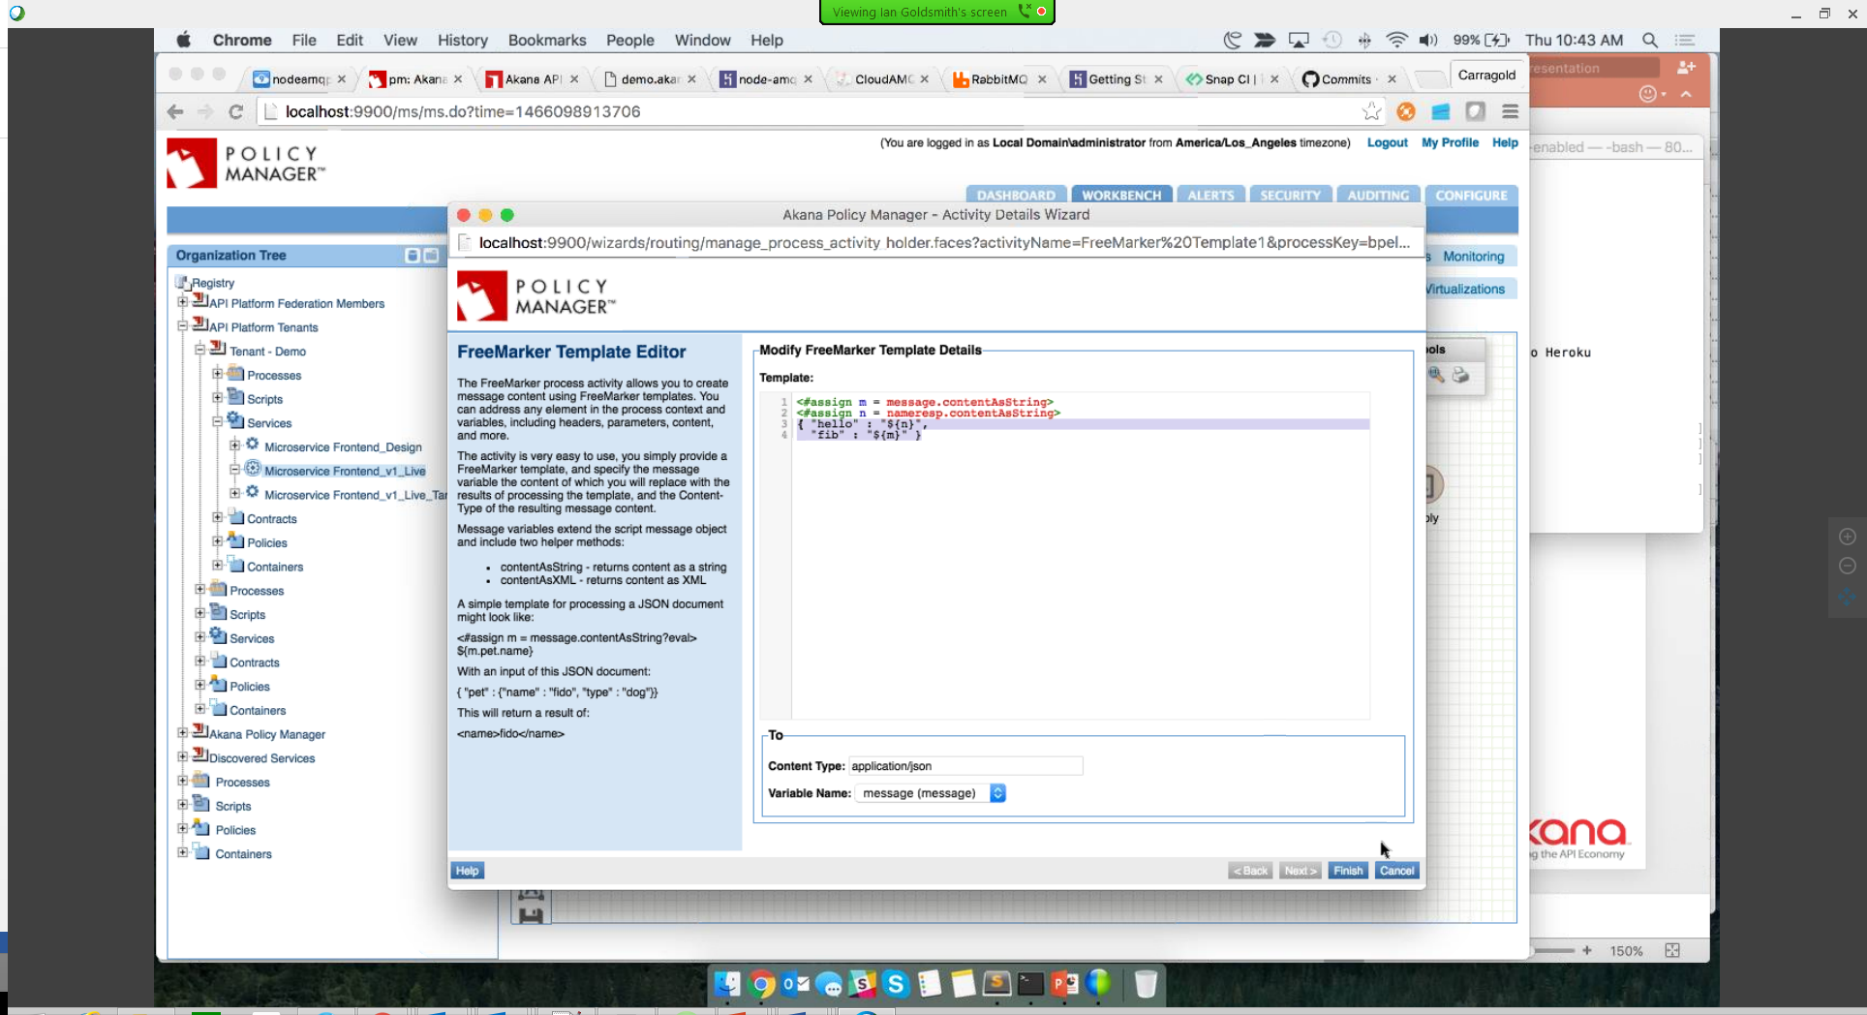

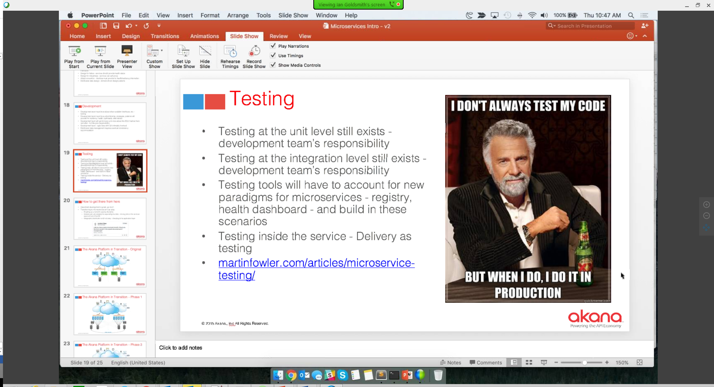

Testing

* Testing at the unit level still exists – dev team’s responsibility
* Testing

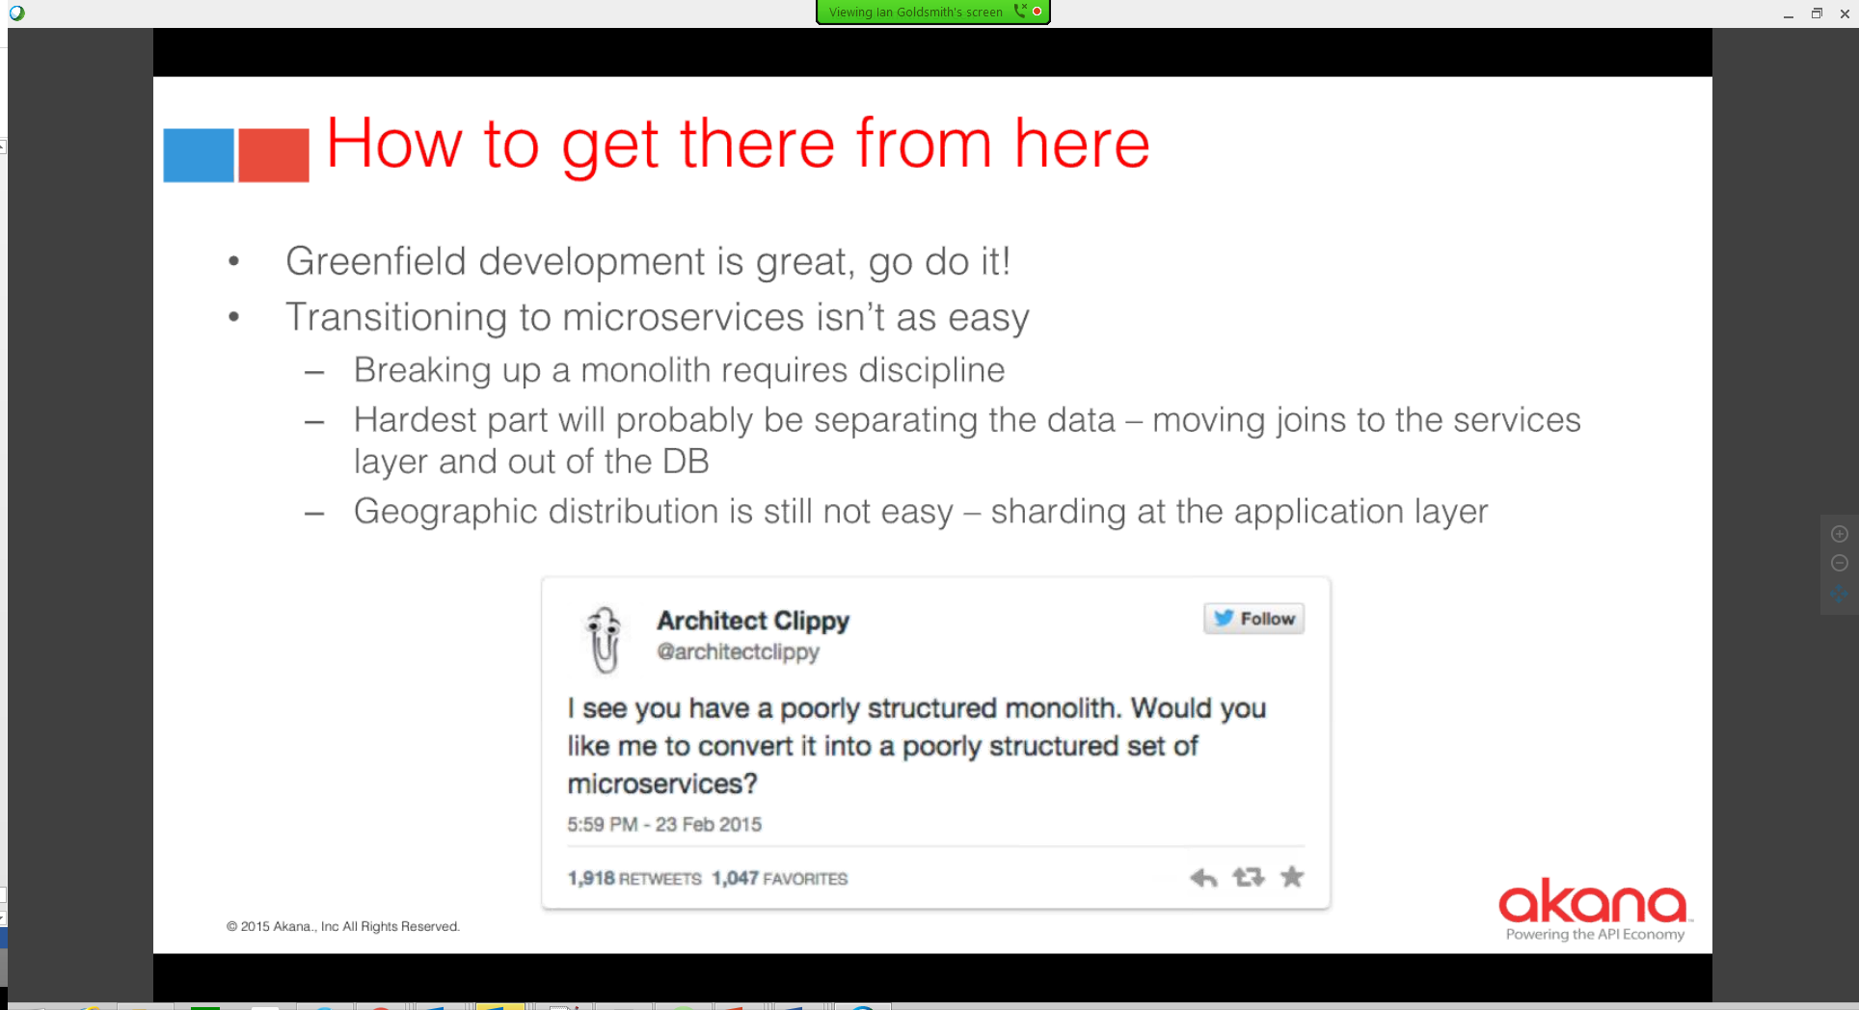

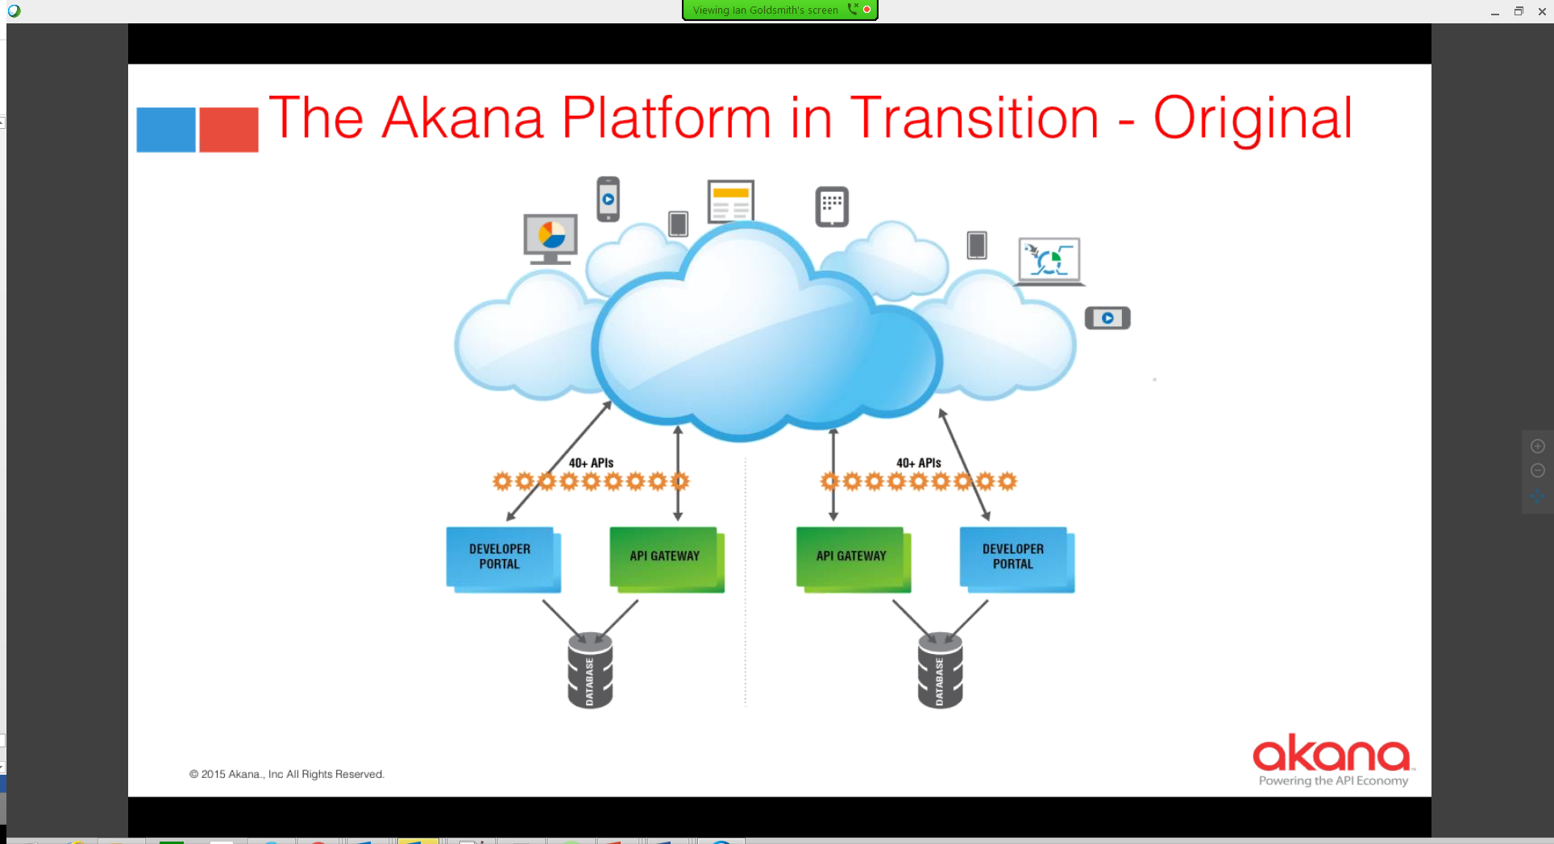

* Pre archiecture
  + API Gateway Developer portal were tightly integrated
  + Geographic distribution – individual instances

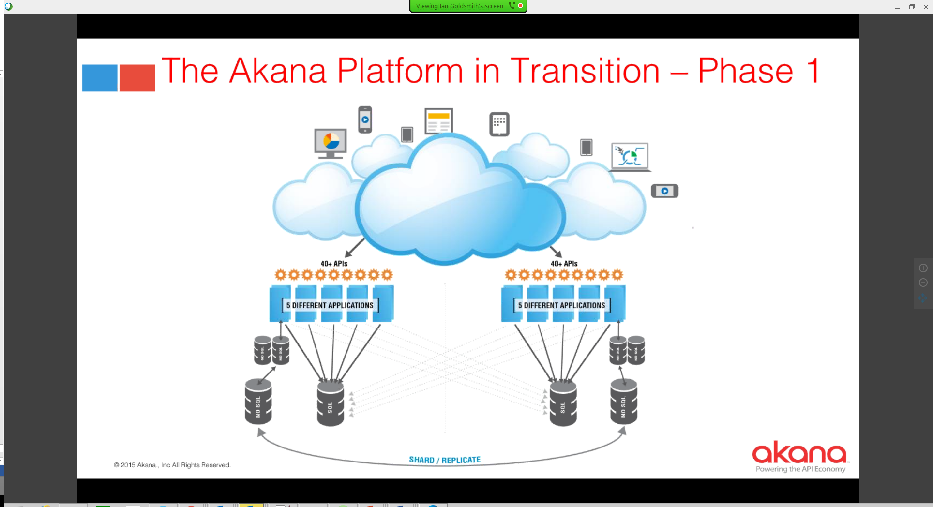

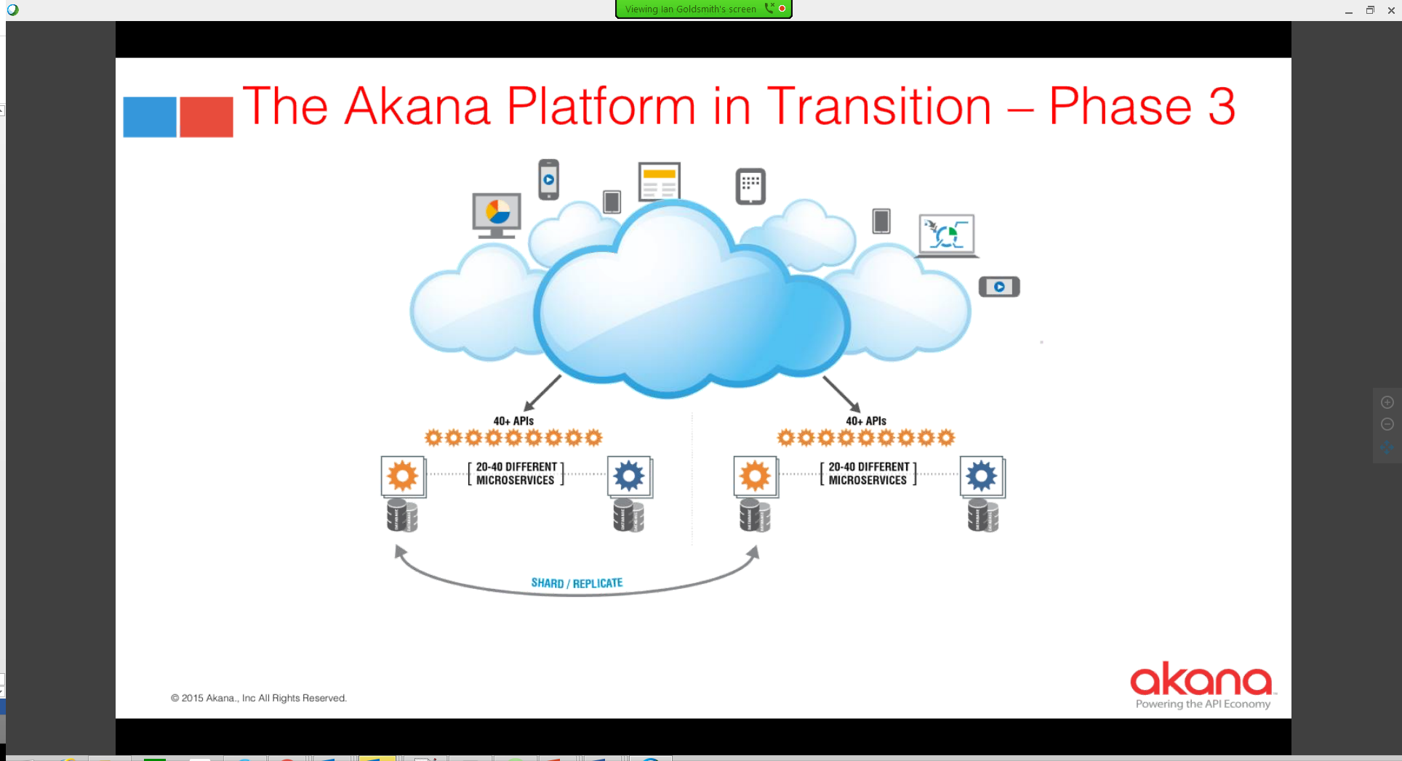

* Current state
  + Single logical platform distributed across multiple continents
  + Using eventual consistency

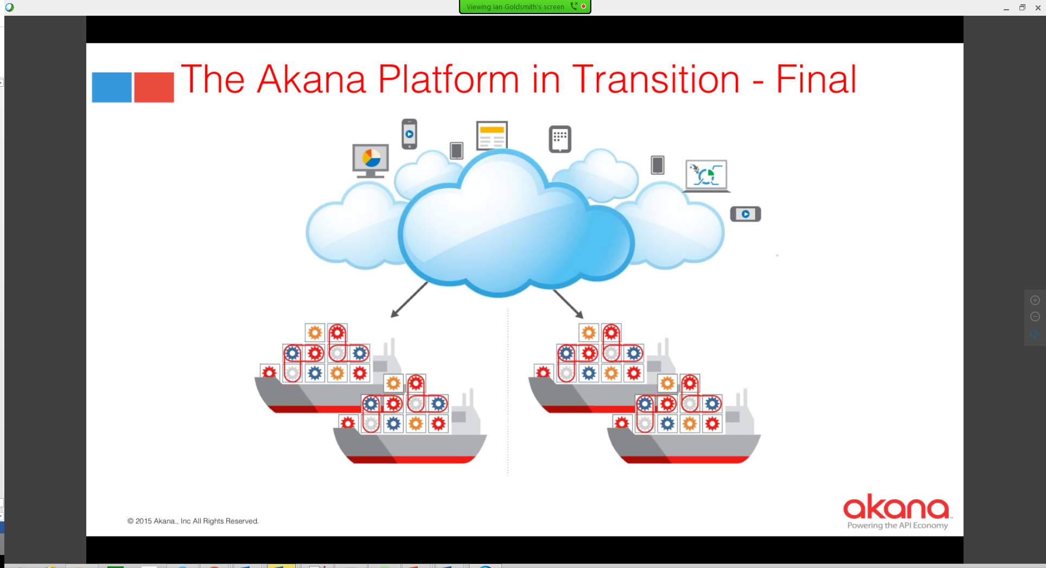

* Not yet there – currently java deployments

Q&A

* Decentralizing data management – how does it fit to MDM?
  + Don’t mix microservices and MDM
* Data-store scalability
  + Pulled data usage out of SQL store to NoSQL store
    - Allowed very sophisticated sharding strategy
    - You are still limited by the scalability of your core data-store
* Github/microservices

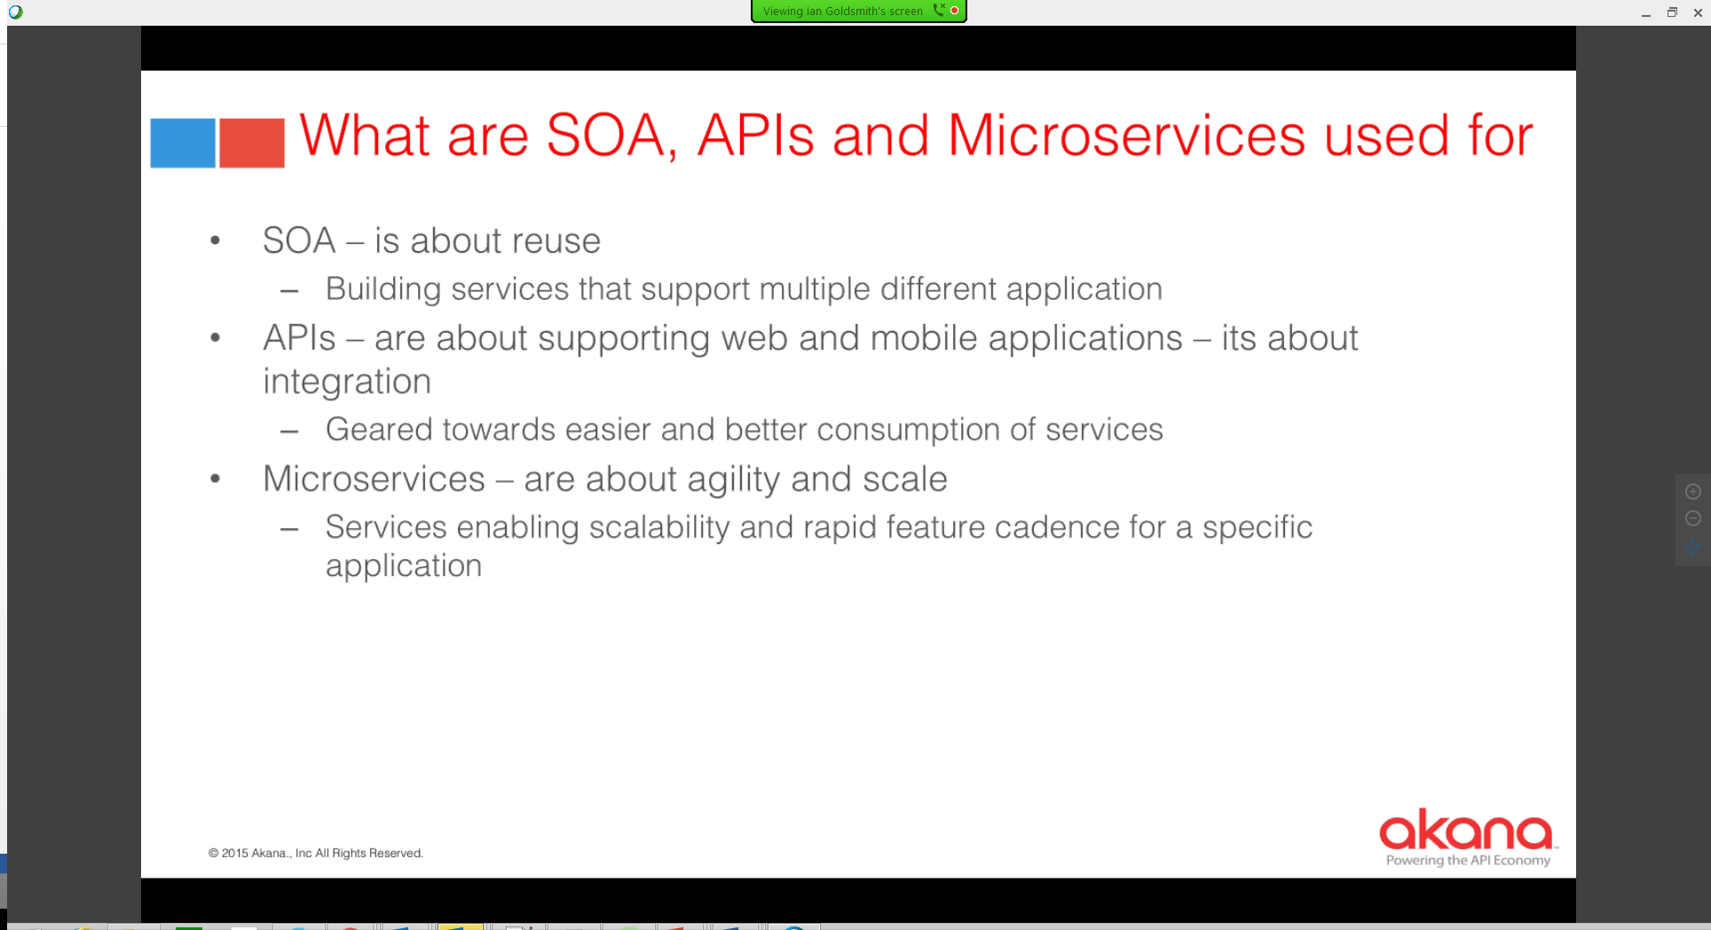

**Microservices Webinar – Iron.io**

July 21, 2016

* The Modern Cloud
  + Cloud-native protocols
    - RESTful APIs that communicate over HTTP with JSON serialization
  + Agile Operations
    - Consistent environments for development and deployment
  + Elastic Workloads
    - Granular workload-aware computing for effective…
* Microservices represents the **convergence** of modern cloud and modern application development
* Common Characteristics
  + Independent – very important
  + Single responsibility
  + Loosely coupled
  + Stateless
  + Asynchronous
  + Interchangeable – very important

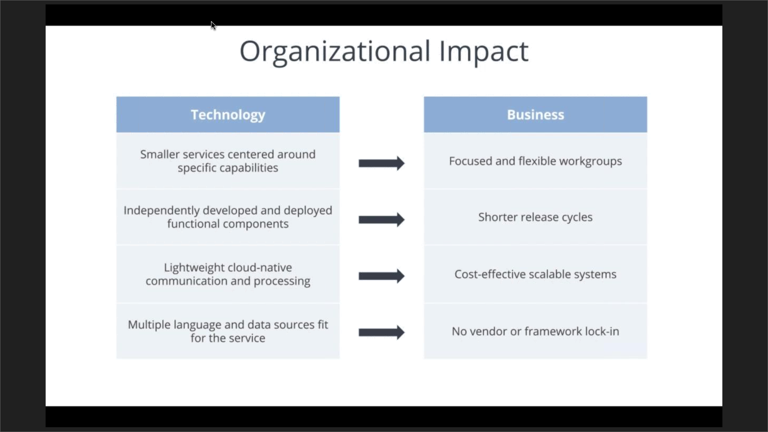

* Considerations
  + Building & maintaining highly available distributed systems is complex
  + More moving parts means more components to keep track of and configure properly
  + Loosely coupled services means steps must be taken to keep data consistent
  + Distributed asynchronous processes create network latency and more API traffic
  + Testing and monitoring individual services is challenging
* Microservices are meant to make development and deployment better, but not necessarily easier
* Decoupling
  + Identify candidate components
    - Business Capability
      * Other considerations
        + Outside of user-response loop
        + 3rd party service API calls
        + Long running processes
        + Transaction processing
        + Scale-out/burst processing
        + Scheduled jobs

Serverless Microservices - Apigee

July 28, 2016

* Serverless attributes
  + Code focused
  + No servers to manage
  + No manual scaling or server provisioning
  + No idle resources
  + No SSH or RDP

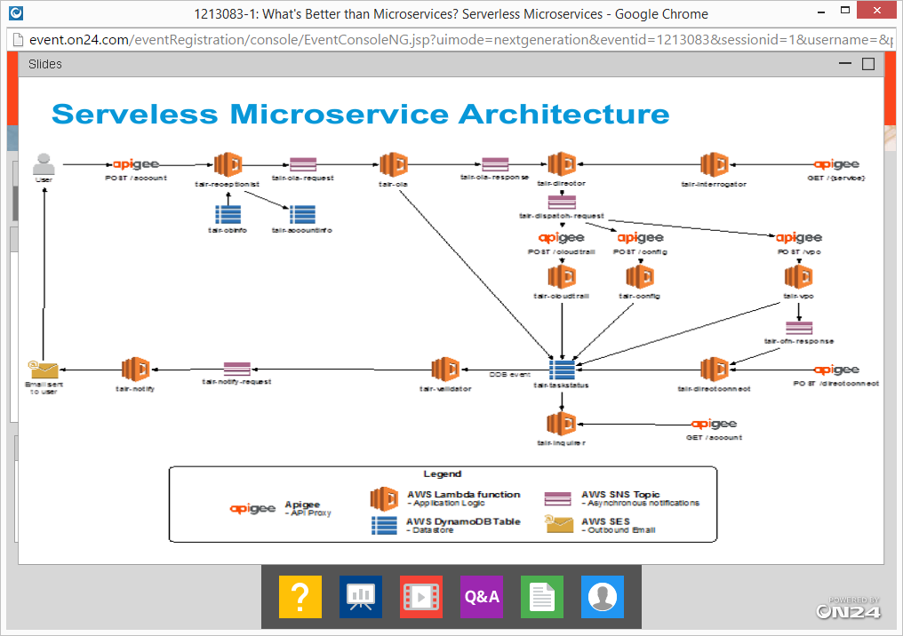

* + They are looking at leveraging PaaS offerings to create a solution since it will mean they do not need to manage absolutely any infrastructure
    - Maintenance is low as all we are managing here is just the code
    - What about the costs?
    - Developer friendly
  + DynamoDB has a component called a stream – any changes to dynamo Db table can trigger this event and stream can invoke a lambda function
    - Dynamo DB helped in microservices share nothing architecture
* How is Apigee edge being used
  + Inter-api call
* Security
  + In AWS they use IAM and IAM role
    - Privilege applies
  + In this particular architecture they have used a zero trust model
* Advantages of a serverless architecture
  + Costs and Agility
    - Costs of running in Lambda function is pretty low since you are paying for actual run time which are in minutes max
    - Managing the infrastructure costs are not there at all
* Can you auto-increase dynamo DB read and write
  + Yes

<https://github.com/alanwill/serverless-demo>

<http://serverless.com>

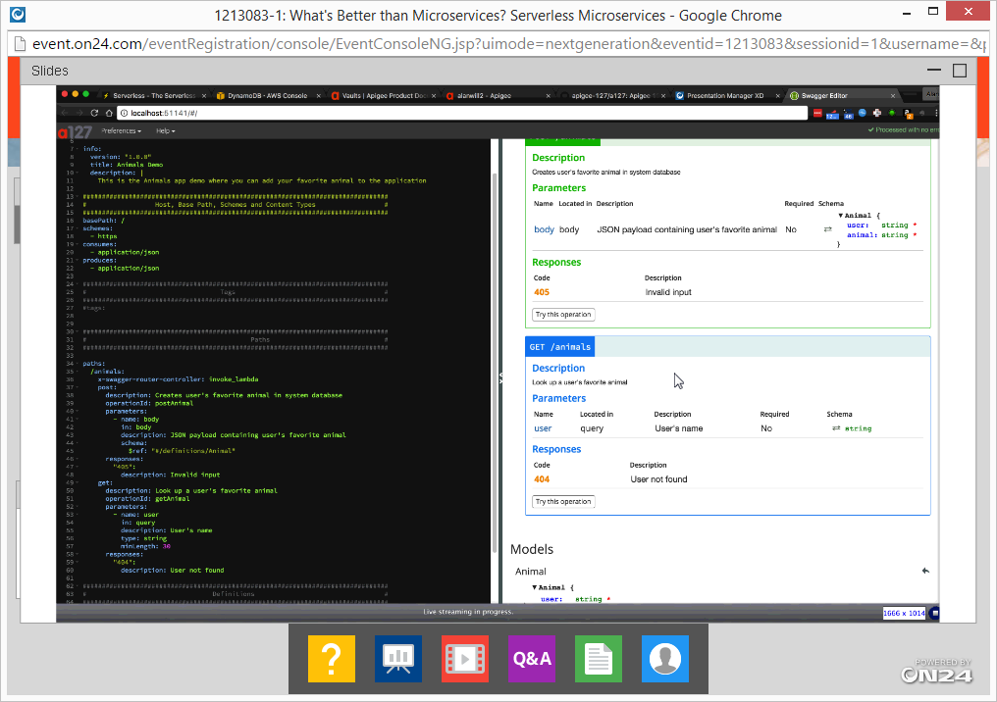

* Best practices on Lambda programming
  + Many of the error in Lambda programming is in the body. When this has to be exposed as an API, we need some code which will get that error code and map it to HTTP error codes

Apigee Edge Proxies

* Support for Node.js
* Also serverless
* Focused on connectors & light-weight API orchestrations
* Apigee Limitations
  + Limited debugging & profiling
  + Not polyglot
  + Not recommended for complex business logic
  + Not a generic event processor

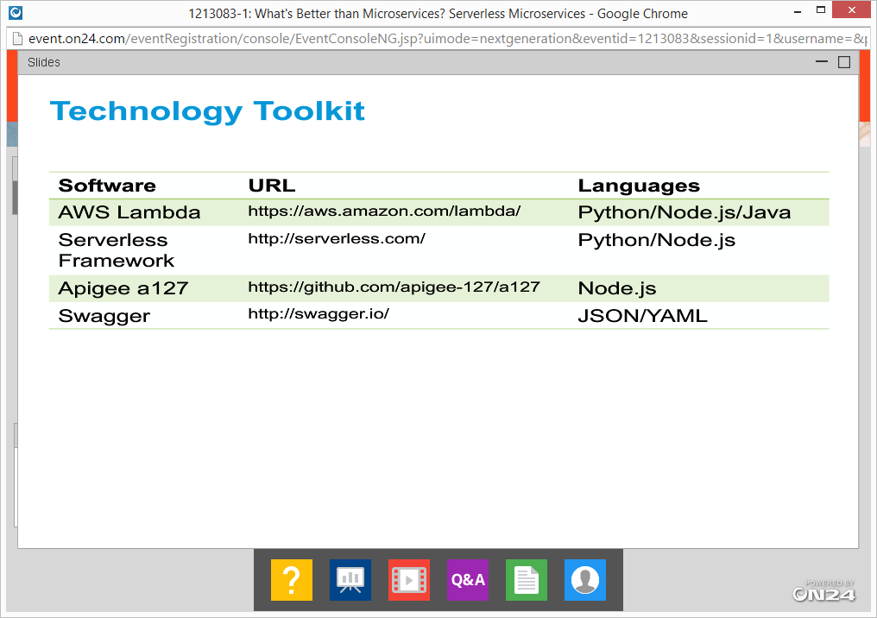

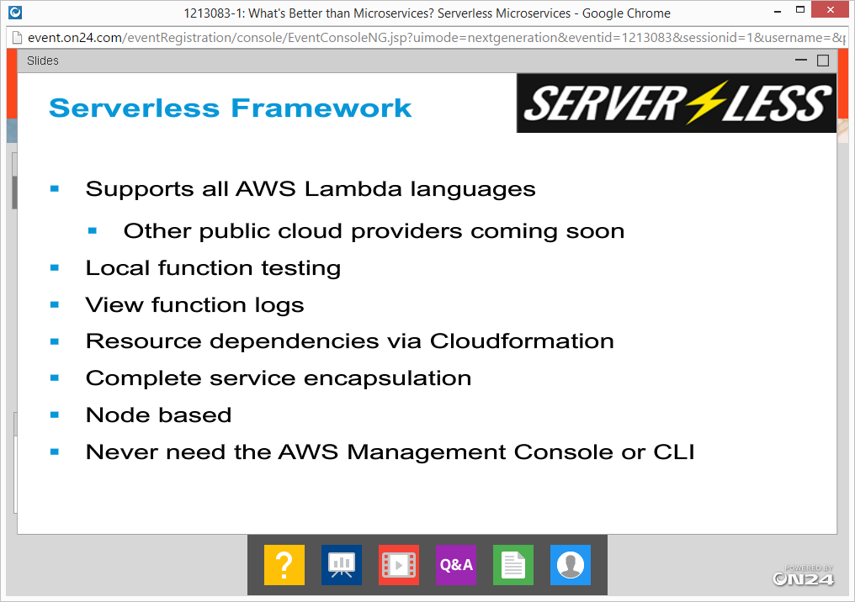

* Serverless Vs Containers

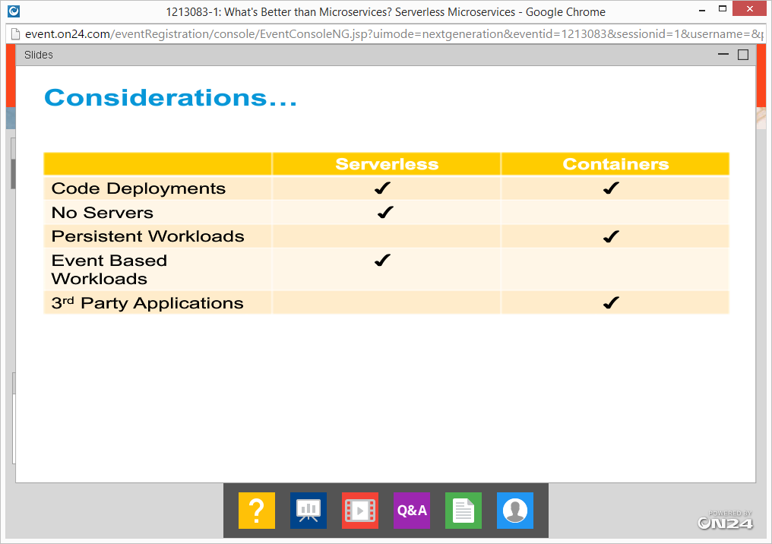

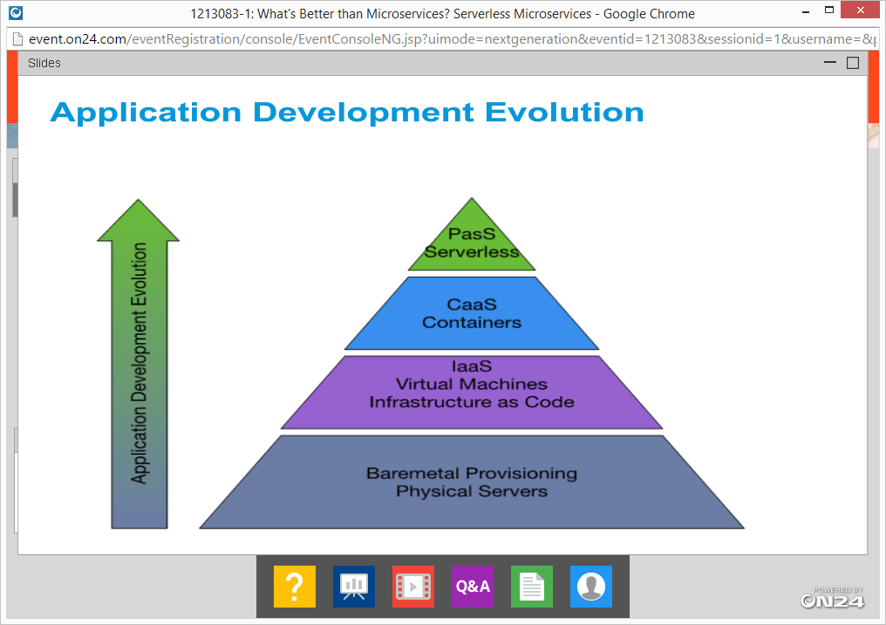

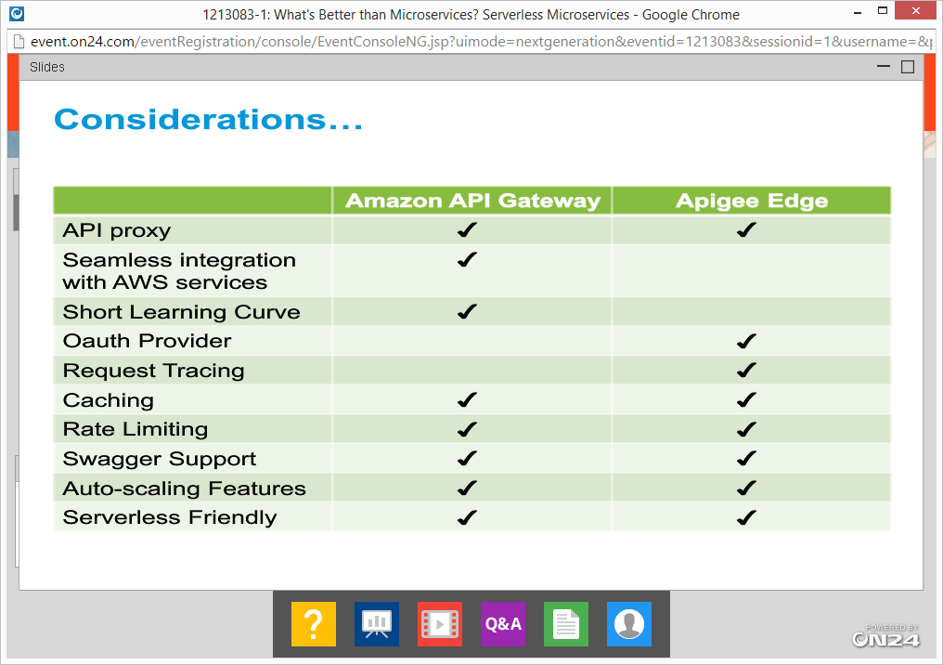

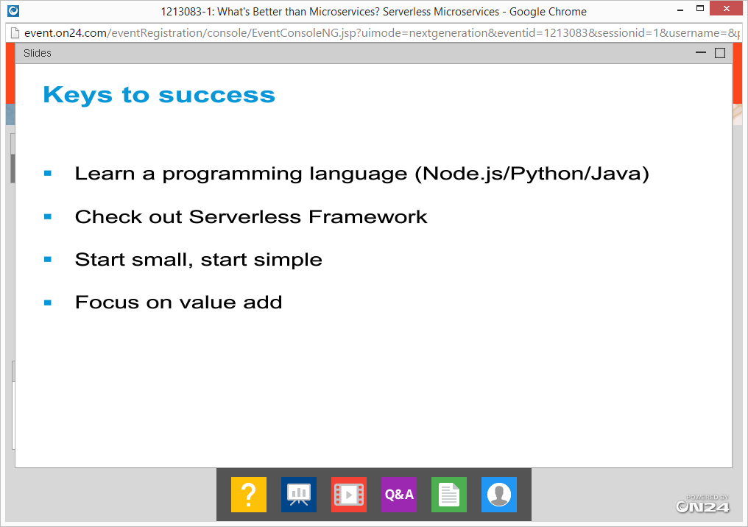

**Apigee with Kubernetes**

November 2, 2016

* When you are building APIs on Kubernetes, how to you take it to Apigee
* Kubernetes
  + Pod is the basic unit of deployment in Kubernetes
    - Contains “containers” which in turn contains applications
  + Service : abstraction of kubernetes which provides access to c

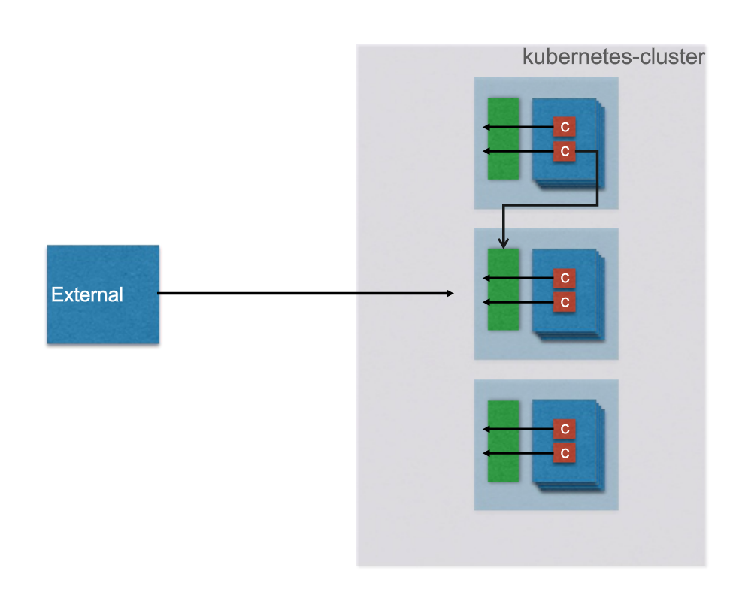

Internal & External calls in Kubernetes clusters

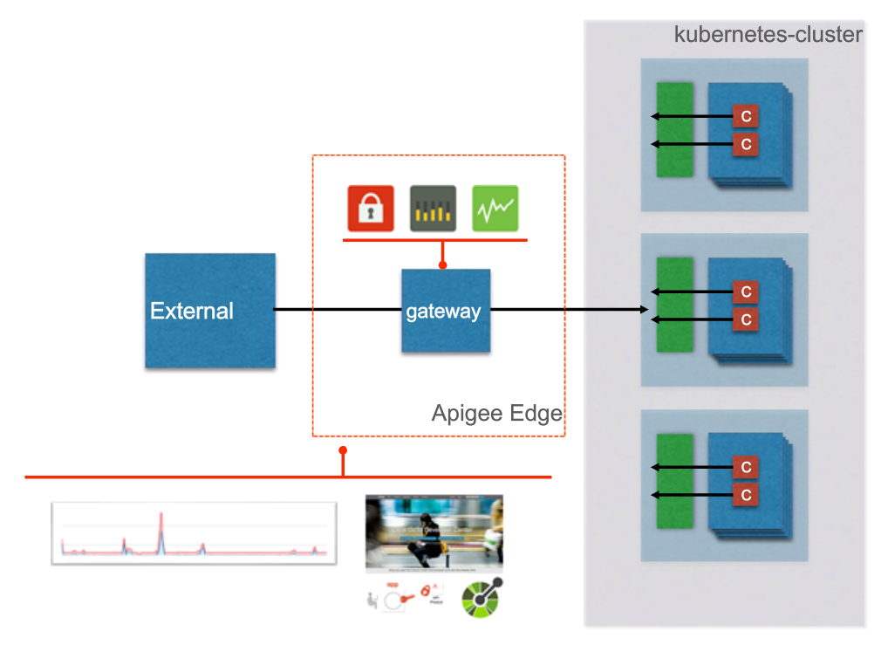

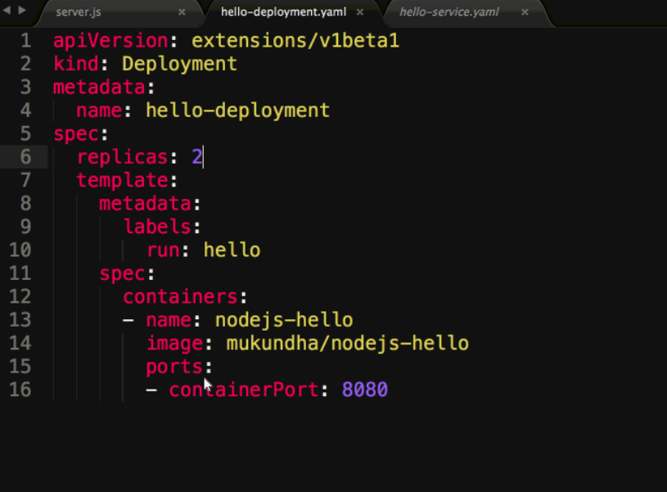

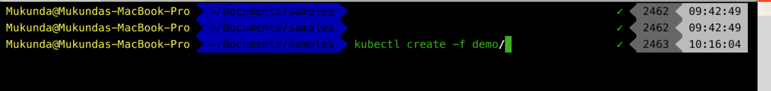

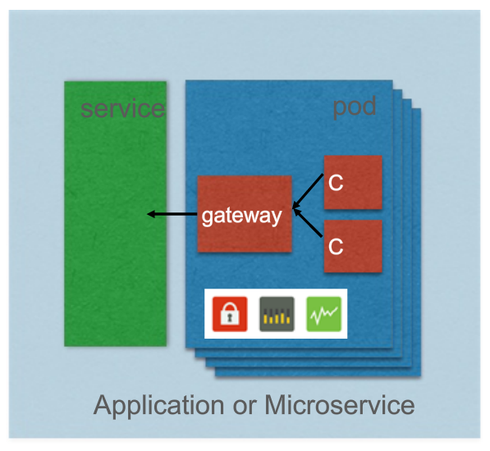

Embedding API gateway capabilities within pod – all policies managed centrally

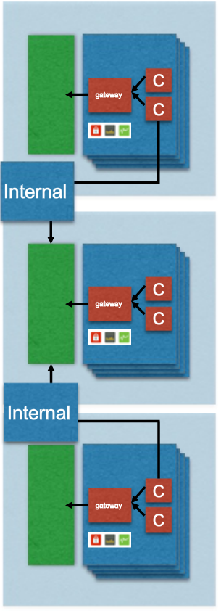

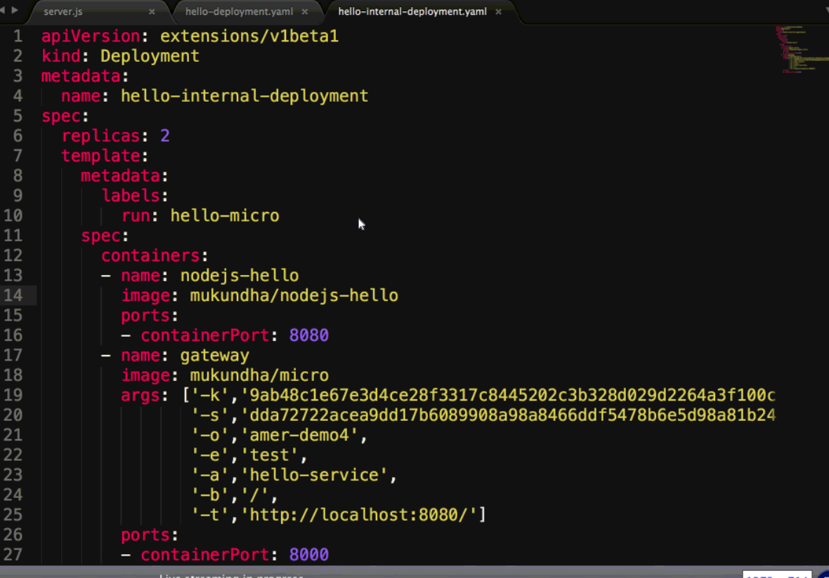

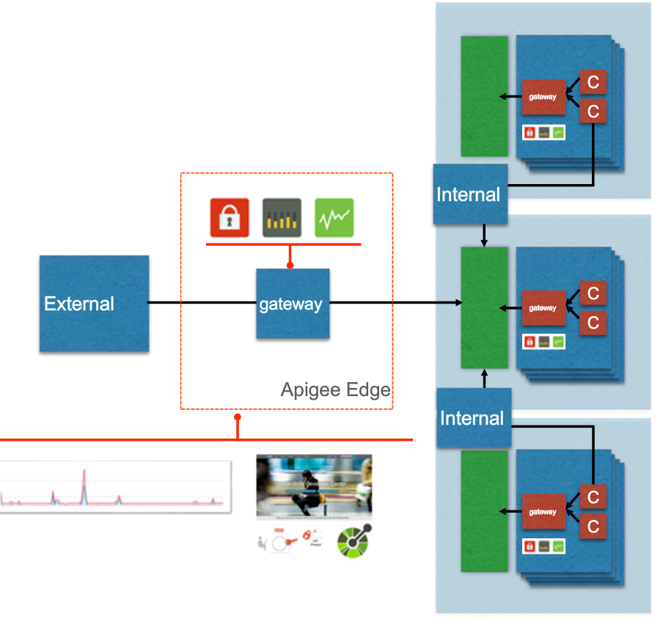

Below the hood

Kubernetes has API control

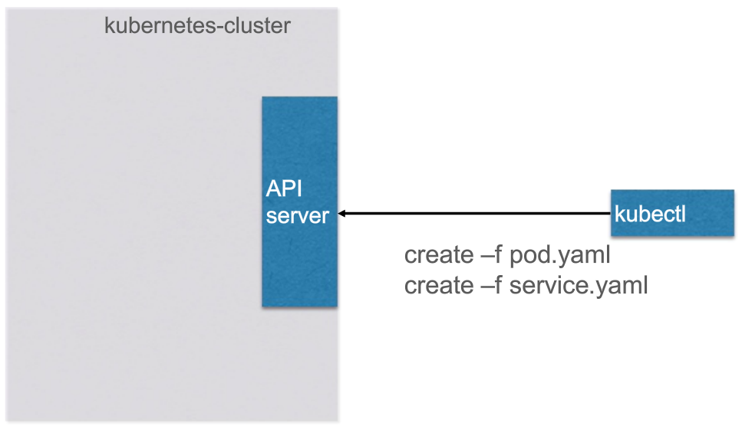

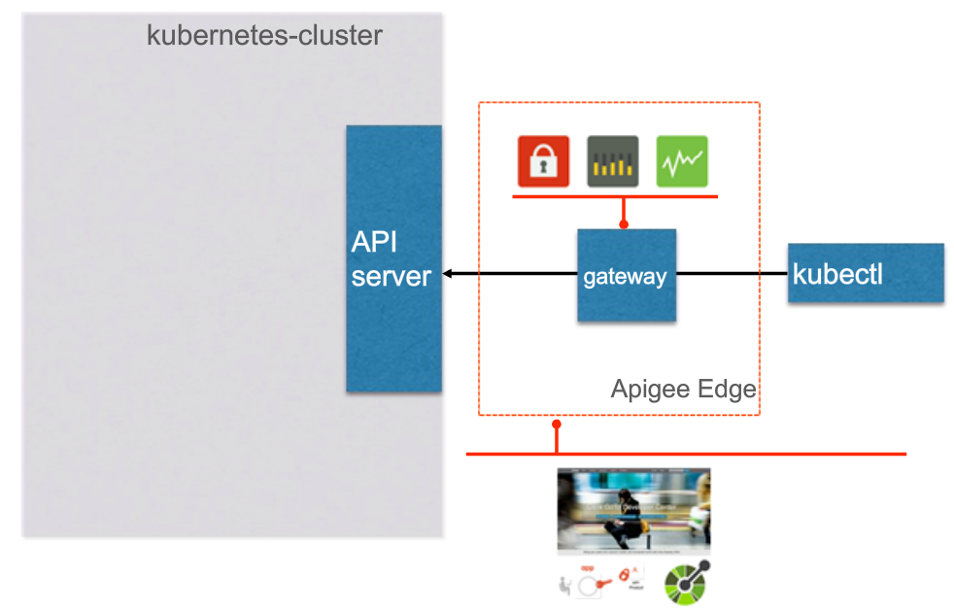

Kubernetes has been integrated with Apigee Tool

Kube-api proxy built by Apigee – all calls will be to the Kube-api proxy rather than direct calls to Kubernetes

This provides a clear way to manage access control and administrators.

Benefits:

* Auth & Auth
* Multiple project teams
* Multiple development environemtns
* Audit & compliance

Kubernetes is coming up with their own tooling, etc.

**Complete story**

